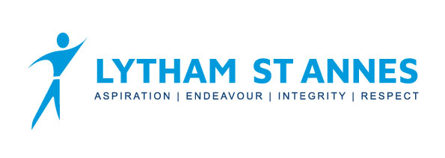
Yr11 French Curriculum Overview

 | Term 1 |  | Term 2 |  | Term 3
GCSE Theme | Theme 2 – Local, national, international & global areas of interest | Theme 3 – Current & future study and employment | Theme 1 – Identity & culture | Theme 2 – Local, national, international & global areas of interest | All 3 themes | All 3 themes
Sub topic | Home, town & neighbourhood  Global issues – the environment | Education Post 16  Careers & ambitions | Technology in everyday life | Social issues – charity & voluntary work  Global issues – poverty & homelessness | Revision & exam skills | Revision & exam skills
Assessment | Listening  Speaking  Reading  Writing |  | Listening  Speaking  Reading  Writing |  | Listening  Speaking  Reading  Writing

Yr11 German Curriculum Overview

 | Term 1 |  | Term 2 |  | Term 3
GCSE Theme | Theme 2 – Local, national, international & global areas of interest | Theme 3 – Current & future study and employment | Theme 1 – Identity & culture | Theme 2 – Local, national, international & global areas of interest | All 3 themes | All 3 themes
Sub topic | Home, town & neighbourhood  Global issues – the environment | Education Post 16  Careers & ambitions | Technology in everyday life | Social issues – charity & voluntary work  Global issues – poverty & homelessness | Revision & exam skills | Revision & exam skills
Assessment | Listening  Speaking  Reading  Writing |  | Listening  Speaking  Reading  Writing |  | Listening  Speaking  Reading  Writing

