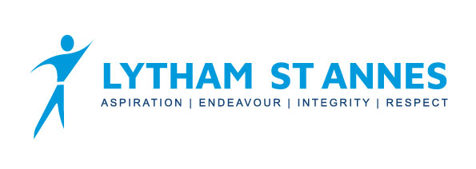
Yr9 French & German Curriculum Overview

 | Term 1 |  |  | Term 2 |  |  | Term 3
Topic | Past holidays | Past holiday activities | Holiday choices | Future holiday plans | Family relationships | My ideal partner | Future life plans | Celebrations
French Language & Structures | French sentence builder 19 | French sentence builder 20 | French sentence builder 21 | French sentence builder 22 | French sentence builder 23 | French sentence builder 24 | French sentence builder 25 | French sentence builder 26
German Language & Structures | German sentence builder 19 | German sentence builder 20 | German sentence builder 21 | German sentence builder 22 | German sentence builder 23 | German sentence builder 24 | German sentence builder 25 | German sentence builder 26
Assessment | Translation from the target language into English  Translation from English into the target language; French or German |  |  | Translation from the target language into English  Translation from English into the target language; French or German |  |  | Translation from the target language into English  Translation from English into the target language; French or German

