Year 11 Enhanced Standard: Assessment 3 Revision

Topic 9 | /20 | Topic 10 | /20 | Topic 11 | /25 | Topic 12 | /10

 | Topic 9: Percentages |  | Mark
1. | Jules buys a washing machine.  20% VAT is added to the price of the washing machine.  Jules then has to pay a total of £600  What is the price of the washing machine with no VAT added? |  | (2)
2. | George wants to watch all 23 games that a football team will play at home next season.  He can buy  a season ticket costing £425  or 23 separate tickets costing £24 each ticket.  What percentage of the total cost of 23 separate tickets does George save by buying a season ticket? |  | (3)
3. | Daniel bakes 420 cakes.  He bakes only vanilla cakes, banana cakes, lemon cakes and chocolate cakes.  $\frac{2}{7}$of the cakes are vanilla cakes.  35% of the cakes are banana cakes.  The ratio of the number of lemon cakes to the number of chocolate cakes is 4:5  Work out the number of lemon cakes Daniel bakes. |  | (5)
4. | Jack has £15 000 to invest in a savings account for 3 years.  He finds information about two savings accounts.  Simple Simple interest 2.3% each year Compound Compound interest 2.15% each year  Jack wants to have as much money as possible in his savings account at the end of the 3 years.  Which of these two savings accounts should he choose? |  | (4)
5. | Amy wants to invest £25000 for 3 years in a bank.  Personal Bank Compound interest 2% each year Compound Compound interest 4.3% for the first year 0.9% for each extra year  Which bank will give Amy the most interest at the end of 3 years?  You must show all your working. |  | (3)
6. | Phil invests £6000 for 5 years.  The investment gets compound interest of x% per annum.  At the end of 5 years the investment is worth £8029.35  Work out the value of x. |  | (3)
 | Topic 10: Congruency and similarity | Mark
1. | 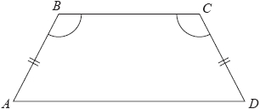  ABCD is a quadrilateral.  AB = CD.  Angle ABC = angle BCD.  Prove that AC = BD. | (3)
2. | 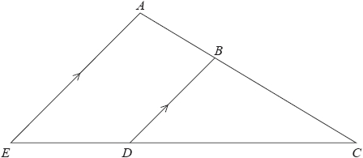  ABC and EDC are straight lines.  EA is parallel to DB.  EC = 8.1 cm. DC = 5.4 cm.  DB = 2.6 cm. AC = 6.15 cm.  Work out the length of AB. | (3)
3. | 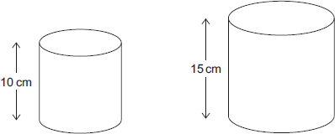  A solid cylinder has a volume of 454 cm³.  The cylinder has a height of 10 cm.  A similar cylinder has a height of 15 cm.  What is the volume of the larger cylinder? | (3)
4. | 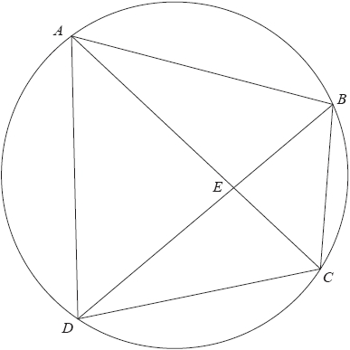  A, B, C and D are four points on the circumference of a circle.  AEC and BED are straight lines.  Prove that triangle ABE and triangle DCE are similar.  You must give reasons for each stage of your working. | (3)
5. | 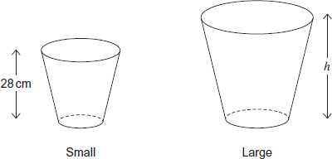  Jim makes two sizes of bin.  They are similar shapes.  The ratio of the areas of the bases of the bins is 4 : 9  Jim says,  “The volume of the large bin is more than 3 times the volume of the small bin.”  Is he correct? You must show your working. | (2)
6. | 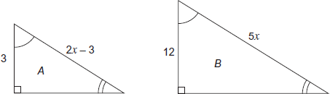  A and B are similar triangles.  All measurements are in cm.  Work out the area of triangle B. | (6)
 | Topic 11: y = mx + c | Mark
1. | The equation of the line L₁ is y – 3x = − 2  The equation of the line L₂ is 3y − 9x + 5 = 0  Show that these two lines are parallel. | (3)
2. | Find an equation of the line that is perpendicular to the line y = 5x + 6 and passes through the point (–2, 5). | (3)
3. | 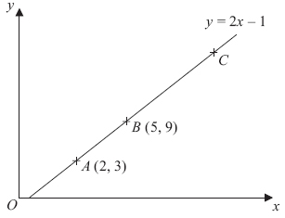  In the diagram, the points A, B and C lie on the straight line y = 2x – 1  The coordinates of A are (2, 3).  The coordinates of B are (5, 9).  Given that AC = 3AB, find the coordinates of C. | (3)
4. | 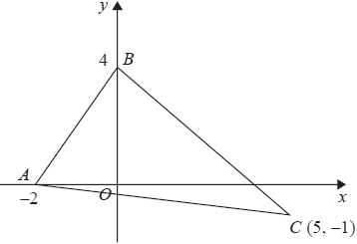  Find an equation of the line that passes through C and is perpendicular to AB. | (4)
5. | The points A(6, 1) and B (−2, 5) are on the line with equation $y=4-\frac{1}{2}x$  M is the midpoint of AB.  Find an equation of the line through M that is perpendicular to $y=4-\frac{1}{2}x$ | (4)
6. | 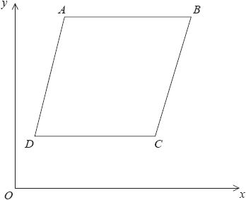  ABCD is a rhombus.  The coordinates of A are (5,11)  The equation of the diagonal DB is  $y=\frac{1}{2}x+6$  Find an equation of the diagonal AC. | (4)
7. | A and B are straight lines.  Line A has equation 2y = 3x + 8  Line B goes through the points (−1, 2) and (2, 8)  Do lines A and B intersect? You must show all your working. | (4)
 | Topic 12: Scattergraphs/capture recapture | Mark
1. | The scatter graph shows the maximum temperature and the number of hours of sunshine in fourteen British towns on one day.  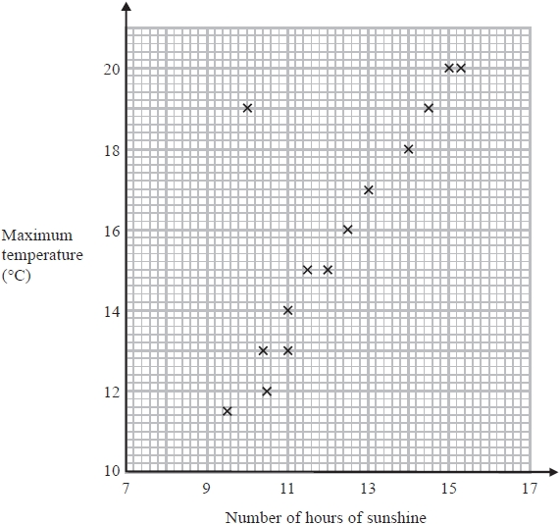  One of the points is an outlier.  a) Write down the coordinates of this point.  b) For all the other points write down the type of correlation.  On the same day, in another British town, the maximum temperature was 16.4°C.  c) Estimate the number of hours of sunshine in this town on this day.  A weatherman says, "Temperatures are higher on days when there is more sunshine."  d) Does the scatter graph support what the weatherman says? Give a reason.  Matt says  “I can use the graph to predict the temperature when there is 8 hours of sunshine”  e) Explain why Matt should not do this. | (1)  (1)  (2)  (1)  (1)
2. | Alex wants to find out how many ducks there are in a park.  One day he puts a tag on each of 30 of the ducks.  The next day he catches 40 ducks.  8 of these ducks have tags on them.  a) Work out an estimate for the number of ducks in the park.  Alex assumed that none of the tags fell off during the night.  b) If Alex's assumption is wrong, explain how this could affect your answer. | (3)  (1)

