YEAR 11 TEST 6 Review Homework calculator allowed ENHANCED

 | Algebra: Tangents and Area
1.  S | Here is a velocity time graph of a motorbike for 25 seconds.  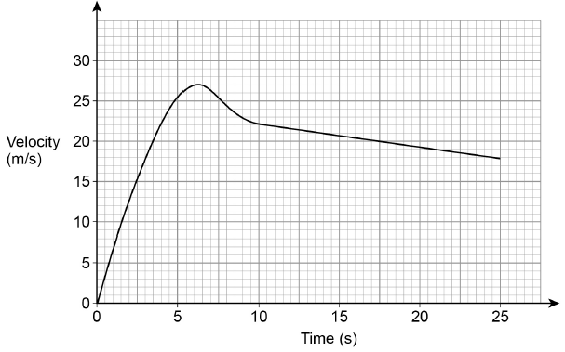  a) After how many seconds was the acceleration zero?  b) Work out the distance travelled in the last 15 seconds. | (1)  (2)
2.  M | Here is a speed-time graph for a car journey.  The journey took 50 seconds.  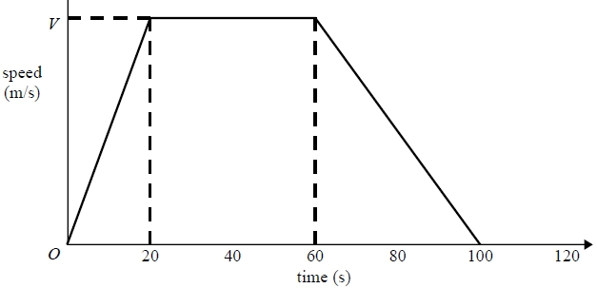  10 20 30 40 50 time seconds  The car travelled 1925 m in the 50 seconds.  Work out the value of V. | (3)
 | Algebra: Equation of a circle
1.  F | The diagram shows the circle  A  O is the centre of the circle  A is the point (5, 12)  a) What is the equation of the circle?  b) Find the gradient of the radius OA.  b) Find the gradient of the tangent at A.  c) Find the equation of the tangent which passes through A. | (2)  (1)  (2)  (2)
2.  F | The diagram shows the circle x² + y² = 10  P lies on the circle and has x co-ordinate 3  The tangent at P intersects the y-axis at Q.  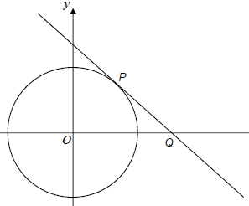  a) Find the gradient of the radius OP.  b) Find the equation of the tangent to the circle passing through P.  c) Work out the co-ordinates of Q. | (2)  (3)  (2)
3.  M | P (-1, 4) is a point on a circle, centre (0, 0).  a) Work out the equation of the tangent to the circle at P.  Give your answer in the form  y = mx + c.  Q  b) The tangent cuts the x axis at the point Q.  Find the area of triangle OQP. | (4)  (3)
4.  M | L is the circle with equation $x^{2}+y^{2}=4$  P = $\left(\frac{3}{2} , \frac{\sqrt{7}}{2}\right)$ is a point on the circle L.  Find the equation of the tangent to L at the point P. | (4)
5.  M | Prove algebraically that the straight line with equation $x-2y=10$  Is a tangent to the circle with equation $x^{2}+y^{2}=20$ | (5)
 | Probability: Frequency trees
1.  S | 75 students took a Mock GCSE paper.  Before the test, they predicted whether they would pass or fail.  $\frac{3}{5}$ people predicted they would pass.  80% of the people who predicted they would pass did pass.  55 people passed altogether.  a) Copy and complete the frequency tree.  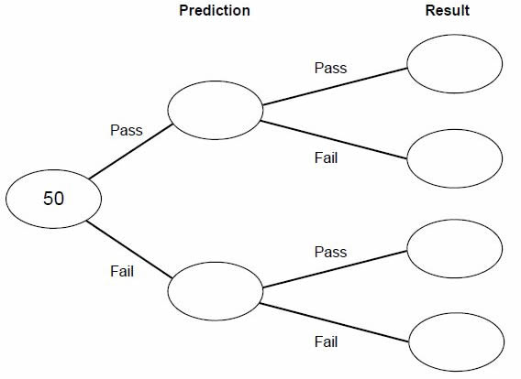  b) A person is picked at random.  What is the probability that they predicted they would fail but actually passed. | (3)  (2)

