Year 7 Core: Assessment 3 Revision Homework (Non-Calc) Name ______________

 | Topic 9: Fractions, decimals and percentages | Mark
1. | Simplify the fractions fully.  a) $\frac{4}{8}$ = ………………… c) $\frac{12}{18}$ = …………………  b) $\frac{10}{15}$ = ………………… d) $\frac{15}{21}$ = ………………… | 4
2. | Match the fraction and decimal equivalents.  $$\frac{1}{2}$$ $$\frac{3}{4}$$ $$\frac{1}{10}$$ $$\frac{7}{10}$$ $$\frac{1}{4}$$  0.7 0.25 0.1 0.5 0.75 | 3
3. | Convert the percentages to fractions.  Leave your answer in its simplest form.  50% = $\frac{……}{100}$ = ……… 20% = ……… = ……… 15% = ……… = ……… | 3
4. | Calculate:  - $\frac{1}{2}$ of 18 = ……… b) $\frac{1}{4}$ of 24 = ………  c) $\frac{2}{5}$ x 25 = ……… d) $\frac{3}{7}$ of 21 = ……… | 4
5. | Calculate, leaving your answer in its simplest form:  - $\frac{2}{5}+\frac{1}{5}=$ ……… b) $\frac{7}{10}-\frac{3}{10}=$ ………  c) $\frac{4}{9}+\frac{2}{9}=$ ……… d) $\frac{4}{5}-\frac{1}{10}=$ ……… | 4
6. | Sally has 24 sweets.  She gives ¼ of her sweets to Jamie.  How many sweets does she have left?  ……………… | 2
 |  | 20

 | Topic 10: 2D shapes and angles | Mark
1. | Fill in the missing directions on the compass.  North  North-west  …………………  …………………  South-east  …………………  East  ………………… | 4
2. | Name the types of angles:  …………………… ……………………… ……………………… | 3
3. | Connor has drawn a triangle.  The triangle has 3 sides of the same length and 3 equal angles.  What type of triangle did Connor draw?  ……………………… | 1
4. | Calculate the size of the missing angles:  d  135°  b  a  120°  50°  c  a = ………… b = ………… c = ………… d = ………… | 4
5. | Name these shapes:  ………………………… ………………………… ………………………… | 3
 |  | 15

 | Topic 11: Linear graphs | Mark
1. | 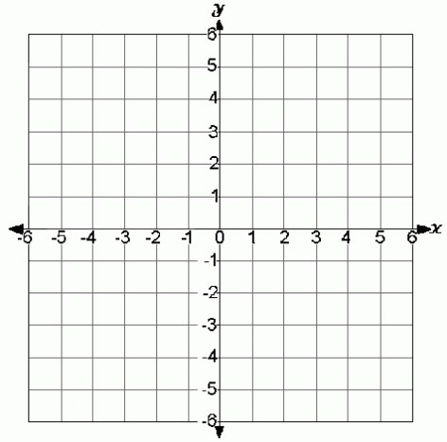  On the axes, mark the following coordinates:  (-2, 3), (3, 2), (-2, -1), (3, -1)  Join the co-ordinates together.  What shape have you made? …………………………… | 5
2. | The line x = 4 is shown on the diagram.  x = 4  - Is x = 4 a horizontal or vertical line?  ……………………………  - Plot the line y = -3.  - Plot the line x = -5.  - Plot the line y = 2. | 4
3. | 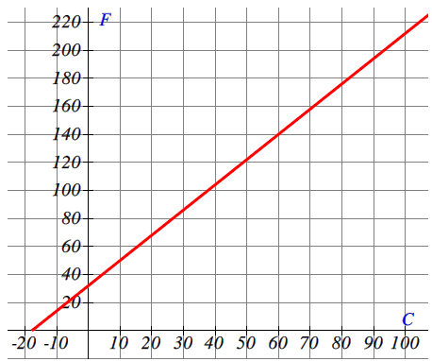  The graph shows the conversions between  °C and °F.  Use the graph to convert:  - 70°C = …………………°F  - 120°F = …………………°C  - 10°C = …………………°F | 3
4. | 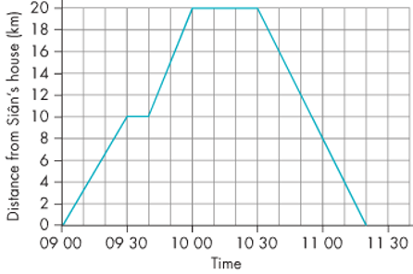  Sian goes to Preston. The graph represents her journey to Preston and home again.  - At what time did Sian set off?  ……………………  - How far is it from Sian’s house  to Preston?  ……………………  - How long did she stay in Preston?  …………………… | 3
 |  | 15

 | Topic 12: Statistical diagrams | Mark
1. | A band played 20 concerts in five continents.  - Fill in the missing gaps in the frequency table.  Continent Tally Frequency  Africa l  Asia l  Europe 10  North America lll  South America 5  Total 20  - Draw a fully labelled bar chart of this information. | 2  3
2. | A group of friends went on an activity weekend.  They chose the following activities:  Biking Karting Biking Karting Archery Horse riding  Biking Archery Karting Archery Horse riding Biking  Biking Archery Biking  - Complete the tally and frequency columns in the table.  Activity Tally Frequency  Biking  Karting  Archery  House riding  - Draw a pictogram to show the results. Use the key: = 2 people  Biking  Karting  Archery  House riding | 2  3
 |  | 10

