Year 7 Enhanced Standard: Assessment 2 Revision Name ______________________________

 | Topic 5: Perimeter and Area | Mark
1. | Find the area of the parallelogram and the triangle.  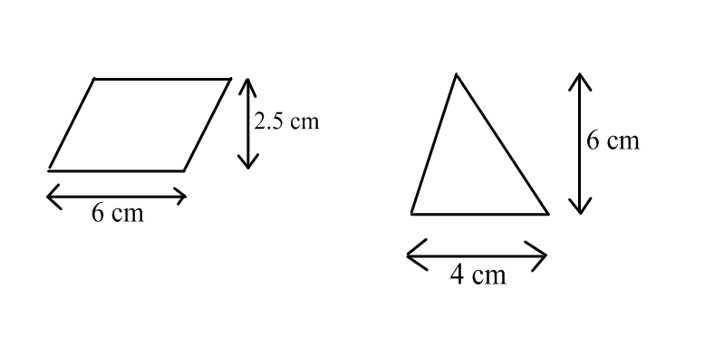  Area parallelogram = Area triangle =  = ………………………cm² = ……………………….cm² | (4)
2. | Find the area of the trapezium.  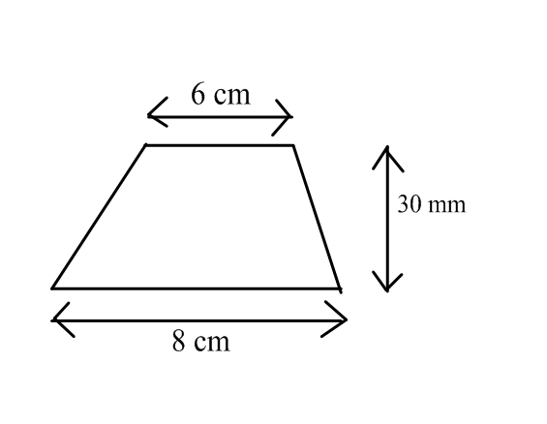  Area = ……………………………………………. | (2)
3. | a) Given that the perimeter of the rectangle is 22cm, fill in the missing lengths and area.  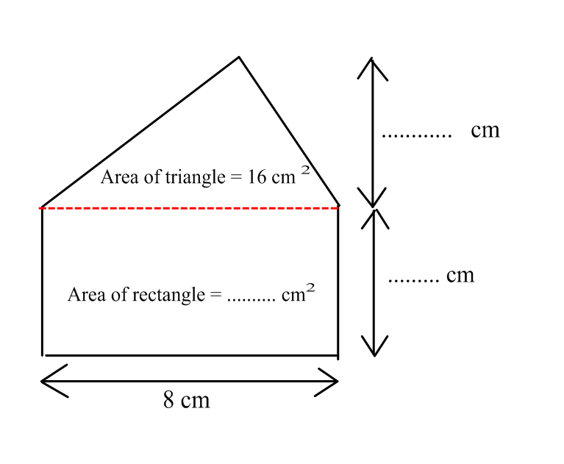  b) What is the total area of the shape? Area = ………………………. | (3)  (1)
 | Total | (10)

 | Topic 6: Ratio and Proportion | Mark
1. | a) Cancel the ratio 15 : 20 to its simplest form. ……………….  b) Write the ratio 3 : 7 in the form 1 : n ………………. | (1)  (1)
2. | Assim and Julie share £120 in the ratio 3 : 5  How much money does each receive?  Assim £…..……..  Julie £ ………… | (1)  (1)
3. | Here are the ingredients to make a pasta bake for 8 people  Pasta 200 g  Tomatoes 300 g  Garlic 20 g  Sausage 150 g  - On Saturday Alison wants to make a pasta bake for 12 people.  Pasta ………….. g  Work out how much of each ingredient she needs. Tomatoes ……………. g  Garlic ……………. g  Sausage .………….. g  - The next Saturday Alison makes a pasta bake and uses 375 g sausage.  How many people was the pasta bake for?  …………………………. | (2)  (1)
4. | Julie wants to buy washing up liquid.  Suds R Us costs £2.99 for 250 ml  Wash Up Happy costs £3.99 for 400 ml.  Which washing up liquid is better value for money. You must show your working.  ……………………………………. | (3)
 | Total | (10)

 | Topic 7: Sequences | Mark
1. | a) Find the next 2terms of the sequences below and explain the term to term rule.  3, 10, 17, ……………… , …………… The term to term rule is ………………………….  34, 31, 28, ………….. , ……………. The term to term rule is ………………………..  2, 4, 8, ……………….. , ……………… The term to term rule is ………………………..  81 , 27, 9, …………… , ……………….. The term to term rule is ……………………….  b) Write down the first 5 terms for the following rules  T ( n ) = 2n + 4 U_{n} = 30 – 3n  T ( 1 ) = U₁ =  T ( 2 ) = U₂ =  T ( 3 ) = U₃ =  T ( 4 ) = U₄ =  T ( 5 ) = U₅ = | (2)  (2)
2. | Here is a sequence  9 , 13 , 17 , 21 , 25, …………………………..  - Find the rule for the Nth term of the sequence ……………………………..  - Calculate the 20th term in this sequence ………………………………  - Mark thinks that 117 is in the sequence.  Is Mark correct? …………………………  Give a reason for your answer ……………………………………………………………………………………………………………………………………………………………………………………………………………………………………………………………………………………………………………………………….................................................................................................................................................................... | (2)  (1)  (1)
3. | Find the Nth term for the following sequence  35 , 32 , 29 , 26, 23, ……….  ……………………………………….. | (2)
 | Total | (10)

 | Topic 8: Probability | Mark
1. | Choose the correct word to describe the probability of these events from the list below.  Impossible Very Unlikely Even Likely Certain  The probability a baby is born as a boy ………………………  The probability that the next person you meet will be 4 m high …... …………………  The probability that you will win the National Lotto Lottery ………………………..  A normal six sided die is thrown. Mark with an arrow on the number line the probability that the die lands on a three. | (1)  (1)
2. | a) The probability it will rain tomorrow is 0.93  What is the probability that it will not rain? ……………………………………  b) A spinner has Blue, Red, Yellow and White sides. The probabilities of the spinner landing on Blue, Red or White is given in the table below.  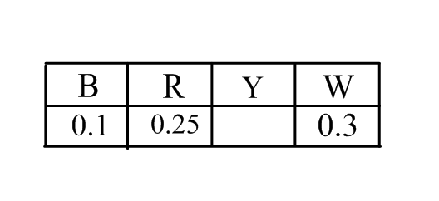  What is the probability the spinner lands on a Yellow? ………………………………….  - A different spinner also has Blue, Red, Yellow and White sides. The probabilities of the spinner landing each colour are given in the table below.  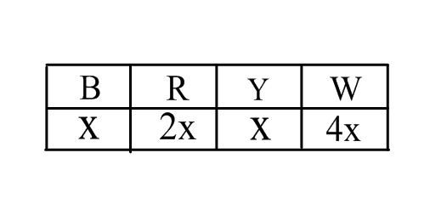  What is the probability this spinner lands on red? ………………………………….. | (1)  (1)  (1)
3. | Timmy throws a normal six sided die 1200 times.  How many times would he expect to throw a 5 ? …………………………………… | (1)
4. | Complete the sample space diagram to show all the outcomes when a 2 p coin and a 10 p coin are thrown.  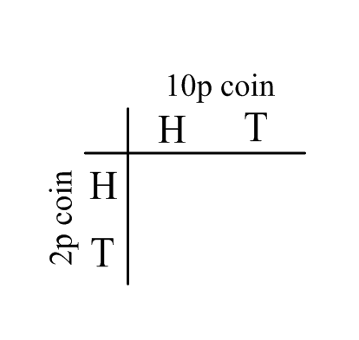  What is the probability of throwing a tail followed by a head ? ………………….  What is the probability of throwing two tails ? ………………….. | (1)  (1)  (1)
4. | A coin is thrown 1000 times. There are 100 Heads and 900 Tails. Julie says the coin is fair. Is she right? Give a reason for your answer. …………………… because ………………………………………………………………………………………………………………………………………. | (1)
 | Total | (10)

