Year 8 Core: Assessment 3 Revision HW (Non-Calculator) Name __________________
 | Topic 9: Fractions
1. | (a) Write 0.24 as a fraction in its simplest form ……………………………  (b) Write 36% as a fraction in its simplest form ……………………………  (c) Write $\frac{4}{5}$ as a percentage …………………………… | (1)  (1)  (1)
2. | There are 120 people at a party.  $\frac{1}{3}$of the people leave the party.  Work out the number of people still at the party.  …………………………… | (1)
3. | Sam has £48.  He spends $\frac{3}{4}$of the £48.  Work out how much money Sam has left.  …………………………… | (2)
4. | Work out:  - $\frac{2}{7}$ + $\frac{3}{7}$ …………………………… (b) $\frac{7}{8}$ - $\frac{3}{8}$ …………………………… | (2)
5. | Work out $\frac{2}{7}+\frac{1}{5}$  …………………………… | (2)
 |  | 10
 | Topic 10: 2D Shapes and Angles
1. | 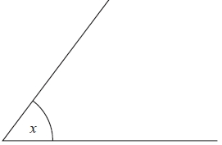  (a) Write down the special name for this type of angle  …………………………………  (b) Measure the angle marked x  …………………………… ˚ | (2)
2. | (a) Work out the size of the angle marked x.  ……………………………°  (b) Give a reason for your answer.  ………………………………………………………………………………………………………………………………………………………………… | (2)
3. | (a) Work out the size of the angle marked x.  …………………………… °  (b) Give a reason for your answer.  ………………………………………………………………………………………………………………………………………………………………… | (2)
4. | (a) What is the special name given to this type of triangle?  …………………………  (b) Work out the size of the angle marked x.  ………………………… ° | (2)
5. | Name each shape:  ………………………………………………… ………………………………………… | (2)
 |  | 10
 | Topic 11: Linear Graphs
1. | 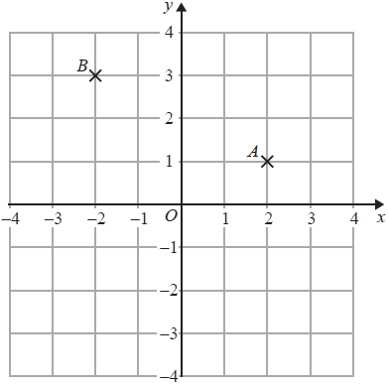  (a) Write down the coordinates of the point A.  (................... , ......................)  (b) Write down the coordinates of the point B.  (................... , ......................)  (c) On the grid, draw the line x = 3 | (3)
2. | 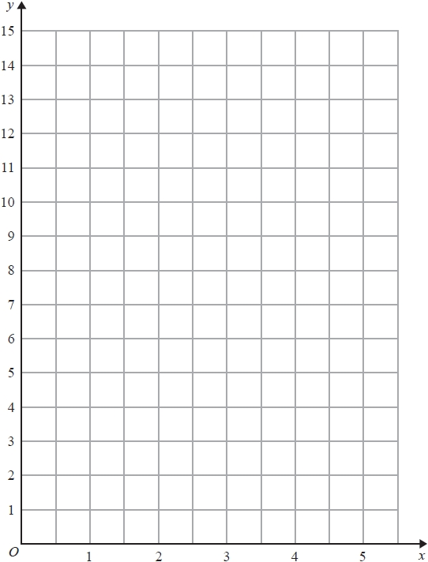  (a) Complete the table of values for  y = 2x + 3 for values of x from 0 to 5  x 0 1 2 3 4 5  y  (b) on the grid, draw the graph of  y = 2x + 3  for values of x from 0 to 5 | (2)  (2)
3. | 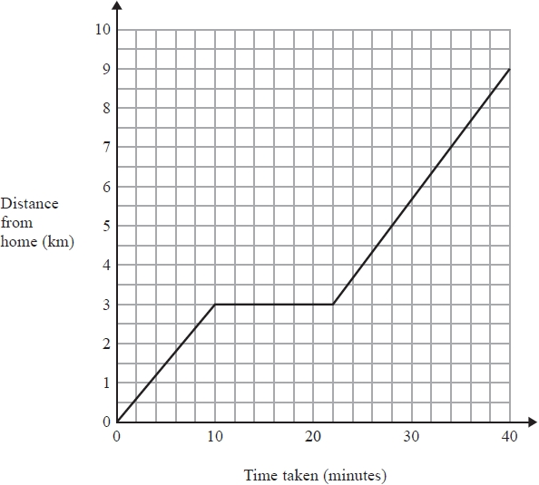  One day Jane cycled from home to college.  She stopped at a shop on the way to college.  The travel graph shows Jane's journey from home to college.  (a) Write down the distance from Jane's home to college  …………………………… km  - Write down how long Jane stopped at the shop …………………………… minutes | (2)
4. | 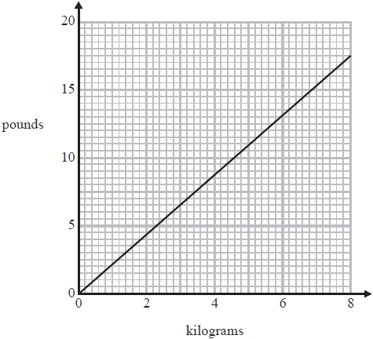  You can use this conversion graph to change between kilograms and pounds.  Use the conversion graph to change 5 kilograms to pounds.  …………………………… pounds | (1)
 |  | 10

 | Topic 12: Statistical Diagrams
1. | (a) A band played 20 concerts in four different continents.  Asia Europe Asia Europe America America Europe America Asia Europe  Europe Asia America Africa Europe Asia Europe Europe America America  Complete the tally chart below.  Continent Tally Frequency  Africa  Asia  Europe  America  (b) Draw a fully labelled bar chart to show this information. | (2)  (2)
2. | The bar chart shows the number of dogs and cats taken to a vet one week.  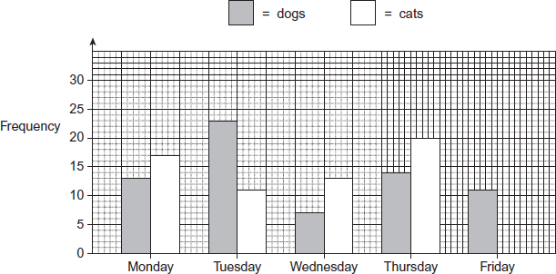  (a) How many dogs were taken to the vet on Tuesday?  ……………………………  (b) Work out the total number of dogs and cats taken to the vet on Monday  ……………………………  (c) An equal number of dogs and cats were taken to the vet.  How many cats must have been taken to the vet on Friday? …………………………… | (1)  (1)  (2)
3. | 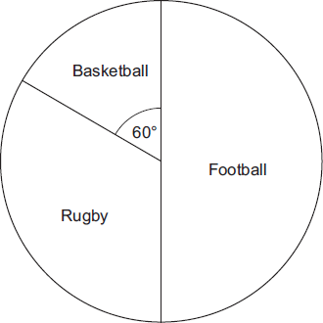  The pie chart shows the sports played by 30 boys.  (a) How many boys play Football?  ……………………………  (b) How many boys play Rugby?  …………………………… | (1)  (1)
 |  | 10

