Year 8 Foundation: Assessment 1 Revision Homework (No Calc) Name ______________

 | Topic 1: Negative Numbers | Mark
1. | Fill in the missing numbers:  -13 ……… -3 2 ……… 12 ……… ……… | 1
2. | At 8 am, the temperature was - 3°C.  At midday, the temperature was 6°C higher.  What was the temperature at midday?  ………………………… | 2
3. | Put an inequality sign in the box. Choose from > <  (a) -3 +5  (b) 3 -7  (c) -2 -4 | 3
4. | Calculate:  (a) -8 - 4 = ………… (b) - 6 + 2 - 4 = ………… | 2
5. | Calculate the following:  (a) 7 - - 3 = ………… (b) -3 - + 8 = ………… | 2
6. | (a) Re-write down the following numbers in order from smallest to largest:  –2 –8.5 –8 9 –11  ……………… ……………… ……………… ……………… ………………  (b) Re-write down the following numbers in order from smallest to largest:  –2.6 8.3 –1.3 –2 2.7  ……………… ……………… ……………… ……………… ……………… | 2

 | Topic 2: Algebraic Manipulation | Mark
1. | There are x sweets in a packet.  I eat 4 sweets.  Write an expression for the number of sweets left in the packet.  ………………………… | 1
2. | Simplify:  (a) 2a +3a + a …………………………  (b) 3a + 2b + 4a + b …………………………  (c) a x 5b ………………………… | 3
3. | Write an algebraic expression for:  (a) Double d …………………………  (b) Half of b ………………………… | 2
4. | Find the value when x = 3  (a) 2x + 5 …………………………  (b) x - 5 ………………………… | 2
5. | Find the value when a = 2 and b = 5  (a) 3a + 4b …………………………  (b) 2a – b ………………………… | 2
6. | Please write an expression for the perimeter of the shape  2a  a  a  2a  ………………………… | 2

 | Topic 3: Averages | Mark
1. | 3 2 4 6 3 3 4  Find the: (a) mode ………………………… (b) range …………………………  (c) median ………………………… | 1  1  2
2. | Calculate the mean of these homework marks. 7 3 5 4 6  ………………………… | 2
3. | Find the mean of these temperatures: 5 9 -1 3 -2 10  ………………………… | 2
4. | Four numbers have a mean of 4.  Three of the numbers are 1, 4 and 8.  What is the fourth number?  ………………………… | 2
5. | There are two children in the Peacock family.  The range of their ages is exactly 6 years.  What age could the two children be?  ……… and ……… | 1
6. | (a) What is the range of the number of pets owned ? ………  (b) What is the total number of pets owned? ……… | 2  1  2
7. | 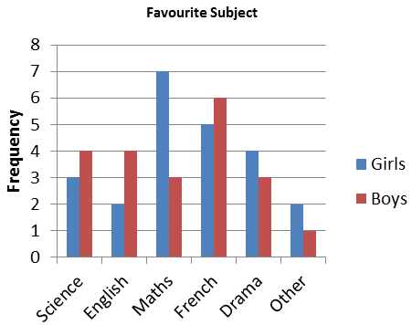  What was the mean of boys and girls choosing maths as their favourite subject?  ………………………… | 2

 | Topic 4: Number Properties | Mark
1. | 3, 6, 8, 9, 12, 15  Which number from this list is:  (a) a prime number ………… (b) a square number ………… | 2
2. | (a) Write down all the factors of 24  ……… ……… ……… ……… ……… ……… ……… ………  (b) Write down all the factors of 36  ……… ……… ……… ……… ……… ……… ……… ……… ………  (c) Write down the highest common factor of 24 and 36.  ……… | 5
3. | (a) Find the first five multiples of 10 ……… ……… ……… ……… ………  (b) Find the first five multiples of 6 ……… ……… ……… ……… ………  (c) Find the lowest common multiple (LCM) of 10 and 6. ……… | 3
4. | Alison says that “25 is a prime number” Is Alison correct? Explain your answer.  …………………………………………………………………………………………………………………………………………………  ………………………………………………………………………………………………………………………………………………… | 2
5. | Sort each of the numbers below into the Venn diagram.  23 15 6 25 12 21 32 45 10  Multiples of 3  Multiples of 5 | 3

