Year 8 Higher Standard: Assessment 2 Revision Name _____________________

 | Topic 5: Perimeter and Area | Mark
1. | Find the area of the parallelogram and the triangle.  Area parallelogram = Area triangle =  = ………………… cm² = ………………… cm² | (4)
2. | Find the area of the trapezium. Find the circumference of the circle.  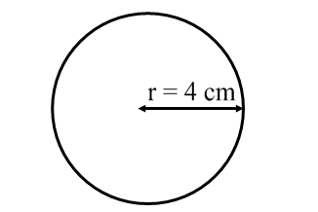  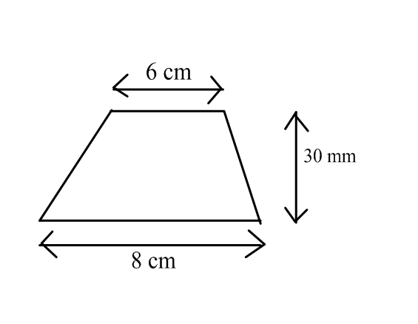  Area = ………………… cm² Circumference = ………………… cm | (2)
3. | a) Given that the perimeter of the rectangle is 22cm, fill in the missing lengths and area.  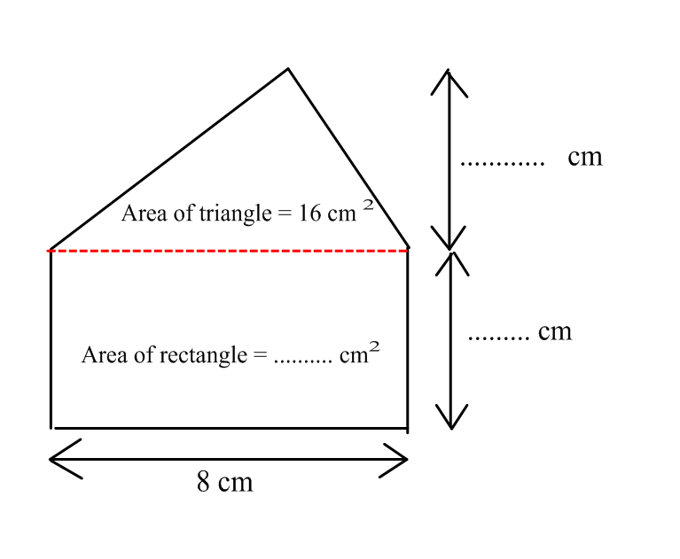  b) What is the total area of the shape?  Area = ………………… cm² | (3)  (1)
 | Total | (10)

 | Topic 6: Ratio and Proportion | Mark
1. | a) Write the ratio 15 : 20 in its simplest form.  ……………….  b) Bricks are made by mixing cement and water in the ratio 3 : 4  A builder uses 12 litres of cement.  How much water does he need?  ……………… | (1)  (1)
2. | Assim and Julie share £120 in the ratio 3 : 5  How much money does each receive?  Assim £ ……………… Julie £ ……………… | (2)
3. | Here are the ingredients to make a pasta bake for 8 people  Pasta 200 g  Tomatoes 300 g  Garlic 20 g  Sausage 150 g  - On Saturday Alison wants to make a pasta bake for 12 people.  Work out how much of each ingredient she needs.  Pasta ………… g Tomatoes ………… g  Garlic ………… g Sausage ………… g  - The next Saturday Alison makes a pasta bake and uses 375 g sausage.  How many people was the pasta bake for?  …………………………. | (2)  (1)
4. | Julie wants to buy washing up liquid.  Suds R Us costs £2.99 for 250 ml  Wash Up Happy costs £3.99 for 400 ml.  Which washing up liquid is better value for money.  You must show your working.  …………………………. | (3)
 | Total | (10)

 | Topic 7: Sequences | Mark
1. | Here is a pattern of squares:  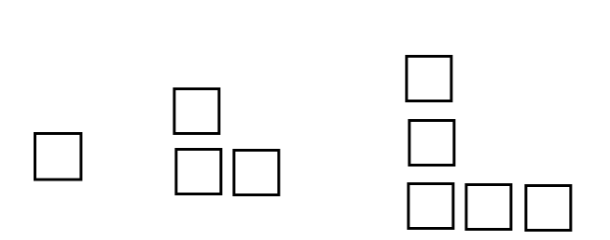  a) Complete the table of results:  Pattern number 1 2 3 4 5  Number of squares  b) How many squares are needed for the 20th pattern ?  ………………  c) Which pattern will have 43 squares?  ……………..  d) Complete the word formula  Number of squares = ………… x Pattern Number - ………… | (1)  (1)  (2)  (1)
2. | Here is a sequence  9 , 13 , 17 , 21 , 25, ……  - Find the rule for the n^{th} term of the sequence ………………………….  - Calculate the 20th term in this sequence ………………………….  - Mark thinks that 117 is in the sequence.  Is Mark correct? ………………………….  Give a reason for your answer.  ………………………………………………………………………………………………………………………………………………………  ……………………………………………………………………………………………………………………………………………………… | (1)  (1)  (1)
3. | Find the n^{th} term for the following sequence  35 , 32 , 29 , 26, 23, ………  …………………………. | (2)
 | Total | (10)

 | Topic 8: Probability | Mark
1. | Matthew has numbered cards 2, 3, 5, 6, 13, 17, 21 in a bag.  He organises the cards depending on whether the number is an EVEN or PRIME number and puts the information in a Venn diagram.  a) Complete the Venn diagram below to organise Matthews’ numbers.  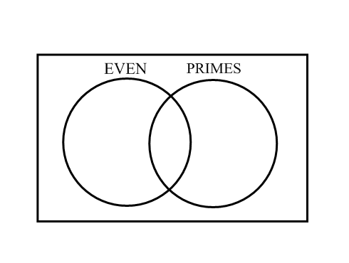  b) Matthew picks a card at random from the bag.  What is the probability the number is even ? …………………………. | (2)  (1)
2. | The probability it will rain tomorrow is 0.93  What is the probability that it will not rain?  …………………………. | (1)
3. | Timmy throws a fair six sided die 1200 times.  How many times would he expect to throw a 5 ?  …………………………. | (1)
4. | a) Complete the tree diagram to show the outcomes when a 2p coin and a 10p coin are thrown.  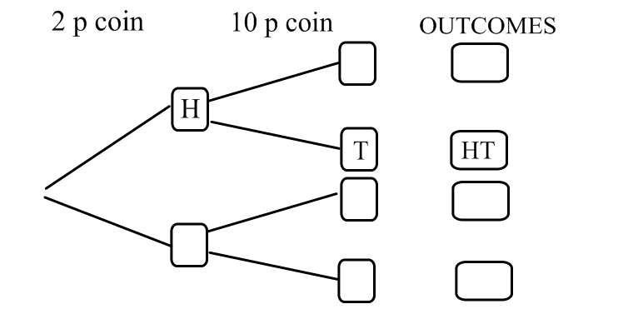  b) What is the probability of throwing a tail followed by a head ? ………….  c) What is the probability of throwing two tails ? …………. | (1)  (1)  (1)
4. | 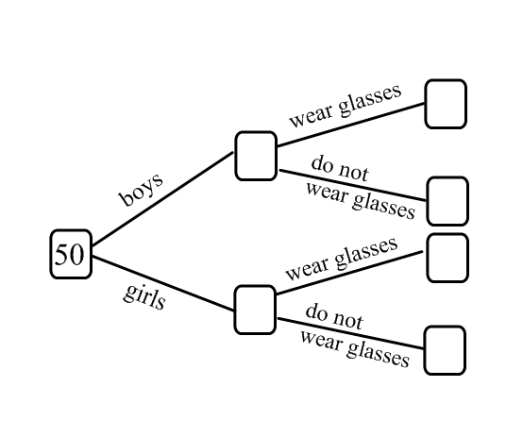  50 students are in Holmes college.  There are 27 boys.  19 boys do not wear glasses.  5 girls do wear glasses.  a) Complete the frequency tree.  The teacher chooses a student at random.  b) What is the probability that the student is a girl who wears glasses ?  ………….  The teacher chooses a boy.  c) What is the probability the boy wears glasses?  …………. | (2)  (1)  (1)
 | Total | (12)

