Year 9 Core Standard: Assessment 3 Revision Name _____________________________
 | Topic 8: Probability | Mark
1.  S | Mark on the number line with an arrow the probability of an event occurring:  - Throwing a number greater than 6 on a fair 6 sided die.  - Throwing an odd number on a fair 6 sided die.  - Throwing a number less than 7 on a fair 6 sided die.  - Throwing a number less than 5 on a fair 6 sided die.  1  0 | (4)
2.  F | a) The probability it will rain tomorrow is 0.93.  What is the probability that it will not rain?  ……………………  b) Timmy throws a normal six sided die 1200 times.  How many times would he expect to throw a 5 ?  ……………………  c) A spinner can land on Red, Green, Pink or Blue.  Colour Red Green Pink Blue  Probability $$\frac{1}{10}$$ 0.3 0.05  - What is the probability that the spinner lands on Pink ?  ……………………  - What is the probability that the spinner lands on Red or Green ?  …………………… | (1)  (1)  (2)  (1)
3.  F | Two spinners, one numbered from 1,2,3,4,5 and the other 2,4,6,8 , are spun and the product of the scores is noted.  Complete the sample space diagram with all the possible outcomes.  x 2 4 6 8  1  2  3  4  5  What is the probability of getting an odd number ? ……………………  What is the probability of getting a prime number ? ……………………  What is the probability of getting a square number ? ……………………  What is the probability of getting a 7 ? ……………………  What is the probability of getting a number less than 50 ? …………………… | (6)
 | Total | (15)

 | Topic 9: Fractions Decimals Percentages | Mark
1.  S | Write the following as fractions in their simplest form.  - 0.25 …………………… b) 30% ……………………  c) 0.05 …………………… d) 45% …………………… | (4)
2.  F | Write these five fractions in order of size. Start with the smallest fraction.  $$\frac{3}{4}$$ $$\frac{1}{2}$$ $$\frac{5}{6}$$ $$\frac{5}{12}$$  ……………… ……………… ……………… ……………… | (2)
3.  S | a) Find $\frac{1}{5}$ of 20 .……………………  b) Find $\frac{3}{5}$ of 20 …………………… | (1)  (1)
4.  F | Calculate:  a) $\frac{2}{5}+\frac{1}{6}$ b) $\frac{6}{7}-\frac{2}{3}$  ………………………………………… …………………………………………  c) $\frac{2}{5}×\frac{3}{8}$ d) $\frac{4}{5}÷\frac{9}{10}$  ………………………………………… ………………………………………… | (2)  (2)
5.  M | Isobel receives £60 for her birthday.  She spends 25% on clothes.  She spends $\frac{1}{5}$ on a McDonalds meal.  How much has she got left over?  …………………… | (3)
 | Total | (15)

 | Topic 10: Angles | Mark
1.  F | Find the missing angles and give reasons for your answers.  25° a 205° b  a = …………………… b = ……………………  ………………………………………………………………………… ………………………………………………………………………… ………………………………………………………………………… ………………………………………………………………………… d 60° 85° 150°  100°  c  c = …………………… d = ……………………  ………………………………………………………………………… ………………………………………………………………………… ………………………………………………………………………… ………………………………………………………………………… | (2)  (2)
2.  S | Name the following shapes:  …………………… …………………… ……………………  …………………… …………………… | (5)
3.  M | What is the sum of the interior angles of a pentagon?  …………………… | (1)
 | Total | (10)

 | Topic 11: Graphs | Mark
1.  S | a) On the grid draw and label the following lines  x = 4  y = - 2 | (2)
2.  M | - Complete the table and plot the graph of y = 2x + 1  x -3 -2 -1 0 1 2 3  y -1 3  - What is the gradient of the graph y = 3x + 4 ? ……………………  - What is the y intercept of the graph y = 2x – 5 ? …………………… | (2)  (1)  (1)
3.  F | 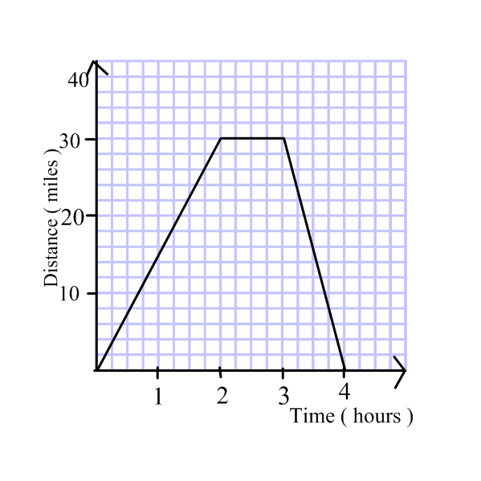  Alice cycles to the shops and back home again.  Here is her distance time graph.  a) How far has Alice travelled after 2 hours? ……………………  b) What speed is Alice travelling on the way to the shops? ……………………  c) How long does Alice stay at the shops? ……………………  d) When was Alice travelling fastest …………………… | (4)
 | Total | (10)

