Year 9 Enhanced: Assessment 1 Revision Name _________________________

 | Topic 1: | Mark
1. | The height of a tree is 3.5metres correct one decimal place.  Calculate the error bound for the minimum and maximum possible height of the tree.  ………… ≤ height < ………… | 2
2. | The following triangle has been measured to the nearest mm  Calculate the upper and lower bound for the perimeter of the triangle.  3.7cmm  4.5cm  3.9cmm  ……………………………… | 3
3. | Bags of nails weigh 200 grams each.  Boxes of screws weigh 140 grams each.  Both measurements are given to the nearest 10 grams.  Show that 4 bags of nails could weigh the same as 6 boxes of screws.  …………………………………………………………………………………………………………………………………………………  …………………………………………………………………………………………………………………………………………………  ………………………………………………………………………………………………………………………………………………… | 3
4. | 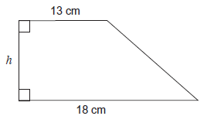  The area of this trapezium is 280 cm² to the nearest 10 cm  The lengths 13 cm and 18 cm are given to the nearest centimetre.  Work out the maximum possible value of the height h | 4
5. | Derek runs 200m in 28seconds.  The distance is measure to the nearest Metre.  The time was measured to the nearest second.  Calculate Derek’s quickest speed . | 3

 | Topic 2: Quadratics | Mark
1. | Factorise x² + 8x  ……………………………… | 1
2. | Factorise: x² + 4x + 3  ……………………………… | 1
3. | Solve: x² + 7x + 12 = 0  x = ……………… or x = ……………… | 3
4. | Solve: x² - 100 = 0  x = ……………… or x = ………………  What would the graph look like?  Draw a sketch labelling where the graph cuts the axes. | 3  1
5. | Solve: x² + 3x - 28 = 0  x = ……………… or x = ……………… | 3
6. | The square and the rectangle have the same area.  All lengths are in centimetres.  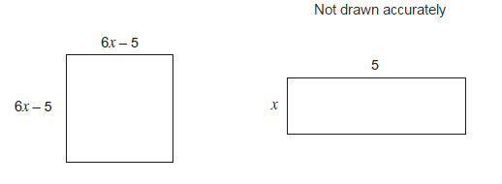  Show that 36x² – 65x + 25 = 0 | 3

 | Topic 3: cumulative frequency and box plots | Mark
1.  100  80  60  40  20  0 10 20 30 40 50 60 70  Age in years  Cumulative frequency | The table shows information about the ages of 100 rugby supporters.  Age a y(ears) Frequency  5 ≤ a < 15 12  15 ≤ a < 20 11  20 ≤ a < 40 25  40 ≤ a < 55 39  55 ≤ a < 70 13  - Plot the cumulative frequency diagram.  - Use your graph to find the median.  ………………………………  - Use your graph to calculate the interquartile range.  ………………………………  The youngest supporter was 4 and the oldest rugby supporter was 68.  d) Draw a box plot for this information.  - 10 20 30 40 50 60 70  Age in years | 4  1  2  3

 | Topic 4: Indices and Standard form | Mark
1. | Rewrite the following  a) a⁻² = ………………………………  b) $b^{\frac{1}{2}}$ = ………………………………  c) $c^{\frac{5}{3}}$ = ……………………………… | 3
2. | Write the following as ordinary numbers:  - 5.23 x 10⁶ = ………………………………  - 6.578 x 10⁴ = ………………………………  - 3.49 x 10⁻⁴ = ………………………………  - 9.23 x 10⁻¹ = ……………………………… | 4
3. | Write the following in standard form:  - a) 589000 = ……………………………… b) 0.0421 = ………………………………  - c) 67.2 x 10⁴ = ……………………………… d) 14.6 x 10⁻²= ……………………………… | 4
4. | The distance between the Earth and the Moon is roughly 3.844 x 10⁵ km  The distance between the Earth and Mars is about 225 million km.  How many more times is the distance between the Earth and Mars, than the distance between the Earth and the moon.  …………………………………………………………………………………………………………………………………………………  …………………………………………………………………………………………………………………………………………………  ……………………………… | 2
5. | a = 4 610 000 000  b = 2.5 × 10⁵  Find the value of $\frac{ab -b}{b^{2}}$  Give your answer in standard form, correct to 3 significant figures.  ……………………………… | 2

