Year 9 Foundation: Assessment 3 Revision HW (Non-Calculator) Name _________________

 | Topic 8: Probability | Mark
1. | Choose from the following words  impossible unlikely even chance likely certain  Getting Tails when you toss a coin …………………………  Rolling a number less than 2 on a dice ………………………… | (2)
2. | Place an arrow where each probability lies.  0 ¼ ½ ¾ 1  a) Next year will have 12 months. Label A  b) Choosing the letter L from the work UNLIKELY . Label B. | (2)
3. | In a class 10 pupils have brown hair, 8 pupils have blonde hair and  3 have black hair. What is the probability of picking:  a) a person with blonde hair? ……………  b) a person who does not have brown hair? …………… | (2)
4. | A spinner has four sections A, B, C and D.  The table shows the probabilities of the spinner landing on A, B or C.  Outcome A B C D  Probability 0.2 0.3 0.1  Work out the probability of landing on D. …………………… | (2)
5. | Complete the list of possible outcomes when a dice is rolled and a coin is tossed at the same time.  (Heads, 1) ………………………………………………………………………………………………………………………………  ………………………………………………………………………………………………………………………………………………… | (2)
 |  | 10

 |  | Topic 9: Fractions | Mark
1. |  | (a) Write 0.3 as a fraction ……………………  (b) Write 36% as a decimal ……………………  (c) Write $\frac{1}{2}$ as a percentage …………………… | (1)  (1)  (1)
2. |  | There are 120 people at a party.  $\frac{1}{3}$of the people leave the party.  Work out the number of people still at the party.  …………………… | (1)
3. |  | Sam has £48. He spends $\frac{3}{4}$of the £48.  Work out how much money Sam has left.  …………………… | (2)
4. |  | Work out:  - $\frac{2}{7}$ + $\frac{3}{7}$ …………………… (b) $\frac{7}{8}$ - $\frac{3}{8}$…………………… | (2)
5. |  | Work out $\frac{2}{7}+\frac{1}{5}$  …………………… | (2)
 | Topic 10: 2D Shapes and Angles |  | Mark
1. | 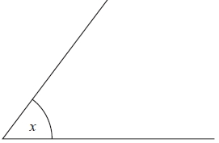  (a) Write down the special name for this type of angle  …………………………………  (b) Measure the angle marked x  …………………………… ˚ |  | (2)
2. | (a) Work out the size of the angle marked x.  ……………………°  (b) Give a reason for your answer.  ………………………………………………………………………………………………………………………………………………… |  | (2)
3. | (a) Work out the size of the angle marked x.  ……………………°  (b) Give a reason for your answer.  ………………………………………………………………………………………………………………………………………………… |  | (2)
4. | (a) What is the special name given to this type of triangle?  …………………………  (b) Work out the size of the angle marked x.  ………………………… ° |  | (2)
5. | Name each shape:  ………………………………………………… ………………………………………… |  | (2)
 |  |  | 10
 | Topic 11: Linear Graphs |  | Mark
1. | 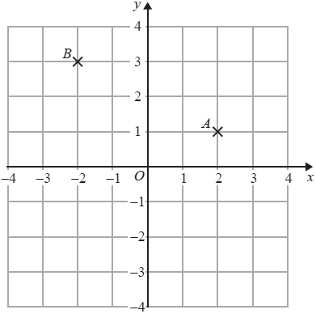  (a) Write down the coordinates of the point A.  (................... , ......................)  (b) Write down the coordinates of the point B.  (................... , ......................)  (c) On the grid, draw the line x = 3 |  | (3)
2. | 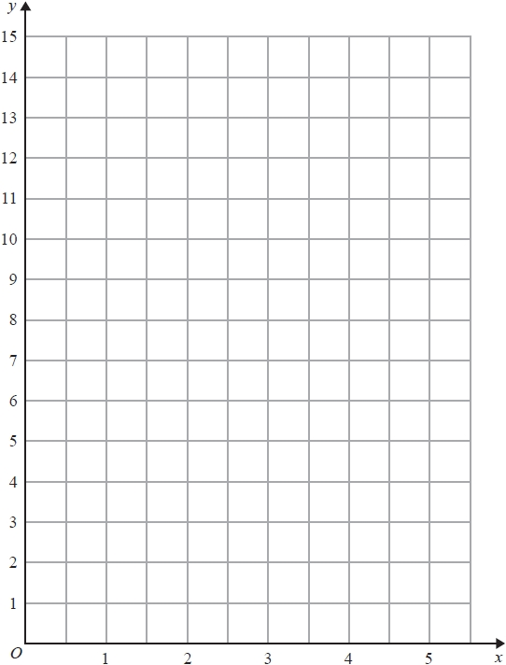  (a) Complete the table of values for  y = 2x + 3 for values of x from 0 to 5  x 0 1 2 3 4 5  y  (b) on the grid, draw the graph of  y = 2x + 3  for values of x from 0 to 5 |  | (2)  (2)
3. | 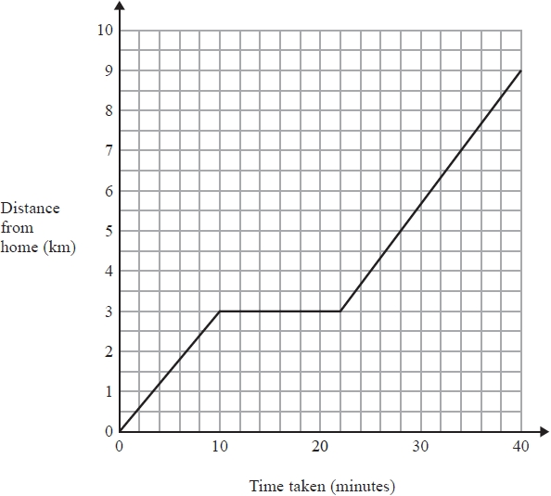  One day Jane cycled from home to college.  She stopped at a shop on the way to college.  The travel graph shows Jane's journey from home to college.  (a) Write down the distance from Jane's home to college  .........................km  - Write down how long Jane stopped at the shop ............... minutes |  | (2)
4. | 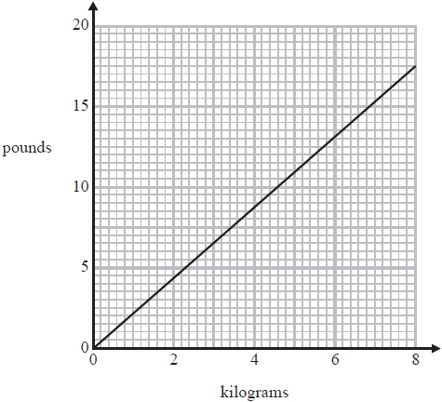  You can use this conversion graph to change between kilograms and pounds.  Use the conversion graph to change 5 kilograms to pounds.  ........................................... pounds |  | (1)
 |  |  | 10

