Year 9 Core Standard: Assessment 2 Revision Name ________________________

 | Topic 5: Perimeter and Area |  | Mark
1. | Find the area of the parallelogram and the triangle.  Area parallelogram Area triangle =  ………………………cm² ……………………….cm² |  | (4)
2. | Find the area of the trapezium.  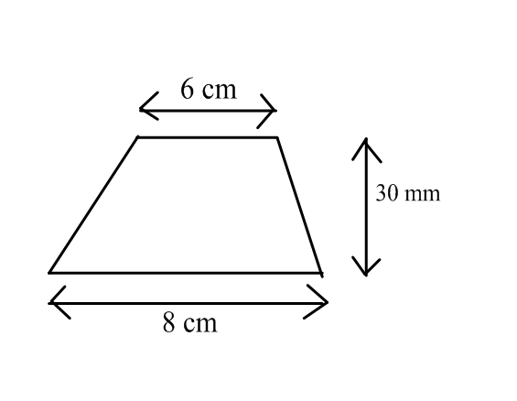  Area = ……………………………………………. |  | (2)
3. | a) The perimeter of the rectangle is 22cm.  Fill in the missing lengths and area.  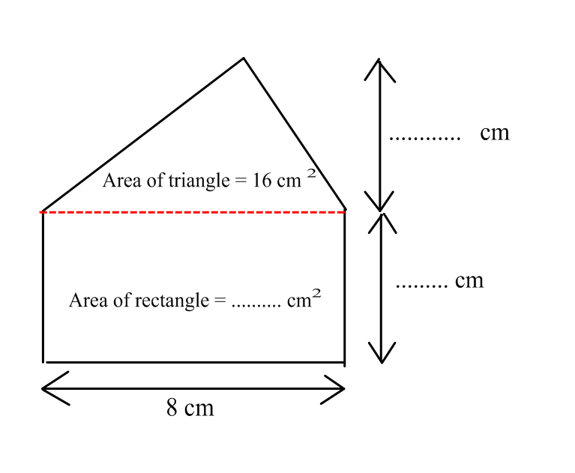  b) What is the total area of the shape? Area = ………………………. |  | (3)  (1)
 |  | Total |  | (10)

 | Topic 6: Ratio and Proportion | Mark
1. | a) Write the ratio 15 : 20 in its simplest form. ……………….  b) Bricks are made by mixing cement and water in the ratio 3 : 4  A builder uses 12 litres of cement.  How much water does he need?  ……………… | (1)  (2)
2. | Assim and Julie share £120 in the ratio 3 : 5  How much money does each receive?  Assim £…..…….. Julie £ ………… | (2)
3. | Here are the ingredients to make a pasta bake for 8 people  Pasta 200 g  Tomatoes 300 g  Garlic 20 g  Sausage 150 g  - On Saturday Alison wants to make a pasta bake for 12 people.  Work out how much of each ingredient she needs.  Pasta ………….. g  Tomatoes ……………. g  Garlic ……………. g  Sausage .………….. g  - The next Saturday Alison makes a pasta bake and uses 200 g sausage.  How many people was the pasta bake for?  …………………………. | (4)  (1)
 | Total | (10)

 | Topic 7: Sequences | Mark
1. | 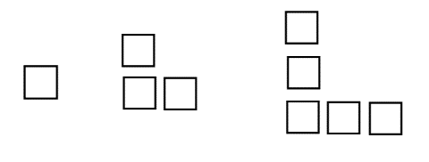  Here is a pattern  Complete the table of results  Pattern number 1 2 3 4 5  Number of squares  How many squares are needed for the 10th pattern ? ……………..  How many squares are needed for the 20th pattern ? ………………  Which pattern will have 43 squares? ……………..  Complete the word formula  Number of squares = …………….. X Pattern Number - ……………….. | (3)  (2)
2. | Here is a sequence  9 , 13 , 17 , 21 , 25, …………………………..  - Find the rule for the Nth term of the sequence ……………………………..  - Calculate the 20th term in this sequence ………………………………  - Mark thinks that 117 is in the sequence.  Is Mark correct? …………………………  Give a reason for your answer ………………………………………………………………………………………………………………………………………………………………………………………………………………………………………………………………………………………………………………………………. | (1)  (1)  (1)
3. | Find the n^{th} term for the following sequence  35 , 32 , 29 , 26, 23, ……….  ……………………………………….. | (2)
 | Total | (10)

