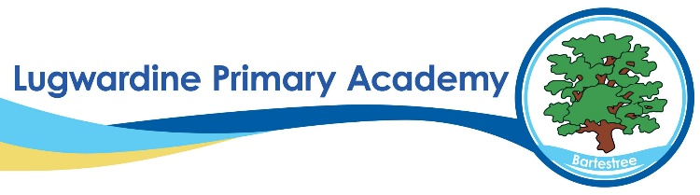 DT Whole School Curriculum Overview

​ | Autumn 1​ | Autumn 2​ | Spring 1​ | Spring 2​ | Summer 1​ | Summer 2​
Year 1​ | ​ | Moving Parts (sliders) ​  Moving Pictures ​ | ​ | Creating Paper Toys ​ | ​ | Cooking and Nutrition ​
Year 2​ | ​ | Nutrition pizza topping ​ | ​ | To make a light house ​ | ​ | Sewing buttons onto fish ​
Year 3​ | ​ | Photograph frames ​  Structures ​ | ​ | Moving Easter Bunny ​ | ​ | Make a Healthy Sandwich ​
Year 4​ | ​ | Mechanical moving parts ​ | ​ | Nutrition - scones ​ | ​ | Castles – draw bridges ​
Year 5​ | ​ | Structures links to Victorians​ | ​ | Textiles with Tudor focus​ | ​ | Victorian sweets/cakes​
Year 6​ | ​ | Bread rolls​ | ​ | Controllable vehicles​ | ​ | Day of the Dead sewing/masks​

