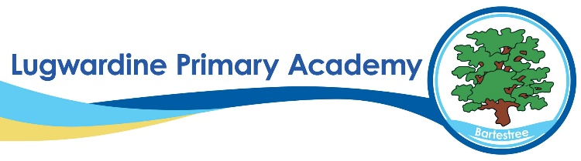 Geography Whole School Curriculum Overview
​ | Autumn 1​ | Autumn 2​ | Spring 1​ | Spring 2​ | Summer 1​ | Summer 2​
Year 1​ | Our local area​ | ​ | Wonderful weather​ | ​ | Where is Africa?​ | ​
Year 2​ | Locational and Place: Where in the world would you go? Brazil ​ | ​ | Skills and fieldwork: Where is the Capital? ​ | ​ | Human and Physical: Would you like to be beside the seaside? ​ | ​
Year 3​ | How can I save the rainforests? ​ | ​ | How is Earth so extreme? ​ | ​ | What is the UK? ​ | ​
Year 4​ | ​ | All around the world​ | ​ | Water​ | ​ | Contrasting locations​
Year 5​ | ​ | Marvellous Maps​  Local walk and map reading tasks ​ | ​ | Magnificent Mountains ​ | ​ | Enough for everyone Link with Di Hemming Sustainability workshops ​
Year 6​ | ​ | Raging rivers ​ | ​ | Changing world ​ | ​ | Trade and economics ​

