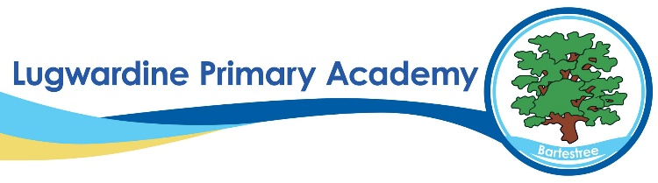 History Whole School Curriculum Overview

​ | Autumn 1​ | Autumn 2​ | Spring 1​ | Spring 2​ | Summer 1​ | Summer 2​
Year 1​ | ​ | Gunpowder plot​ | ​ | Toys​ | ​ | Travel and transport​
Year 2​ | ​ | Who was Florence Nightingale?​ | ​ | The Great Fire of London​ | What was it like living in a castle?​ | ​
Year 3​ | Stone Age to Iron Age​ | ​ | Ancient Egypt​ | ​ | The Railways​ | ​
Year 4​ | Romans​ | ​ | Vikings and Anglo Saxons​ | ​ | Crime and Punishment​ | ​
Year 5​ | ​ | Ancient Greece​ | ​ | Tudors – local study​ | ​ | The Victorians​
Year 6​ | WWII​ | ​ | The Ancient Mayans​ | ​ | ​ | Leisure and Entertainment​

