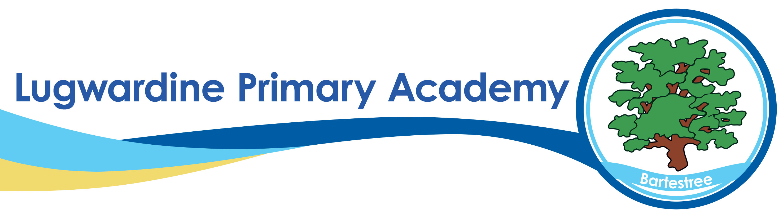

How We Use Artificial Intelligence (AI) at Lugwardine Primary Academy

What Is Generative AI?
Generative Artificial Intelligence (AI) refers to a type of technology that can produce original content—such as text, images, or ideas—by learning from vast amounts of information. Examples include tools like ChatGPT, which can answer questions, draft documents, generate ideas, and support creative or administrative tasks in a way that mimics human conversation.
At Lugwardine, we view AI not as a replacement for staff expertise, but a supportive tool that can enhance learning, teaching, and school operations.

How AI Benefits Our School Community
We are embracing the thoughtful and ethical use of AI to bring real benefits to our pupils, staff, and leadership team. Key advantages include:
- Reducing teacher workload by supporting planning, marking, and resource creation
- Providing tailored learning materials and feedback to meet the individual needs of pupils
- Supporting school leaders with data analysis and administrative efficiency
- Enabling more time for high-quality teaching, learning, and personal connection
We remain committed to placing children’s safety, wellbeing, and educational outcomes at the heart of every decision we make about using new technologies.

Evaluating AI Tools: Our Principles
Before any AI tool is used at Lugwardine, it is rigorously reviewed to ensure it meets our standards. We assess tools against the following criteria:
- Safety: Is it secure and appropriate for a primary school setting?
- Effectiveness: Does it support teaching, learning, or operations meaningfully?
- Compliance: Does it adhere to data protection laws, safeguarding policies, and our internal governance?
This thorough evaluation helps us ensure that AI supports—not compromises—our values, and protects pupil privacy and wellbeing at all times.

AI Tools We Currently Use
We have introduced a small number of carefully selected AI tools that support our educational mission:
- ChatGPT: Used by staff to generate ideas, draft letters, and reports, and assist with lesson planning. This reduces workload and helps staff focus more time on direct pupil interaction and curriculum delivery.
- Twinkl AI: Helps teachers to create tailored, age-appropriate resources, supporting differentiation and inclusive learning for all children.
- SLT AI Tools: Used by senior leaders to analyse school data (e.g., attendance, assessments, trends) and streamline reporting, freeing time to focus on improving outcomes and supporting staff and pupils.
- Canva Magic Write: Assists in creating visually engaging presentations and resources with quick text generation support.
- Khanmigo (by Khan Academy): Provides AI-powered tutoring and teacher support aligned with the curriculum.
- MagicSchool.ai: Offers classroom management and lesson planning features with AI support for teachers.
- Google Gemini (formerly Bard): Used to support quick idea generation and research tasks.
- EdPuzzle with AI: Enhances interactive video lessons with AI-generated questions and feedback.
- TeachMateAI: Supports teachers with planning, marking, and generating differentiated learning resources.
- Tactiq AI: Summarises meetings and planning sessions, helping staff track actions and follow-ups efficiently.

What We Do Not Use AI For
At Lugwardine Primary Academy, we are clear about what AI cannot and should not replace. We do not use AI for:
- Making automated decisions about pupils or staff
- Replacing professional judgement, personal teaching, or safeguarding responsibilities
- Allowing unsupervised pupil use of AI tools
All use of AI is designed to support human decision-making and relationships, not replace them.

Want to know more?
Please review our Safe Use of AI Policy located on our website or contact us at school.
We are always happy to discuss how we responsibly integrate innovation to support learning, protect wellbeing, and uphold our values.

