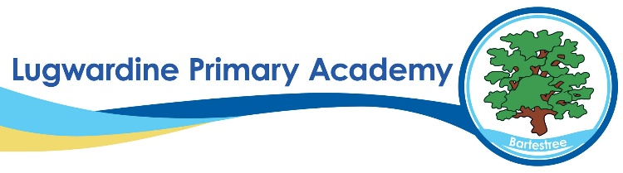 MFL Whole School Curriculum Overview
​ | Autumn 1​ | Autumn 2​ | Spring 1​ | Spring 2​ | Summer 1​ | Summer 2​
Y3 | Getting to Know You​ | All About Me | Food, glorious Food​ | Family and Friends​ | Our School​ | Time
Y4 | All Around Town​  ​ | On the Move | Going Shopping​ | Where in the world? | What’s the Time?​  ​ | Holidays and Hobbies
Y5 | Pleased to Meet You​  ​ | All About Ourselves | That’s Tasty!​ | Family and Friends​ | School Life​ | Time Travelling​
Y6 | Let’s Visit a French Town​  ​ | Let’s Go Shopping | This is France!​  ​ | All in a Day | Our Precious Planet​ | More to Explore​

