 Maths Whole School Curriculum Overview
YR
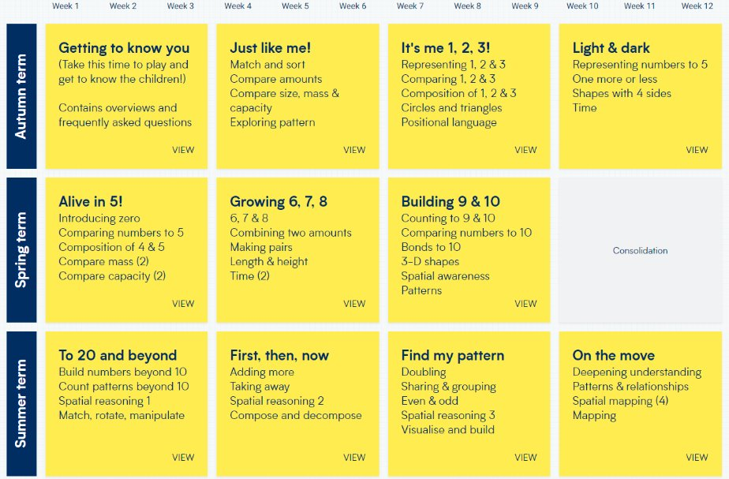

Maths Whole School Curriculum Overview
Y1
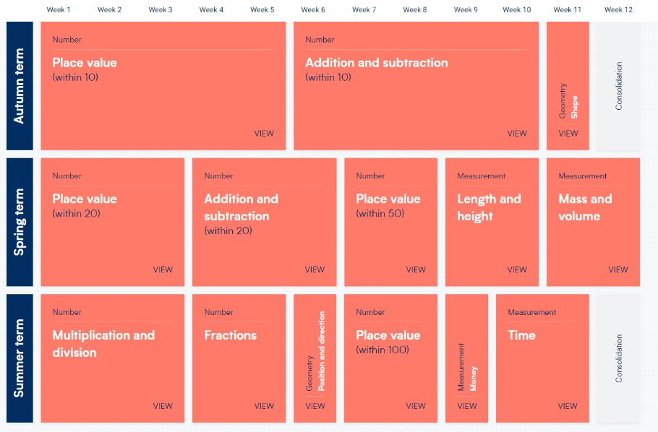

Maths Whole School Curriculum Overview
Y2
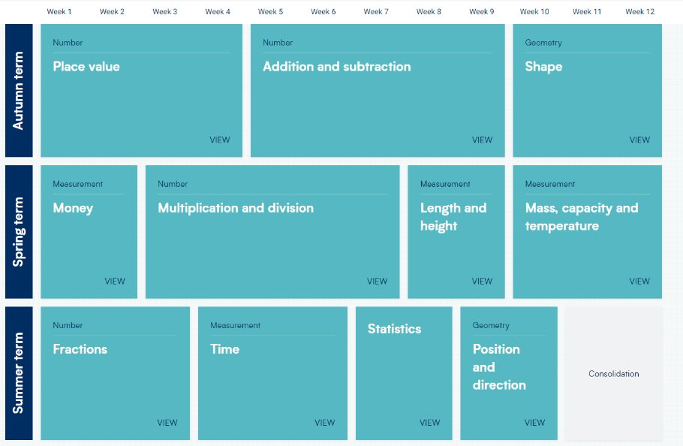

Maths Whole School Curriculum Overview
Y3
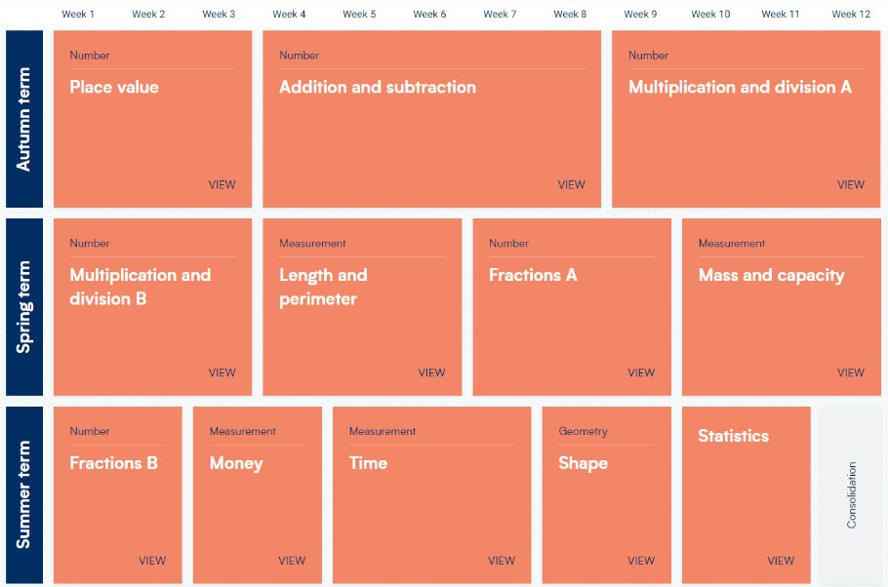
Maths Whole School Curriculum Overview
Y4
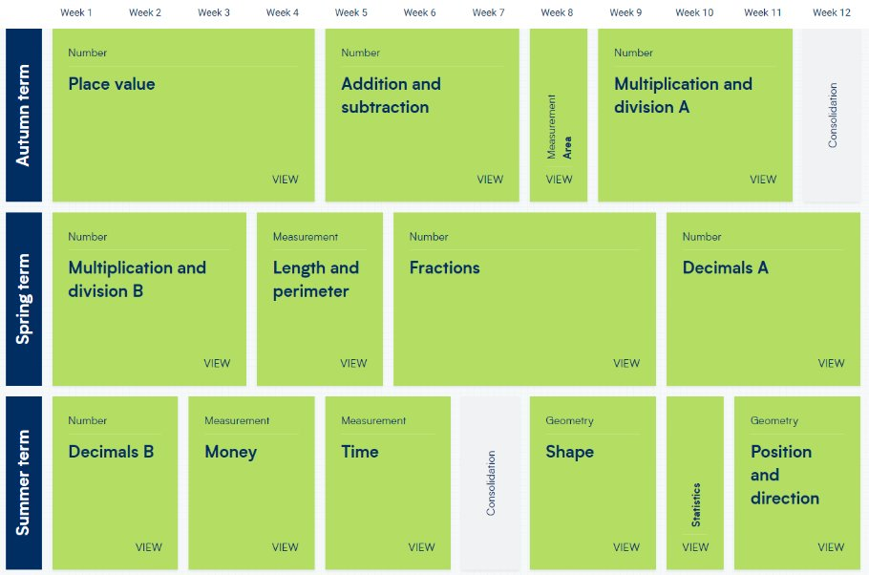

Maths Whole School Curriculum Overview
Y5
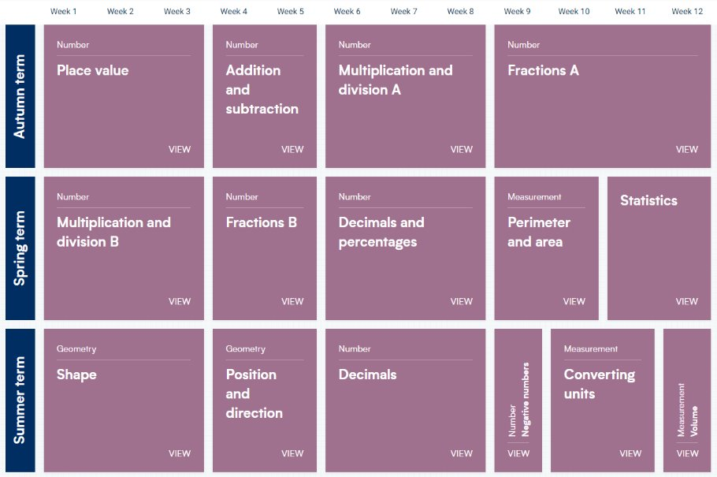

Maths Whole School Curriculum Overview
Y6
