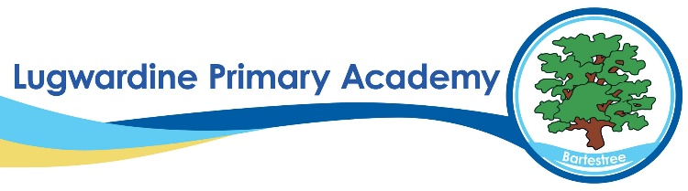 Music Whole School Curriculum Overview
​ | Autumn 1​ | Autumn 2​ | Spring 1​ | Spring 2​ | Summer 1​ | Summer 2​
Year R​ | Me!​  Harvest Festival (Singing)​ | My Stories!​  Nativity Performance​ | Everyone! (Nursery Rhymes)​ | Our World! (Nursery Rhymes)​ | Big Bear Funk! (Nursery Rhymes)​ | Reflect, Rewind and Replay!​
Year 1​ | Hey You! (Hip Hop) Harvest Festival (Singing)​ | Nativity Performance (Singing)​ | In the Groove (Singing)​ | Round and Round (Latin)​ | Your Imagination​  (Singing)​ | Reflect, Rewind and Replay!​  ​
Year 2​ | Hands, feet, heart (South African music)​ | HO HO HO! (Singing)​ | I wanna play in a band! (Rock)​ | Zootime! (Reggae)​ | Friendship song​ | Reflect, Rewind and Replay!​  ​
Year 3​ | Let your spirit fly (R&B)​ | Christmas Carols​ | Three Little birds (Reggae)​ | The Dragon Song​ | Bringing us Together (Disco)​ | Reflect, Rewind and Replay!​  ​
Year 4​ | Mamma Mia! (Pop)​ | Christmas Carols​ | Stop! (Rap)​ | Lean on me (Soul/Gospel)​ | Blackbird (Beatles)​ | Reflect, Rewind and Replay!​
Year 5​ | Livin on a Prayer (Rock)​  Young Voices​ | Classroom Jazz​ | Make you feel my love (Pop)​ | The Fresh Prince of Bel Air (Hip Hop)​ | Dancing in the Street​ | Reflect, Rewind and Replay!​  ​
Year 6​ | Happy ​  Young Voices​ | Classroom Jazz 2​ | A New Year Carol​ | You got a friend in me​ | Music and me​ | Reflect, Rewind and Replay!​  ​

