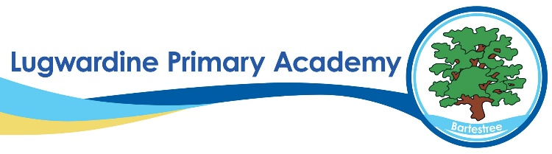 PE Whole School Curriculum Overview
​ | Autumn 1​ | Autumn 2​ | Spring 1​ | Spring 2​ | Summer 1​ | Summer 2​
Year R​ | Me and Myself | Movement and Development | Throwing  and  Catching | Ball Skills | Fun  and  Games | Working  with  Others
Year 1​ | Football  Fitness | Badminton  Gymnastics 1 | Netball  Dance | Dodgeball  Gymnastics 2 | Cricket  Athletics | Tennis  Athletics
Year 2​ | Hockey  Fitness | Volleyball  Gymnastics 1 | Tag Rugby  Dance | Basketball  Gymnastics 2 | Rounders  Athletics | Cricket  Athletics
Year 3​ | Football  Fitness | Badminton  Gymnastics 1 | Netball  Dance | Dodgeball  Gymnastics 2 | Cricket  Athletics | Tennis  Athletics
Year 4​ | Hockey  Fitness | Volleyball  Gymnastics 1 | Swimming  Dance | Basketball  Gymnastics 2 | Rounders  Athletics | Cricket  Athletics
Year 5​ | Football  Fitness | Badminton  Swimming | Netball  Dance | Dodgeball  Gymnastics 2 | Cricket  Athletics | Tennis  Athletics
Year 6​ | Hockey  Fitness | Volleyball  Gymnastics 1 | Tag Rugby  Dance | Basketball  Gymnastics 2 | Rounders  Athletics | Cricket  Athletics

