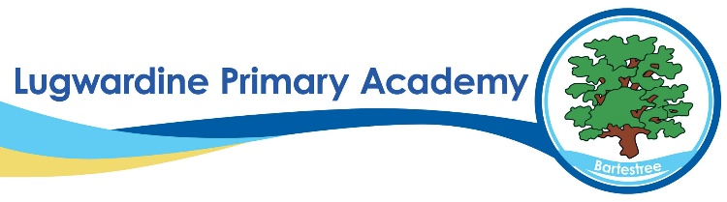 PSHE Whole School Curriculum Overview
Year | Autumn | Spring | Summer
1 | Teams (Relationships)  Think Positive (Health and Wellbeing) | Diverse Britain (Living in the wider world)  Be Yourself (Relationships) | It’s My Body (Health and Wellbeing)  Aiming High (Living in the wider world)
2 | VIPs (Relationships)  Safety First (Health and Wellbeing) | One World (Living in the wider world)  Digital Wellbeing (Relationships) | Money Matters (Living in the wider world)  Growing Up (Health and Wellbeing)
3 | Teams (Relationships)  Think Positive (Health and Wellbeing) | Diverse Britain (Living in the wider world)  Be Yourself (Relationships) | It’s My Body (Health and Wellbeing)  Aiming High (Living in the wider world)
4 | VIPs (Relationships)  Safety First (Health and Wellbeing) | One World (Living in the wider world)  Digital Wellbeing (Relationships) | Money Matters (Living in the wider world)  Growing Up (Health and Wellbeing)
5 | Teams (Relationships)  Think Positive (Health and Wellbeing) | Diverse Britain (Living in the wider world)  Be Yourself (Relationships) | It’s My Body (Health and Wellbeing)  Aiming High (Living in the wider world)
6 | VIPs (Relationships)  Safety First (Health and Wellbeing) | One World (Living in the wider world)  Digital Wellbeing (Relationships) | Money Matters (Living in the wider world)  Growing Up (Health and Wellbeing)

