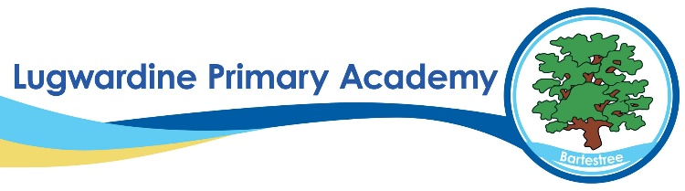 Science Whole School Curriculum Overview
​ | Autumn 1​ | Autumn 2​ | Spring 1​ | Spring 2​ | Summer 1​ | Summer 2​
YR | Me and my small world  What’s in my basket  Senses | Let’s go outside  What’s changed?  Night and day | Changes in winter  Let it flow  From desert to jungle | Watch it grow  Animal detectives  Pushes and pulls | From city to sea  Look all around  Test it out | Happy and healthy  Our wonderful world  Animal hunt
Y1 | The human body  Seasonal changes | Materials  Seasonal changes | Planting A  Animals | Caring for planet  Seasonal changes  Planting B | Plants  Planting C | Growing and cooking  Seasonal changes
Y2 | Animals’ needs for survival  Humans | Materials  Plastics | Plants (light and dark) | Living things and their habitats | Plants (bulbs and seeds)  Growing up | Wildlife
Y3 | Skeletons  Movement  Nutrition and diet | Food waste  Rocks | Fossils  Soils | Light | Plants A  Forces  Magnets | Plants B  Biodiversity
Y4 | Group and classify living things  Data collection A | States of matter | Sound  Data collection B | Electricity  Energy | Data collection C  Habitats  Deforestation | The digestive system  Food chains
Y5 | Forces | Space  Global warming | Properties of materials | Animals including humans  Life cycles | Reproduction A  Reversible and irreversible changes | Plastic pollution  Reproduction B
Y6 | Living things and their habitats | Electricity  Renewable energy | Light  Light pollution | Circulatory system  Diet, drugs and lifestyle | Variation  Adaptations | Fossils  Consolidation  Themed projects

