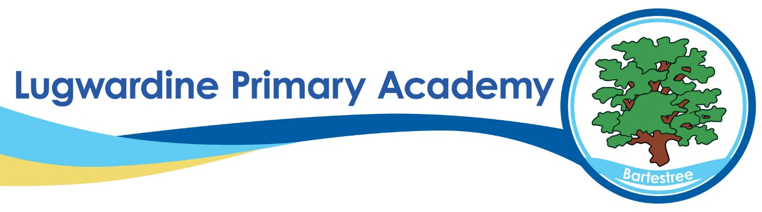

KS2 RESULTS
These tables show the percentage of eligible children at the end of Key Stage 2 achieving each level in the school in 2025. (National result in brackets after school result.)

The number of eligible children is: 23 children so each child represents 3%.

Teacher Assessment | At and above  nationally expected level | Working at  greater depth
Writing | 78% (72%) | 0% (12%)
Science | 96% (82%)

KS2 SATs | At and above nationally expected level | Working at  greater depth | Average  scaled score
Reading | 83% (75%) | 30% (33%) | 106 (106)
Spelling, punctuation and grammar | 65% (73%) | 17% (29%)
Mathematics | 83% (74%) | 17% (26%) | 105.1 (105)
R/W/M combined | 65% (62%) | 0% (8%)

Our results show that our Writing, Science, Reading and Maths are all above the national average.
For spelling and grammar, our results are below the national average, and this is something we will work on.
The number of children achieving the expected level in reading, writing and mathematics combined is above the national average.
We are very proud of all our pupils and the enormous efforts they have made in their time with us at Lugwardine.

