**Lyminster Primary** **School**

Home-School Agreement

2024-2026

**Home School Agreement**

The school exists for the pupils and to facilitate their intellectual, emotional, physical, moral, aesthetic and social development. The partnership with parents is vital in the success of all aspects of this, as is the encouragement from both home and school for the children themselves to take responsibility for their learning, conduct and organization.

[](https://www.google.co.uk/url?sa=i&rct=j&q=&esrc=s&source=images&cd=&ved=2ahUKEwjImu7SiI_kAhUipHEKHcN9BgoQjRx6BAgBEAQ&url=https://www.pinterest.com/pin/409264684868195860/&psig=AOvVaw2RzO14yeXcjQsI-LqoXnk0&ust=1566308661415404)

**As a UNICEF Rights Respecting School we are all – staff, parents/carers, pupils and visitors – bound together in our commitment to promote and respect the universal rights of every child as laid out in the United Nations Convention on the Rights of the Child. More information on the Convention can be found here: https://www.unicef.org.uk/what-we-do/un-convention-child-rights/**

As a school we will:

* Maintain a safe environment and care for your child’s overall wellbeing, by adhering to rigorous policies and procedures (including all statutory requirements), observing, listening, and following up on any concerns.
* Create a stimulating educational environment which develops all aspects of the child.
* Foster a culture of high expectations for every child, in their learning, conduct and personal development.
* Assist the children to build upon their knowledge and experience enabling them to become confident and successful learners whatever their starting points.
* Encourage high self-esteem and a positive attitude to learning through nurturing relationships and interventions, praise and acknowledgement.
* Prepare pupils to be active and engaged citizens of the world through a broad, balanced, relevant and differentiated curriculum that encourages the children to value each other, regardless of difference, their community and their environment.
* Promote co-operation in supporting all children’s learning and development, in partnership with parents, pre-school groups, secondary schools and the local community, by inviting and engaging with regular dialogue.
* 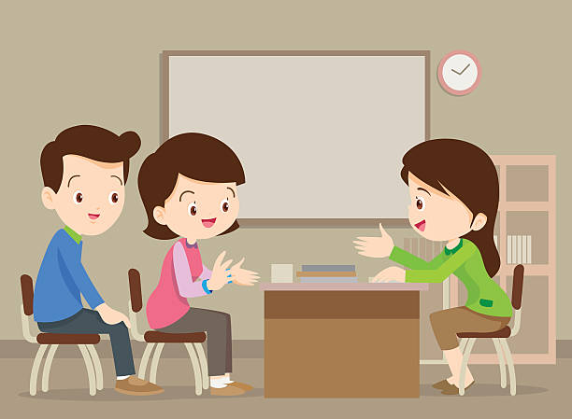Communicate regularly and accessibly to all parents/carers so that you are well-informed about the school and how you can support learning.
* Listen and respond to any concerns.
* Show respect to each other, all pupils, parents/carers and the wider community.

As parents/carers I/we will:

* + Ensure regular attendance and punctuality, and that the children are safe in coming to and from school (including safe and considerate parking).
  + Promptly notify the school of cause of absence or any change of address/contact details.
  + Encourage my child/children to read or hear him/her read on a regular basis.
  + Support my child’s learning by ensuring completion of any homework.
  + Support the school in maintaining high standards of behaviour, particularly with regard to my child.
* Support the school by notifying us directly, and early, of any concerns you may have, so that they can be resolved quickly. This includes if action has been taken but we are still not satisfied.
* Be a positive role model for all of our children, by behaving respectfully towards staff, pupils and other parents/carers at all times.
* Comply with all school policies and procedures which affect us, such as the policies on photography and site security.
  + Comply with the school uniform.
  + Respond to any reasonable request by the school to discuss my child’s education or welfare, and engage with the regular communication from school, scheduled parent meetings etc.
  + [](https://www.google.co.uk/url?sa=i&rct=j&q=&esrc=s&source=images&cd=&ved=&url=https://www.vectorstock.com/royalty-free-vectors/play-online-games-kids-vectors&psig=AOvVaw2t1g8pHRAtXzEFk__J1UQe&ust=1566309853983337)Ensure that my child has what he/she needs to take a full part in all activities (eg PE kit, water bottle etc) and that these belongings and all clothing are named.
* Endeavour to support the PTA as much as we can in fundraising and other activities.

As a pupil I will:

* + **Be an Inspiration** (show that I am willing to work and do my best.)
  + **Be Respectful and Kind** (and not harm or disrupt another pupil in their work or play.)
  + **Be Proud of My Individuality** (and supportive of others’!)
* Show respect equally to all adults who help in school or are visiting.
* Abide by all other school rules, including the golden rules of keeping safe.
* Be honest and take responsibility for the consequences of my actions.
* Be a role model for any younger pupils and an excellent ambassador for the school.
  + Encourage my parents to be involved with my learning, including by taking home any letters etc.
* Complete and hand-in my homework to the best of my ability and without fuss.
* Read regularly at home and record this in my reading diary.
  + Take pride in my appearance and wear school uniform – I will also be as independent as possible in taking care of this uniform and my other belongings.
  + Come to school regularly and on time, without creating fuss for my parents or carers.
  + Help to keep the school and local environment a pleasant place in which to work and play by keeping it tidy and free of litter.
  + Ask for help when I need it and tell someone if I have a worry – in whatever way I feel most able to do this.

**Signed:**

**_________________________________________ Headteacher**

**_________________________________________ Parent/Carer**

**_________________________________________ Pupil**

**Date………………………………..**