**Individual Support Plan (ISP)**

Photo of child / young person

|  |  |  |  |
| --- | --- | --- | --- |
|  |  |  |  |
|  |  |  |  |
|  |  |  |  |
|  |  |  |  |
|  |  |  |  |
|  |  |  |  |
|  |  |  |  |
|  |  |  |  |

|  |  |
| --- | --- |
| **Name of child / young person** |  |
| **Date of birth** |  |
| **Name of school / setting** | Lyminster Primary School |
| **Class Teacher/SENDCo** | /Rachel Yarrow |

|  |  |  |  |
| --- | --- | --- | --- |
|  | | **All About Me** |  |
| **D.O.B.** | ADD PIC |
| **Year Group:** | **CLASS TEACHER:**  **KEY ADULTS:** | **Date of Update:** |
| **Access Arrangements**  **(how I like to be welcomed and transition)** | **I would like you to know that:**  **This means that:**   * . | **I find it difficult to:** |
|  |

|  |  |
| --- | --- |
| **I am doing well at:** | **I really enjoy:** |
| **I would like to achieve by the end of the year:** | |
| **It would help me if you could:** | **I will help myself by:** |

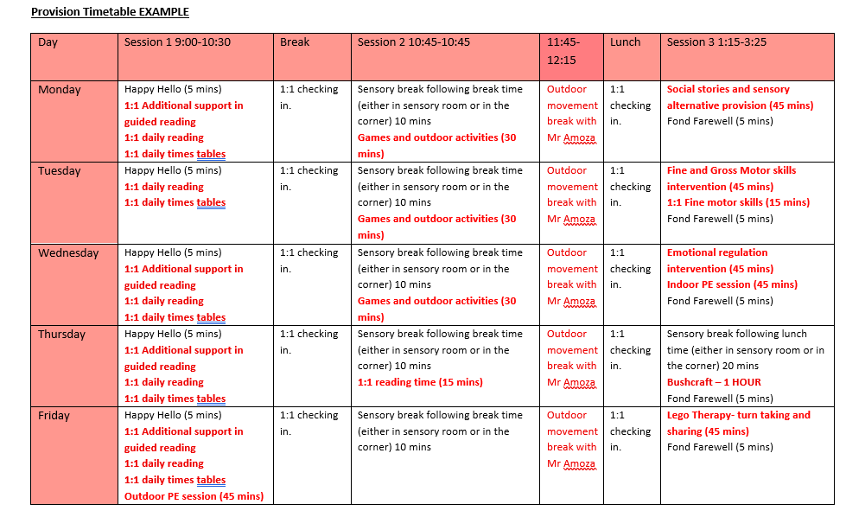

**Assess**

|  |  |
| --- | --- |
| **Teacher Assessments of Progress and Attainment** | |
| **Date** | **Teacher Assessment and Notes** |
| Autumn | Reading:  Writing:  Maths:  Progress toward age related expectations: |
| Spring | Reading:  Writing:  Maths:  Progress toward age related expectations: |
| Summer | Reading:  Writing:  Maths:  Progress toward age related expectations: |

**My Strengths and Areas of Need**

|  |
| --- |
| **Cognition and Learning** |
| My Strengths |
|  |
| My Areas of Need |
|  |

|  |
| --- |
| **Communication and Interaction** |
| My Strengths |
|  |
| My Areas of Need |
|  |

|  |
| --- |
| **Social, Emotional and Mental Health** |
| My Strengths |
|  |
| My Areas of Need |
|  |

|  |
| --- |
| **Sensory and Physical** |
| My Strengths |
|  |
| My Areas of Need |
|  |

|  |
| --- |
| **Independence and Community Engagement** |
| My Strengths |
|  |
| My Areas of Need |
|  |

**Plan, Do, Review: Cycles of Support**

**My Termly Support Plans**

|  |  |  |  |  |  |  |
| --- | --- | --- | --- | --- | --- | --- |
| **Pupil Name –** | | **Date –** | | | | **Plan number – 1** |
| **Year Group and Term –** | | | | |
| **Termly targets, based on my areas of need** | **Strategies and support in place** | **Area of need relating to target** | **Review date** | | **Staff Progress review – what has gone well? Additional barriers identified?** | |
| **My Target is:**  **Where I am now**  **1 2 3 4 5 6 7 8 9 10** |  |  |  | |  | |
| **Where I am now**  **1 2 3 4 5 6 7 8 9 10** | |
| **My Target is:**  **Where I am now**  **1 2 3 4 5 6 7 8 9 10** |  |  |  | |  | |
| **Where I am now**  **1 2 3 4 5 6 7 8 9 10** | |
| **My Target is:**  **Where I am now**  **1 2 3 4 5 6 7 8 9 10** |  |  |  | |  | |
| **Where I am now**  **1 2 3 4 5 6 7 8 9 10** | |
| **Child or young person’s view of progress:** | | | | | | |  |  |  | **Where I am now**  **1 2 3 4 5 6 7 8 9 10** |
| **Parent / Carer view of progress:** | | | | | | |
| **Teacher reflections:** | | | | | | |
|  |  |  |  |  |  |  |

**Plan, Do, Review Cycles of Support**

**My Termly Support Plans**

|  |  |  |  |  |  |  |
| --- | --- | --- | --- | --- | --- | --- |
| **Pupil Name –** | | **Date –** | | | | **Plan number – 1** |
| **Year Group and Term –** | | | | |
| **Termly targets, based on my areas of need** | **Strategies and support in place** | **Area of need relating to target** | **Review date** | | **Staff Progress review – what has gone well? Additional barriers identified?** | |
| **My Target is:**  **Where I am now**  **1 2 3 4 5 6 7 8 9 10** |  |  |  | |  | |
| **Where I am now**  **1 2 3 4 5 6 7 8 9 10** | |
| **My Target is:**  **Where I am now**  **1 2 3 4 5 6 7 8 9 10** |  |  |  | |  | |
| **Where I am now**  **1 2 3 4 5 6 7 8 9 10** | |
| **My Target is:**  **Where I am now**  **1 2 3 4 5 6 7 8 9 10** |  |  |  | |  | |
| **Where I am now**  **1 2 3 4 5 6 7 8 9 10** | |
| **Child or young person’s view of progress:** | | | | | | |  |  |  | **Where I am now**  **1 2 3 4 5 6 7 8 9 10** |
| **Parent / Carer view of progress:** | | | | | | |
| **Teacher reflections:** | | | | | | |
|  |  |  |  |  |  |  |

**Key conversations**

|  |  |  |
| --- | --- | --- |
| **Chronology of Key Events** | | |
| Date | What happened? Who did you talk to? What did you find out? | Comment / Actions |
|  |  |  |
|  |  |  |
|  |  |  |
| Insert further rows as required | | |

SPACE FOR ADDITIONAL SCANS / SUPPORTING DOCUMENTS

Use annex of additional documents for complex needs as required