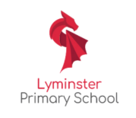
Lyminster Science Fair
What is the scientific process?
What is a science fair?
What do you need to do?

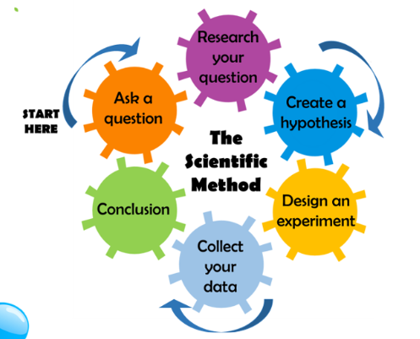

Pick a project to complete going through the six stages of the scientific process. Your teacher will help you with this

A science fair is a competition where students present experiments, projects and their findings to an audience.

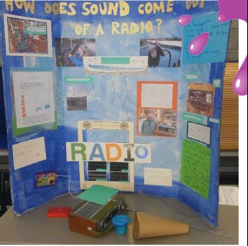
Each class will present their projects at the Science Fair
showcase on Friday 19th June. There will be prizes for the
winning team from each class.

