Outside -Sand Area
Resources: spades, gold coins, jewellery, treasure, numerals, buckets with numbers on to collect coins.
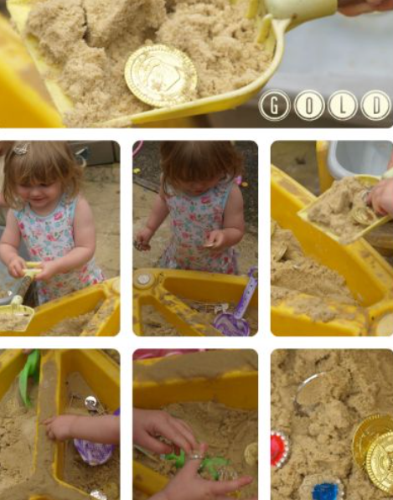
Learning Focus:
EYFS – matching quantity to numeral – Composition of numbers. Counting up to 20.
Year 1 – Recognise numerals up to 100. Pairs of numbers to 10/20. Using concrete resources to represent numbers.
Adult targeted questioning:
What number is that? How many coins have you found? What is more than/less than?
Can you count….? Can you find some treasure?
Who has more coins? What if I give you 1 more?
Outside – Water/Mud Area – 8 children
Resources: Set up 1: Jugs, measuring cylinders, bowls, spoons, a selection of food colouring to make coloured water, colour charts from B&Q. Set up 2:
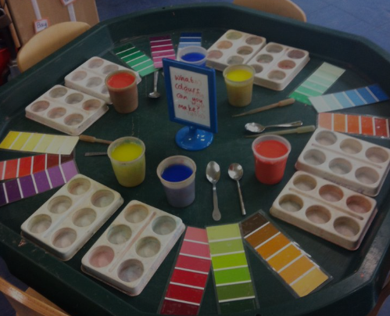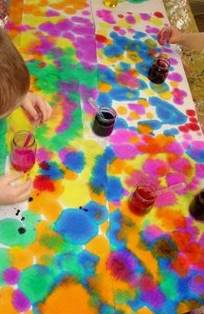
Learning Focus:
EYFS – Use a range of one-handed tools. Create with a purpose in mind. Explore colour mixing.
Year 1 – Use some mathematical language related to capacity including full, half full, and empty. Use tools to cut and combine herbs and flowers. Name the primary and secondary colours.
Adult targeted questioning:
What colour have you made? Can you make a different colour? Can you make it darker or lighter? What does it remind you of? Can you tell me how to make it so I can make some too?

Outside -Art Area
Resources: Set up 1:pots of poster paints including autumnal colours; red, yellow, orange, brown, and green to create a giant autumn tree. Circular sponges, corks or fingers can be used to mark-making. Set up 2:paint sticks, leaves, and paper.
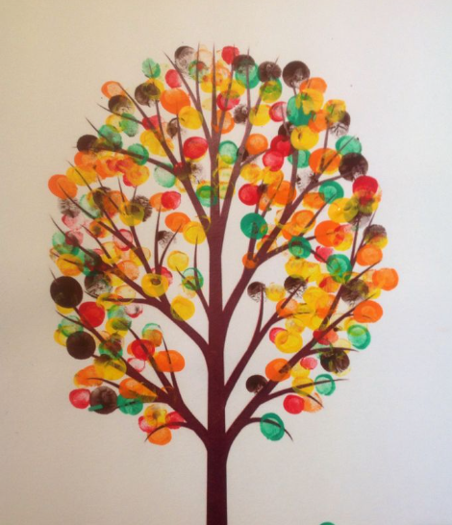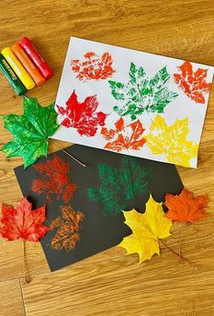
Learning Focus:
EYFS – Use a range of one-handed tools. Explore colour and texture. Talk about the world and changes over time.
Year 1 – Explore colour, shape and line. Observe seasonal changes and explain changes over time.
Adult targeted questioning:
Why are the leaves different colours? Why do they change? What happens to the green leaves? What are the leaves on the floor? What will happen to the tree when all the leaves fall off? Why do some trees/bushes still have green leaves?

Outside – Small World area
Resources: set up 1: cars, train track, tuff trays, maps, road signs, wooden blocks, ramps, crates, blank paper, and pens.
Set up 2: Dinosaurs, rocks, sand, leaves, sticks and pinecones.
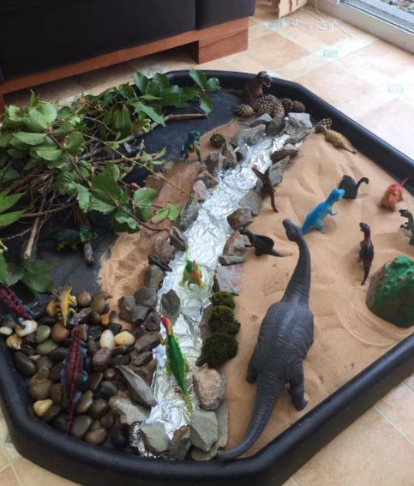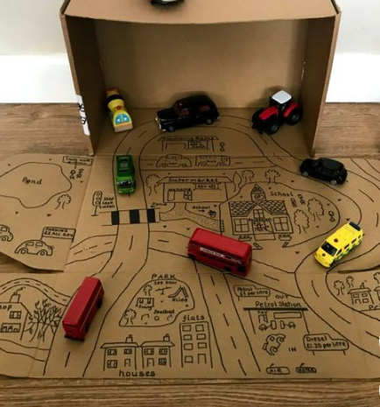
Learning Focus:
EYFS – Enjoy their own imaginative play. Create narratives in their play. Make props to support their play.
Year 1 – Use some mathematical language related to directions and positional language including left, right, over, under, forwards, and turn. Build and construct with a purpose in mind.
Adult targeted questioning:
Can you make a bridge/tunnel? Where is your car driving to? How many cars can you see? Can you make some parking bays/houses, how many do we need? Which car travels the furthest down the ramp? Why? What is the name of this dinosaur? What does your dinosaur eat? Can you make a shelter/nest for your dinosaur?

Outside – Construction and role play
Resources: Big wooden blocks, role play hose, superhero costumes and mask, telephones and walkie-talkies, mobile phones, laptop.
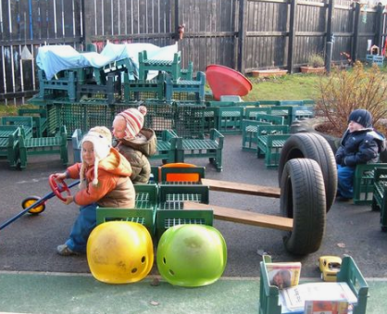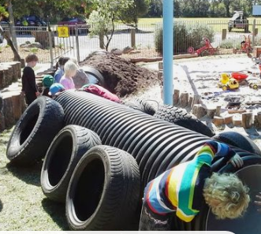

Learning Focus:
EYFS – Enjoy their own imaginative play. Create narratives in their play. Make props to support their play.
Year 1 – Use new topic-related vocabulary. Engage in drama and role-play linked to their experiences and what they have read in books.
Adult targeted questioning: What have you built? What does it do? What superhero are you and what’s your superpower? What’s inside your superhero lair?

Outside – Transportable Mark Making
Resources: Clipboards and plain paper, writing bags, phonics mats, magnetic letters, rolls of paper, whiteboards, pencils, whiteboard pens..
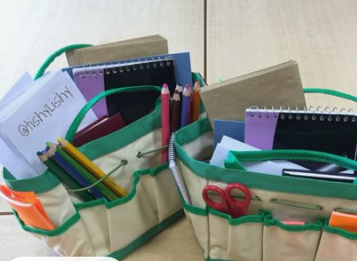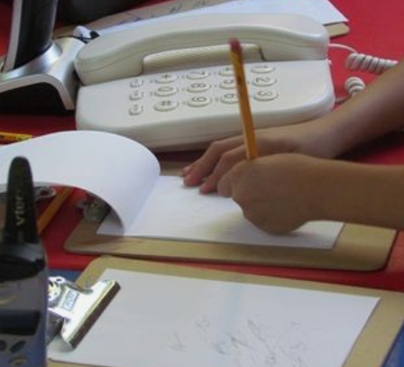
Learning Focus:
EYFS – hold a pencil correctly using a pincer grip. Give meaning to the marks they make. Represent some initial sounds in simple words.
Year 1 – Use their sounds to make phonetic attempts at new words. Write labels, lists and simple sentences. Begin to have some grammatical awareness of finger spaces, capital letters and full stops. Spell some HFW.
Adult targeted questioning: Tell me what you have written. What sounds do you need to write the word ….? Do you have a full stop/capital letter/ finger spaces? Can you write a list ….? Can you add some labels to your picture to give us more information?

Outside -water play
Resources: Set up 1: dinosaurs, washing up bowl, sponges, brown paint mud.
Set up 2: Flowers, coloured water, bowls and spoons.
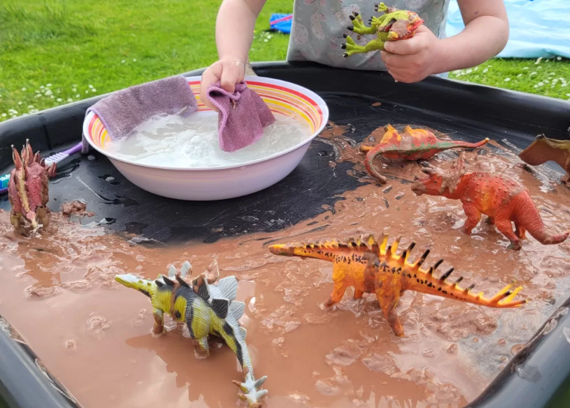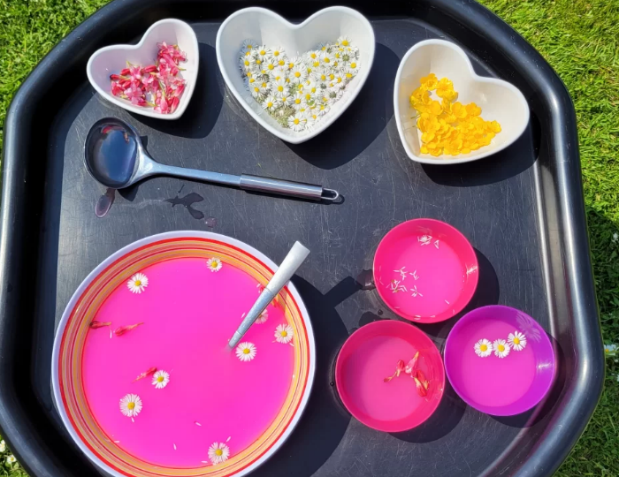
Learning Focus:
EYFS – Use a range of one-handed tools. Explore colour and texture. Talk about the world and changes that occur.
Year 1 –Observe changes over time. Make observations. Name some common flowers
Adult targeted questioning: How are you cleaning your dinosaur? Why is the water changing colour? How are you going to dry your dinosaur? Can I have some flower soup? What flowers have you included? How many different flowers did you use? What does it taste like?

Resources: mud, bowls and containers, watering cans, cutlery, tools and a recipe for a mud pie.

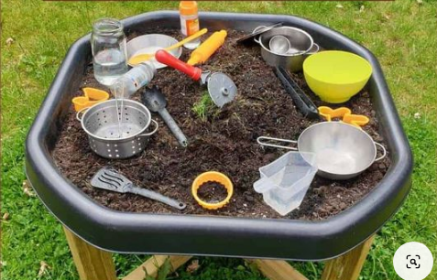
Learning Focus:
EYFS – Use a range of one-handed tools. Explore colour and texture. Talk about the world and changes that occur.
Year 1 – Use new topic-related vocabulary. Engage in drama and role-play linked to their experiences and what they have read in books.
Adult targeted questioning: Can I have a mud pie? How did you make it? What have you included? What does it taste like?

