WB:6/10/24 Outside -Sand Area
Resources: shells, spoons, bowls, jugs of water, baking trays, pinecones, sand. Sign – Sand Cakes for sale
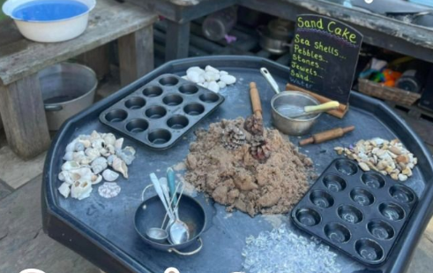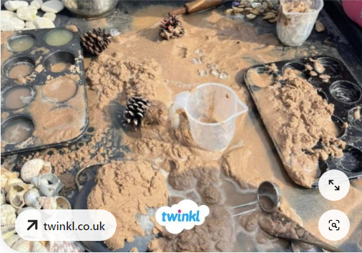
Learning Focus:
EYFS – Enjoy their own imaginative play. Create narratives in their play. Make props to support their play.
Year 1 – Use some mathematical language related to measures, weight, capacity etc. Full, empty, half full more, less, light and heavy.

Adult targeted questioning:
Can I have a sand cake? How did you make it? What have you included? What does it taste like? How much will it cost?
Outside –creative
Resources: Set up 1: tuff tray lined with white paper, paint, cars of different size and shape to mark make in the paint Set up 2: mark make patterns in the tuff tray using chalk markers, provide water pots with brushes for them to erase the patterns.
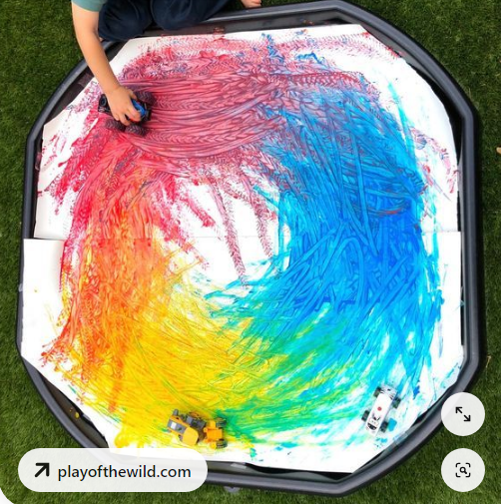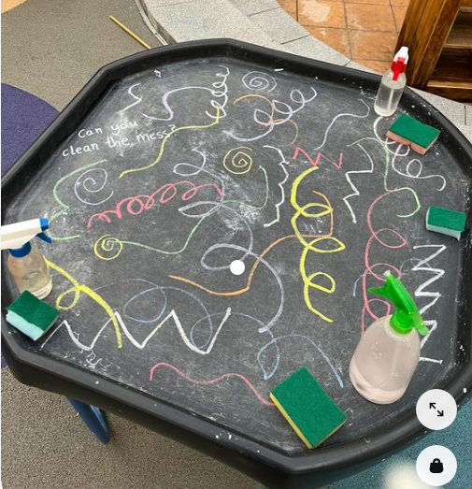
Learning Focus:
EYFS – Use a range of one-handed tools. Explore colour mixing.
Year 1 - Name the primary and secondary colours.
Adult targeted questioning:
What colour have you made? Can you make a different colour? How did you make that mark? Can you describe this pattern? Why does it disappear when you paint over it with water?

Outside -Art Area
Resources: Set up 1:brusho inks, pipettes and tissue paper Set up 2:
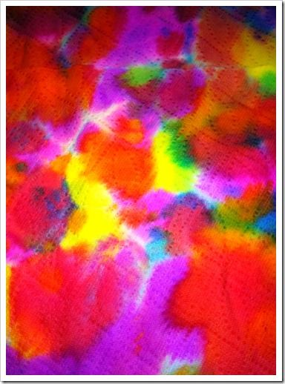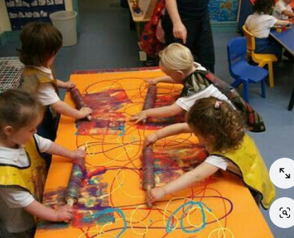
Learning Focus:
EYFS – Use a range of one-handed tools. Explore colour and texture. Talk about the world and changes over time.
Year 1 – Explore colour, shape and line. Colour mixing. Complementary colours.
Adult targeted questioning:
What has happened to the colours as they mix? What do you notice? Have you made any new colours? How did you make that colour? Which colours are your favourite? Which colours go well together?

Outside – Small World area
Resources: set up 1: Dinosaurs, water, twigs and bark, leaves and grass.
Set up 2: babies, washing up liquid, sponges, towels, cups and jugs.
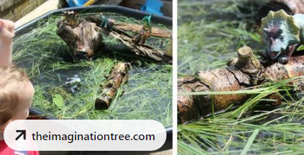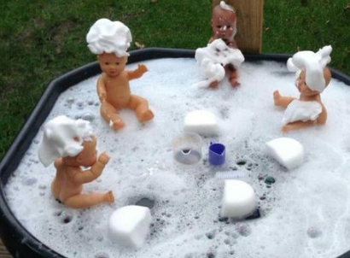
Learning Focus:
EYFS – Enjoy their own imaginative play. Create narratives in their play.
Year 1 – Use new topic-related vocabulary. Engage in drama and role-play linked to their experiences and what they have read in books.

Adult targeted questioning:
What is the name of this dinosaur? What does your dinosaur eat? Can you make a shelter/nest for your dinosaur? How can your dinosaur cross the swamp? How did your baby get all dirty? Is the baby clean now? How can you dry the baby, now?

Outside – Construction and role play
Resources: Big wooden blocks, role play hose, blankets, crates, planks.
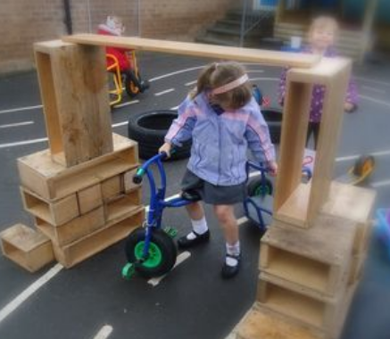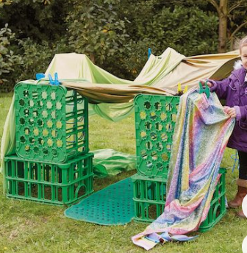

Learning Focus:
EYFS – Enjoy their own imaginative play. Create narratives in their play. Make props to support their play.
Year 1 – Use new topic-related vocabulary. Engage in drama and role-play linked to their experiences and what they have read in books.
Adult targeted questioning: What have you built? What does it do? Is it safe? Can you make it bigger/stronger?

Outside – Transportable Mark Making
Resources: Clipboards and plain paper, writing bags, phonics mats, magnetic letters, rolls of paper, whiteboards, pencils, whiteboard pens..
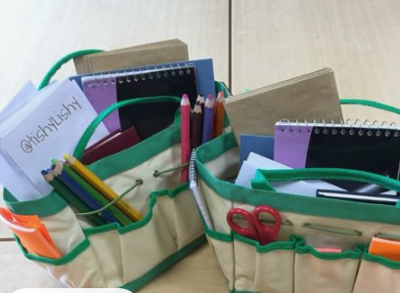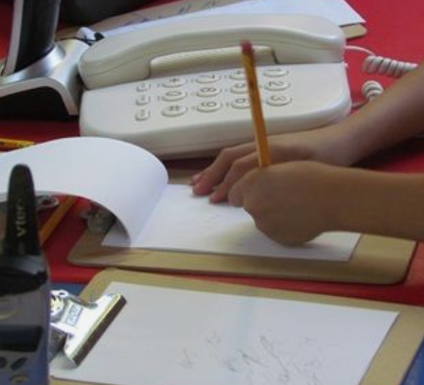
Learning Focus:
EYFS – hold a pencil correctly using a pincer grip. Give meaning to the marks they make. Represent some initial sounds in simple words.
Year 1 – Use their sounds to make phonetic attempts at new words. Write labels, lists and simple sentences. Begin to have some grammatical awareness of finger spaces, capital letters and full stops. Spell some HFW.
Adult targeted questioning: Tell me what you have written. What sounds do you need to write the word ….? Do you have a full stop/capital letter/ finger spaces? Can you write a list ….? Can you add some labels to your picture to give us more information?

Outside -water play
Resources: Set up 1: boats, fish, fishing nets, numbers.
Set up 2: coloured water, bowls and spoons.
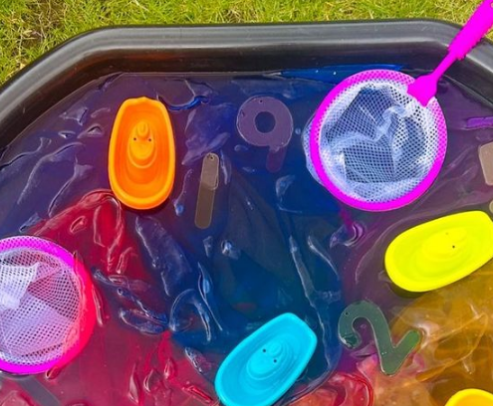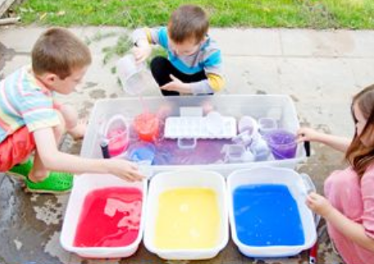

Learning Focus:
EYFS – Use a range of one-handed tools. Explore colour and texture. Identify numerals
Year 1 –Observe changes over time. Use some mathematical language linked to number facts, doubles, halves etc
Adult targeted questioning: what did you catch? What number is this? Is it odd or even? What is 1 more/1 less? What happened when you mixed the colours?

Resources: mud, bowls and containers, watering cans, cutlery, tools and a recipe for a mud pie.

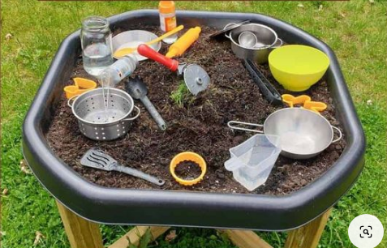
Learning Focus:
EYFS – Use a range of one-handed tools. Explore colour and texture. Talk about the world and changes that occur.
Year 1 – Use new topic-related vocabulary. Engage in drama and role-play linked to their experiences and what they have read in books.
Adult targeted questioning: Can I have a mud pie? How did you make it? What have you included? What does it taste like?

