Outside -Sand Area
Resources: spades, gold coins, jewellery, treasure, numerals, buckets with numbers on to collect coins.
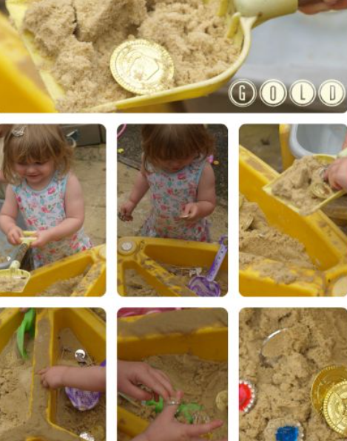
Learning Focus:
EYFS – matching quantity to numeral – Composition of numbers. Counting up to 20.
Year 1 – Recognise numerals up to 100. Pairs of numbers to 10/20. Using concrete resources to represent numbers.
Adult targeted questioning:
What number is that? How many coins have you found? What is more than/less than?
Can you count….? Can you find some treasure?
Who has more coins? What if I give you 1 more?
Inside – Tuff tray – 8 children
Resources: Set up 1: frozen peas, spoons, potato mashers, different sized containers, tweezers, scales for weighing, pictures of the Evil Pea.
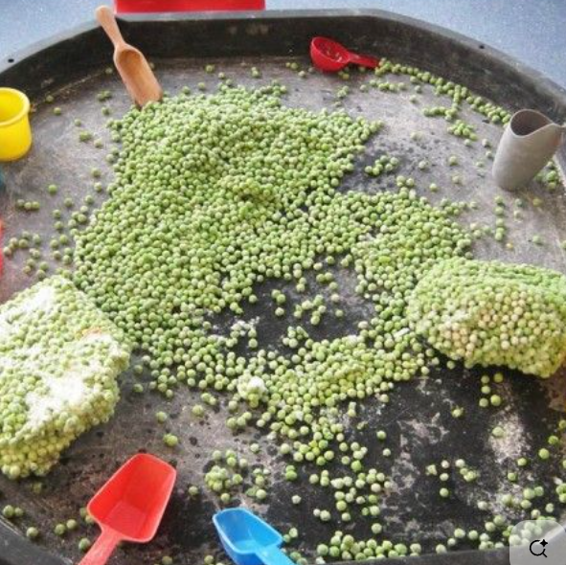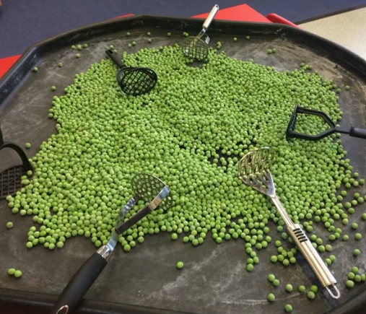
Learning Focus:
EYFS – Use a range of one-handed tools including tweezers and spoons
Year 1 – Use some mathematical language related to weight including heavy, light, the same.
Adult targeted questioning:
Have you found the evil pea? How many peas do you have in your container? How heavy or light are the peas? Can you tell me what you’re doing? How did you get them in there? What has happened to the peas?

Inside -Art Area
Resources: Set up photocopy of a potato, bits of coloured paper cut in to various shapes and sizes, wool, pipe cleaners, sticky eyes, glue, scissors, glue, tape, picture of Supertato.
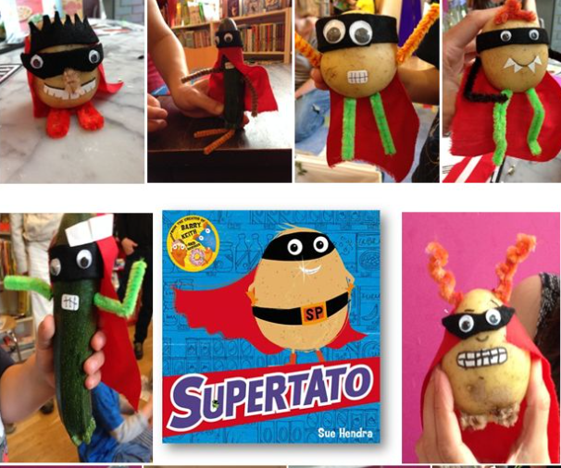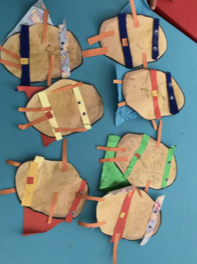
Learning Focus:
EYFS – Use a range of one-handed tools. Combine materials. Experiment with colour and design.
Year 1 – Explore colour, shape and line. Create their own 2d artwork
Adult targeted questioning:
What colour are you going to use? Where are you going to put that bit? How are you going to join those materials? Why did you put that bit there? Can you add anything else? Does it look like Supertato?

Outside/inside – Small World area
Resources: set up 1: frozen vegetables, containers, magnifying glasses, paint brushes, water pots, salt pots, paper towels. Cornflour, green dye, aprons.
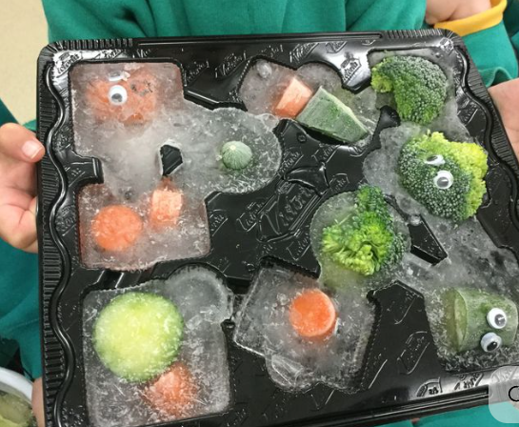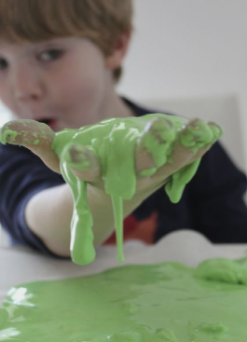
Learning Focus:
EYFS – Observe changes of time. Talk about what is happening to the ice/ cornflour.
Year 1 – Use some scientific language to explain what is happening to the frozen vegetables. Make simple predictions
Adult targeted questioning:
What is happening to the ice? Where is the water coming from? Can we slow down the melting or speed it up? What is ice? How do you know? What are you using? Is it working?

Outside – Construction and role play
Resources: Big wooden blocks, role play hose, superhero costumes and mask, telephones and walkie-talkies, mobile phones, laptop.
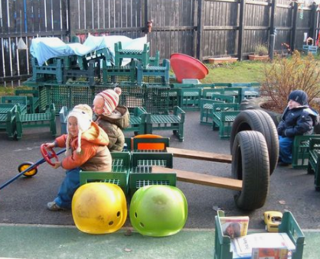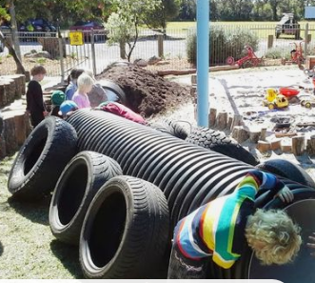

Learning Focus:
EYFS – Enjoy their own imaginative play. Create narratives in their play. Make props to support their play.
Year 1 – Use new topic-related vocabulary. Engage in drama and role-play linked to their experiences and what they have read in books.
Adult targeted questioning: What have you built? What does it do? What superhero are you and what’s your superpower? What’s inside your superhero lair?

Outside/ inside – Transportable Mark Making
Resources: Clipboards and plain paper and Supertato hunt sheet, writing bags, phonics mats, magnetic letters, rolls of paper, whiteboards, pencils, whiteboard pens..
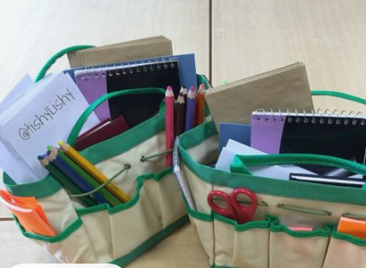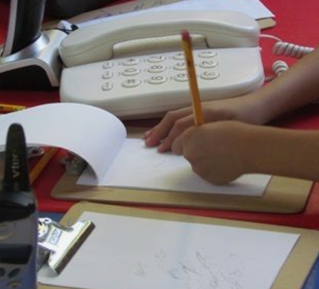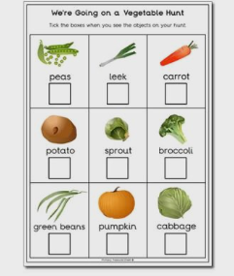
Learning Focus:
EYFS – hold a pencil correctly using a pincer grip. Give meaning to the marks they make. Represent some initial sounds in simple words.
Year 1 – Use their sounds to make phonetic attempts at new words. Write labels, lists and simple sentences. Begin to have some grammatical awareness of finger spaces, capital letters and full stops. Spell some HFW.
Adult targeted questioning: Tell me what you have written. What sounds do you need to write the word ….? Do you have a full stop/capital letter/ finger spaces? Can you write a list ….? Can you add some labels to your picture to give us more information?

Outside -water play
Resources: Set up 1:, washing up bowl, sponges, tea towels, plates and baskets
Set up 2: Flowers, coloured water, bowls and spoons.
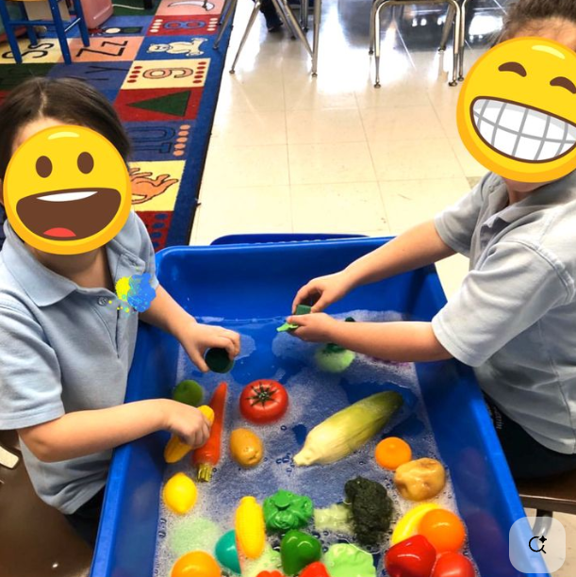
Learning Focus:
EYFS – Use a range of one-handed tools. Talk about the different vegetables.
Year 1 –Make observations. Name some common fruits and vegetables and discuss how they’re grown,
Adult targeted questioning: How are you cleaning your vegetable? How are you going to dry your vegetables? Can I have some carrots? What is your favourite vegetable? Where do they come from? Why do we need to wash them?

Resources: vegetables, paper, paint in primary colours, mixing trays, aprons.

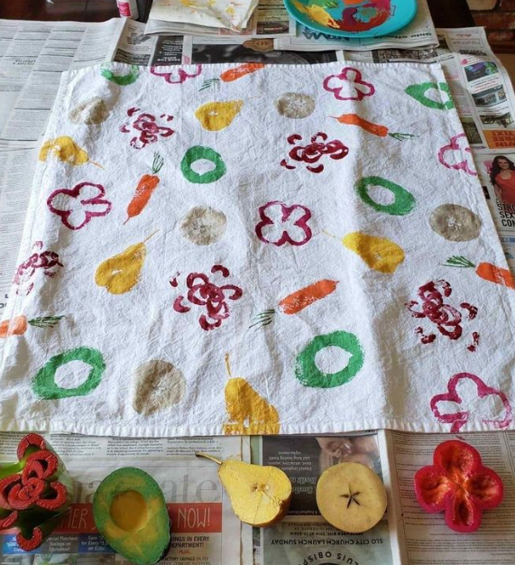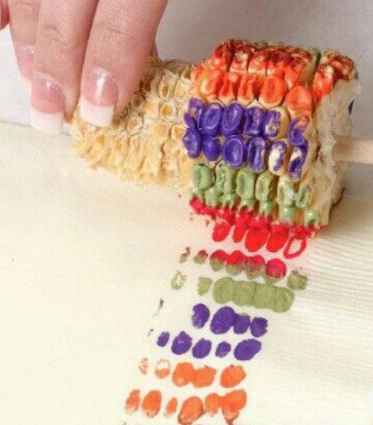
Learning Focus:
EYFS – Use a range of one-handed tools. Explore colour and texture. Talk about the world and changes that occur.
Year 1 – Use new topic-related vocabulary.
Adult targeted questioning: Can you do a pattern? What fruit/ vegetable is this? How did you do that? What colours have you made?

