Science: surface tension/ states of matter
Use this video from Explorify to set the scene
Avoiding pepper
Spark a conversation with this video featuring pepper and water.
This activity is great for describing observations and applying ideas in unfamiliar contexts.
Run the activity 1. You’re going to watch a short video. The aim isn't to find right answers, it's to explore ideas and find out what they know. Do they know what might happen based on the image?
2. After you've watched the video, lead a discussion with your class: What do the class think is going to happen, looking at the props? Why does the pepper float on the surface of the water? Why do they think the washing up liquid behaves differently? Were they surprised by what they saw?
3. Ask the class to describe what they saw using only one word.
Background science Water molecules are highly attracted to each other and hold on tight! In the bowl of water, the molecules have equal pressure on them from all directions, but at the surface there is unequal pressure, as there aren’t any water molecules above them to cling on to.
This gives water a high surface tension, creating a strong skin-like layer on top. If you look carefully you can see a curved shape to the surface of water in a glass. Being tiny and very light, the pepper fragments are able to rest on top of this skin-like layer. Adding washing up liquid breaks that surface tension and the water molecules spread out, taking the pepper for a ride! Take it further
Challenge the class to think about what would happen if other substances were used instead of pepper, such as puffed rice cereal, paper discs from a holepunch or even iron filings. Or, what would happen if you changed the liquid to something like milk or fruit juice?

Practical Activity:
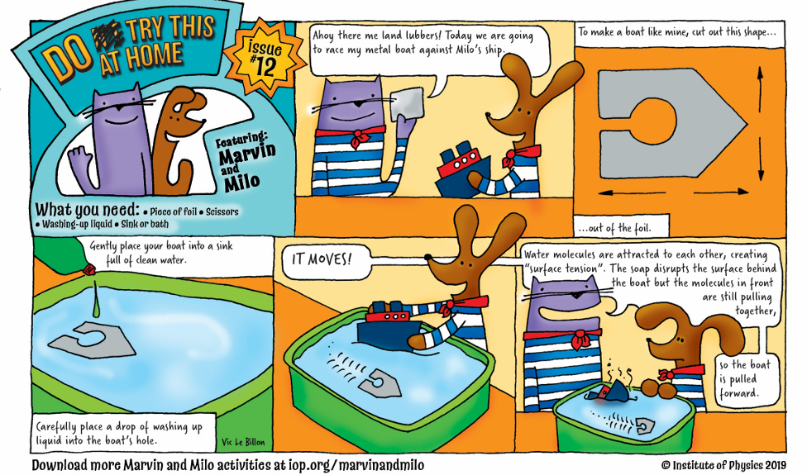

What you need
- A piece of foil
- Scissors
- Washing-up liquid
- A sink or bath
Instructions
- Take your foil and cut a shape 4cm x 10cm. The shape should look like a house (or rectangle with a triangle on top) with the base of the house being the shortest side. From the base cut a slot with a circle on the top.
- Gently place your boat into a sink full of clean water.
- Carefully place a drop of washing-up liquid into the boat's hole.
Results and Explanation
The boat moves! Water molecules are attracted to each other, creating "surface tension". The soap disrupts the surface behind the boat but the molecules in front are still pulling together, so the boat is pulled forward.
Conclusion: Ks1 chn need to record some observations from their experiment using words and images. I saw that the tinfoil boat move. I think this is because of……
Ks2 chn need to conclude where possible using an er sentence. Can they link it back to the science of surface tension as discussed in the starter activity.

Science: Sound
Dancing salt
Run the activity
1. You’re going to watch a short video. The aim isn't to find right answers, it's to explore ideas and find out what they know.
- Do they know what might happen based on the image?
2. After you've watched the video, lead a discussion with your class:
- Have you ever noticed that speakers vibrate when they produce sounds?
- How do sounds reach our ears? What materials do they travel through?
- Was there anything that surprised you in this video?
3. Ask the class to describe what they saw using only one word.

Background science
All sounds are created by vibrations. A vibration is when an object moves backwards and forwards very quickly. Sound waves must have a medium to travel through. This could be any solid, liquid, or gas (including air).
When the cone shaped part of the speaker vibrates (the orange bit in this video) it acts on the air around it. The particles in the air start moving back-and-forth in a way that matches the movement of the speaker. The particles knock into neighbouring particles, causing them to vibrate as well. The vibrations travel as a sound wave in straight lines through the air and away from the speaker in all directions.
When the invisible sound waves meet the cling film they pass on the vibration. This causes the film to move up and down and results in the salt dancing. This gives us an insight into how sounds reach our ears. Although we cannot see the air around us, it is a material and it is made of particles. Beyond our atmosphere, in space there are not enough particles to carry sound waves – this is called a vacuum.
Watch out for:
When sound travels through the air into our ears, children may think that the air particles move from the sound source to the ear. This is not the case. It is the vibration that is passed from one air particle to the next, until it reaches the ear drum.
Practical Activity:
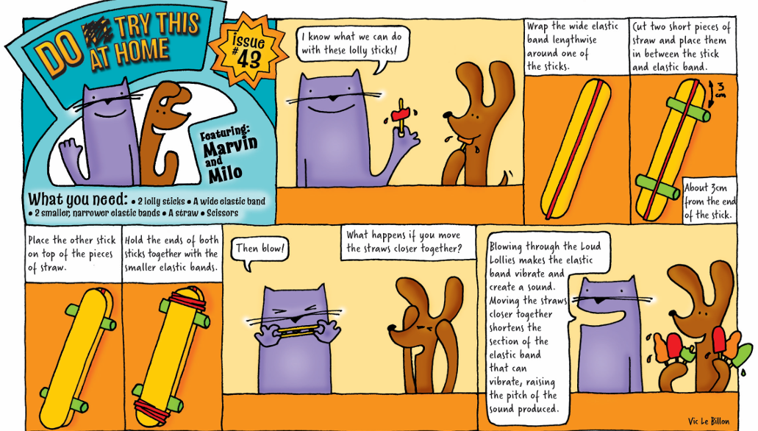

What you need
- 2 lolly sticks
- A wide elastic band
- 2 smaller, narrower elastic bands
- A straw
- Scissors
Instructions
- Wrap the wide elastic band lengthwise around one of the sticks
- Cut two short pieces of straw and place them in between the stick and elastic band - one about 3cm from each end of the stick
- Place the other stick on top of the pieces of straw. Hold the ends of both sticks together with the smaller elastic bands
- Then blow! What happens if you move the straws closer together?
Results and Explanation
Blowing through the Loud Lollies makes the elastic band vibrate and create a sound. Moving the straws closer together shortens the section of the elastic band that can vibrate, raising the pitch of the sound produced.
Conclusion: Ks1 chn need to record some observations from their experiment using words and images. I noticed the sound was different. I think this is because …
Ks2 chn need to conclude where possible using an er sentence. Can they link it back to the science of sound as discussed in the starter activity.

Science: Light
Back to front!
Run the activity
1. You’re going to watch a short video. The aim isn't to find right answers, it's to explore ideas and find out what they know.
- Do they know what might happen based on the image?
2. After you've watched the video, lead a discussion with your class:
- What do they think is going on?
- Can the pupils predict how the light will behave?
- Why do the letters appear reversed?
- How might different jars and letters react in different ways?
3. Ask the class to describe what they saw using only one word.

Background science
When the jar is empty light passes through, after it has been filled with water, the light bends or refracts. The water makes the light change direction, the light from the left side of the paper moves to the right and vice versa. Because the light is reflected like a mirror, we see the word reversed.

Practical activity:

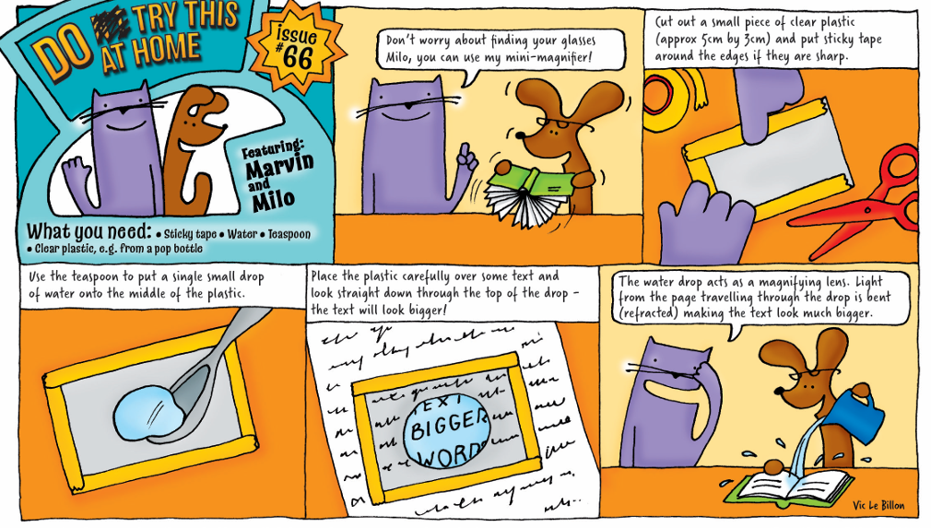
What you need
- Clear plastic, eg from a pop bottle
- Sticky tape
- Water
- Teaspoon
Instructions
- Cut out a small piece of clear plastic (approx 5 cm by 3 cm) and put sticky tape around the edges if they are sharp
- Use the teaspoon to put a single small drop of water on to the middle of the plastic
- Place the plastic carefully over some text and look straight down through the top of the drop
Results and Explanation
The text will look bigger! The water drop acts as a magnifying lens. Light from the page travelling through the drop it is bent (refracted) making the text look much bigger.
Conclusion: Ks1 chn need to record some observations from their experiment using words and images. I noticed the words looked bigger. I think this is because …
Ks2 chn need to conclude where possible using an er sentence. Can they link it back to the science of light as discussed in the starter activity.

Science: states of matter
Multiple liquid densities
Run the activity
1. You’re going to watch a short video. The aim isn't to find right answers, it's to explore ideas and find out what they know.
- Do they know what might happen based on the image?
2. After you've watched the video, lead a discussion with your class:
- Can they describe what they can see?
- What is each liquid and how might it behave?
- What can they see floating?
- What do they notice about how the liquids mix?
3. Ask the class to describe what they saw using only one word.

Background science
This activity shows liquids (golden syrup, water, oil) with different densities and how they mix with each other. Density is a measurement of mass divided by volume, essentially how much 'stuff' is packed into a given space. Golden syrup is the most dense, so sinks to the bottom, next is water, follow by the oil. Even when the jar is turned over the liquids return to this arrangement.

Practical activity:

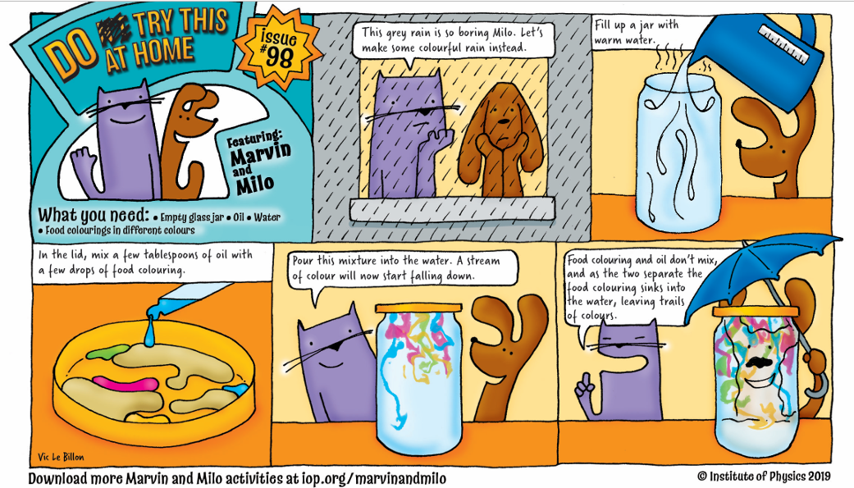
What you need
- Empty glass jar
- Oil
- Food colourings in different colours
- Water
Instructions
- Fill up a jar with warm water
- In the lid, mix a few tablespoons of oil with a few drops of food colouring
- Pour this mixture into the water
- A stream of colour will now start falling down
Results and Explanation
Food colouring and oil don't mix, and as the two separate the food colouring sinks into the water, leaving trails of colours.
Conclusion: Ks1 chn need to record some observations from their experiment using words and images. I noticed the colours didn’t mix. I think this is because
Ks2 chn need to conclude where possible using an er sentence. Can they link it back to the science of states of matter and liquid density as discussed in the starter activity.

Science: Magnetism and energy
Marvellous magnets
Run the activity
1. Show the three images above and ask everyone to come up with as many similarities and differences as they can. If they get stuck, prompt them to think about:
- appearance
- what they do
- where they might be found
2. Then, everyone needs to decide which one is the odd one out and why. Encourage a reason for every answer and there is no wrong answer!

Background science
The images show magnets being used in three ways: in a bank card's magnetic strip, a magnetic window cleaning tool, and a maglev train with no wheels.
Magnets are objects which exert an invisible force called magnetism. A pull (attract) or push (repel) force can be observed when a magnet comes close to magnetic items. Magnets can vary greatly in size and strength so it can be useful to explore these ideas with children, ensuring that there is a sufficient variety of magnets available to test so children come to understand that the size of a magnet does not necessarily equate to its strength.
The pictures in this activity show some examples of our everyday use of magnets. The cash cards we use for contactless or PIN payments have a special magnetic strip which stores important personal data such as the cardholder’s name and bank details to enable fast digital payments. Small yet strong magnets have been put to clever use inside the window cleaning device making the cleaning of the outside windows above ground level much easier with the force of magnetic attraction connecting it to an inside handle.
Large and extremely powerful magnets allow this maglev (magnetic levitation) train to glide above a track supported by force of magnets repelling underneath. This frictionless system can propel trains at extremely fast speeds. The Japanese Shinkansen, or bullet train as it known, regularly travels at speeds of 200 mph but the highest recorded speed of a maglev train was 370mph.
Practical Activity:
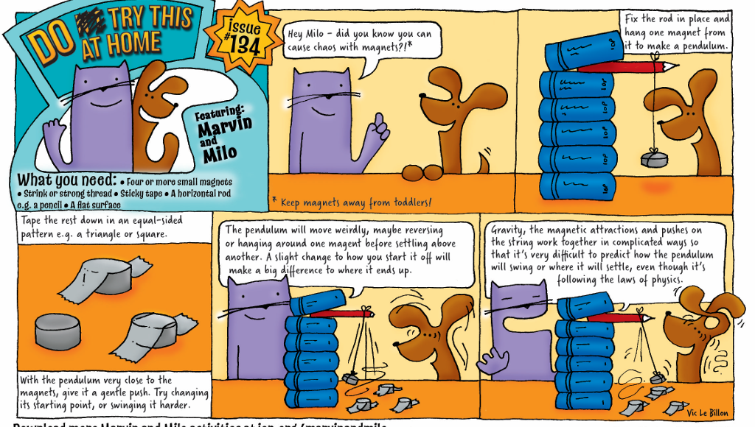

What you need
- Four or more small magnets
- String or strong thread
- Sticky tape
- A horizontal rod e.g. a pencil
- A flat surface
Instructions
- Fix the rod in place and hang one magnet from it to make a pendulum. (Keep magnets away from toddlers!)
- Tape the rest down in an equal-sided pattern e.g. a triangle or square
- With the pendulum very close to the magnets, give it a gentle push. Try changing its starting point, or swinging it harder
Results and Explanation
The pendulum will move weirdly, maybe reversing or hanging around one magnet before settling above another. A slight change to how you start it off will make a big difference to where it ends up.
Gravity, the magnetic attractions and pushes on the string work together in complicated ways so that it’s very difficult to predict how the pendulum will swing or where it will settle, even though it’s following the laws of physics.

Conclusion: Ks1 chn need to record some observations from their experiment using words and images. I noticed the magnet….
I think this happened because
Ks2 chn need to conclude where possible using an er sentence. Can they link it back to the science of magnets and gravity as discussed in the starter activity.
Science: Forces
Move large stones
You will need:
A mix of building materials (card, foil, sticks, cardboard tubes, string, tape, glue, water, elastic bands, packaging and other bits of recycling), a selection of stones or pebbles for each group. Sometimes you have to solve a problem on the spot. Explain that today the class have 5 minutes to move large stones from one side of the table to the other using just the materials provided. They cannot move the rocks by touching them but can put the rocks onto the different materials provided.

Run the activity
1. Explain that working as a team, they will have 5 minutes to look at the materials and create a device or tool that can move stones over a short distance. Encourage them to think about ways they can increase the pulling force without exerting too much effort.
2. After 5 minutes, get them to swap creations or methods with another group. Continue working, but this time on the unfamiliar creation. How can they improve it?
3. After survey the final creations. What have they learned from swapping projects?

Background scienceThe ancient Egyptians who built the pyramids may have been able to move massive stone blocks across the desert by wetting the sand in front of a something built to pull the heavy objects. This image taken from a wall painting in the tomb of Djehutihotep shows a figure on the sledge pouring water in front of it.
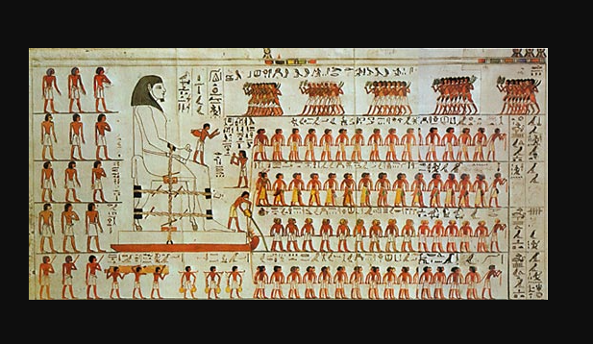
In the UK there are many stone circles that required stone age man to move huge blocks. There are many ideas about how this could have been achieved from using tree trunks as rollers to using wet seaweed as a lubricant.
All of these methods work because they help to reduce friction between the block of stone and the ground when it is pulled. This means that the pulling force can result in a bigger movement of the stone for less effort.
Practical Activity:
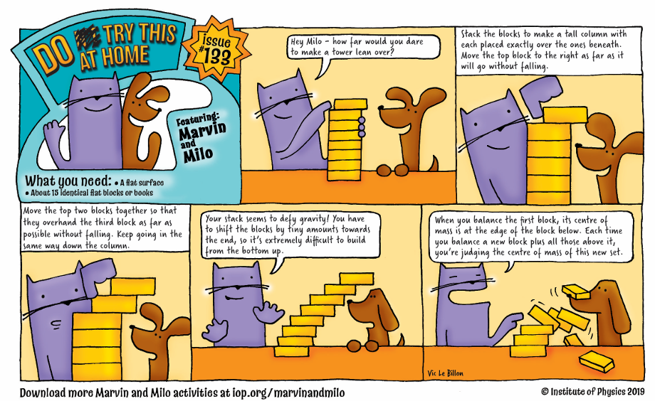
What you need
- About 15 identical flat blocks or books
- A flat surface
Instructions
- Stack the blocks to make a tall column with each placed exactly over the one beneath. Move the top block to the right as far as it will go without falling
- Move the top two blocks together so that they overhang the third block as far as possible without falling. Keep going in the same way down the column
Results and Explanation
Your stack seems to defy gravity! You have to shift the blocks by tiny amounts towards the end, so it’s extremely difficult to build from the bottom up.
When you balance the first block, its centre of mass is at the edge of the block below. Each time you balance a new block plus all those above it, you’re judging the centre of mass of this new set.
Conclusion: Ks1 chn need to record some observations from their experiment using words and images. I noticed the tower didn’t fall over when ….
I think this happened because
Ks2 chn need to conclude where possible using an er sentence. Can they link it back to the science of gravity, forces and the centre of mass as discussed in the starter activity.

