Science

We will be continuing our light topic from last half term, look at natural light sources, as well as how to manipulate light with shadow puppets.

You can support your child by having a go at creating your own shadow puppet theatre at home using torches and card/black paper. Think about how the light is blocked by the paper.
Personal, Social and Health Education (PSHE) and Religious Education (R.E.)

PSHE – In PSHCE this half term, we will be using the Jigsaw scheme to explore what it means to be ‘Healthy Me.’ This will incorporate healthy friendships and group dynamics. The focus will then look at keeping themselves and other safe and the physical effects of smoking and alcohol on the body.

RE – During our RE lessons the children will be looking at the People of God and learning more about Noah. We will look at the relation between the story of Noah and the vows made at wedding ceremonies.

Maths

This half term we will be reviewing Multiplication and Division, as well as developing the children’s fraction, shape and measurement knowledge. We will learn about ½ 1/3 ¼ 1/5 and their related fractions as well as how to add fractions with the same denominator.

You can support your child by encouraging them to practise their Dragon Fire Maths every day. You can also work on fractions at home by sharing objects into groups and cutting up food into equal portions and associating that with the fraction name.

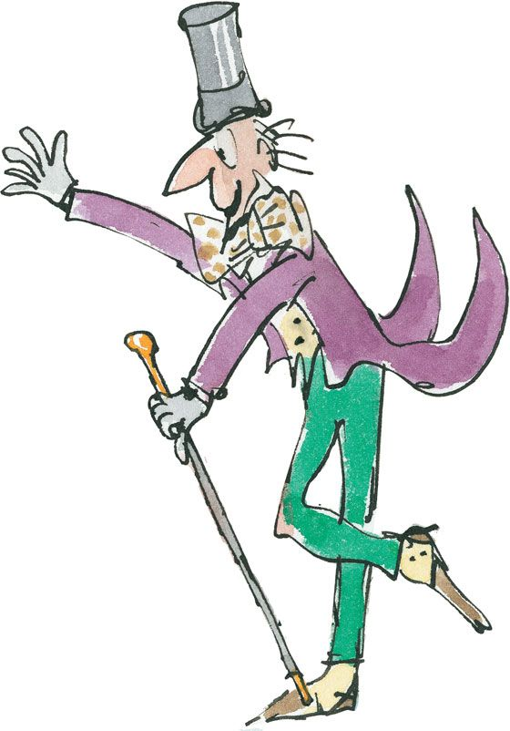
English
Our writing journeys will be inspired by the writing of our class author, Roald Dahl and his love of chocolate. We will be looking at extracts from ‘Charlie and the Chocolate Factory’ as well as several of his other books such as ‘The BFG’, ‘George’s Marvellous Medicine’ and ‘Revolting Rhymes’.

The children’s half term challenge will be focusing on improving pace in their writing to keep their audience engaged, as well as using direct speech. You can support this by reading a range of short stories at home and encouraging your child to use a range of voices for each character to understand their personality.

We will also be working hard on remembering our basic skills, including capital letters and super smart handwriting!

Our spelling tests will continue to be on a Monday.

Year 3
Spring 2 2026
The Wonderful
World of Chocolate
History

In History we will be delving into Maya civilization. We will investigate the impact the Mayans had on the world today. Our focus will be answering the question how and why do civilizations fall?

You can support this at home by looking into traditional Mayan recipes for hot chocolate and having a go at making them. You can also research aspects of Mayan life that we still have today.

Art

In our art lessons we will be creating Mayan prints using patterns from Mayan culture. The children will use their skills of critical thinking to explore Maya art and create their own prints in similar style.

You can support this at home by trying out printing and stamping with vegetables and sponges.

French and Music

In French, we will be improving vocabulary and learning to talk about what we like and don’t like.

In Music, we will be learning improving our singing, learning about how dynamics, pitch, tone and tempo impact how we sing.
Computing

The children will be developing their Digital Literacy skills by learning how to send a receive emails. They will look at different platforms and the components of emails. They will also learn how to identify fake emails and what to do if they receive one.
You can support your child by having conversations about internet safety and how to avoid cyberbullying.

P.E.
In our PE sessions, we will be focussing on Gymnastics and team games this half term. We will be developing the skills of striking and fielding in our outdoor session, as well as looking at balance and movement in our indoor sessions.

You can support your child by encouraging them to be active at home. This could be taking a walk in nature, riding a bike or scooter, or spending an hour at the park every day.

