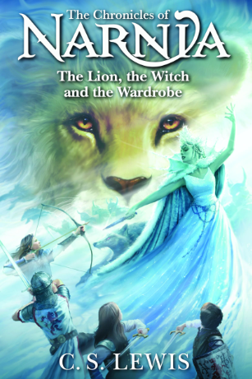
Dear Parents/Carers,

We hope your children had a good half term break and are ready for Spring 2! Can you believe that we are halfway through Year 4 already?

Our topic this half term is our class author, C.S. Lewis, who is most famous for his Chronicles of Narnia, and particularly the book The Lion, the Witch and the Wardrobe. We will be reading and studying this. In addition to this, we will also begin to study the Romans in more detail (we focused on the geography of Italy last half term), which is our history link to our class country. Please see our Topic Web for more detailed information on what your child will be doing in other subjects this half term.

Dates for the Diary

- Monday 23rd February – back to school
- Tuesday 3rd March 3.30pm Year 4 Multiplication Tables Check Parent and Carer presentation – a chance to find out what it is all about and for your child to show them what we do in class to practise including software to help – please do try to come along, it won’t be a long meeting
- Thursday 5th March - World Book Day. The annual event- bring a book to share and dress up as a book character if your child wants to. The whole day’s lessons will be focused on this event. More information to come.
- Wednesday 11th March 2.30-3.30 - Mid-year celebration of learning – parents and carers are invited in to share your child’s work.
- Friday 20th March - Annual pupil reports sent out to parents/carers.
- Friday 27th March - Easter Breakfast
- Friday 27th March - Break up for Easter
- Monday 13th April - Start of Summer term

Reminder: Full P.E. kit needs to be in school every Monday. We frequently have children without their kit, which causes disruption and takes extra time to try to resolve. Earrings still need to be taken out for those days, or ear tape provided for your child to apply before the lesson. They need to be able to do this themselves – we cannot do this for them so please make sure earrings are taken out before school or that they are easy for them to take out. Thank you to all who have been supportive of this- it is appreciated.
Swim Kit needs to be in every Wednesday- again thank you to most parents and carers for this. Please remember that it is White Meadows school policy for children not to wear earrings in the pool, therefore it isn’t ideal to get your child’s ears pierced mid-term. Thank you for your co-operation with this.

Times Table Practise
Times tables practise at home is crucial. Your child should be accessing timestables.co.uk or Times Table Rockstars and/or practising their Dragon Fire Maths (previously Mental Magicians) target every day if possible. We continue to do our weekly test every Friday and do additional daily practise. If you can spend some time practising at home this will help to be more secure in their tables will give them a huge advantage moving into years 5 and 6 and beyond. A top tip might be to focus on all the ‘doubles’ tables such as 3x3, 4x4, 5x5, 6x6 and so on. Just practise them daily in whichever way suits and you should see an improvement! The Multiplication Test will be taken in June by ALL children. There will be a presentation about this for parents/carers to explain the process and answer any questions- please see the dates section for details.

Homework
Thank you again for all the support with this. Children will continue to have weekly spellings to practise and a My Maths task which supports learning in class. If you have lost your child’s My Maths log in, please just ask. This is set every Tuesday and should be done by the following Tuesday although I set it to be active until the Wednesday, so they have a day’s grace. I hope this helps.

Reading at Home
Reading is a vital part of your child’s education – we know you will already have heard this every year! BUT it really IS the MOST important thing you can do with your child. Proficient readers are more successful at GCSE, and it opens the world to children in every way possible. PLEASE, please try to read at least three times a week with your child, even if it is for 5 minutes. Reading together at bedtime is perfect to build into a routine. Ideally this should be every day, where possible. Reading certificates will be awarded in celebration assemblies for the number of times the children have read and to monitor this the children or adults will need to record this in their reading record, numbering each entry: 50 entries – bronze reading award, 100 entries – silver reading award, 150 entries – gold reading award. Reading records will need to be at school every day for adults in school to record one to one reading. We have our own records and so, even if your child has read, this may not always be recorded but they are being read with on a regular basis or being heard read out loud within lessons.

Thank you for all your support. If there are any issues or queries, please remember you can email or call the office, and your message will be forwarded on. We will endeavour to help as soon as we can. We also welcome you having a chat with us at pick up or passing on a message to us via the staff members on the gate, at drop off. If you would like to become more involved in school (e.g. as a reader), or if you have any artefacts, reading books or other resources to offer the school, it is always greatly appreciated.

Kind regards,

Ms Woods and the Year 4 Team

