Computing
In Computing the children will be doing a second unit of work which consists of ‘computational thinking’. They will be using a programme called Scratch (we have used this in the Autumn term) to create shapes by coding. This will be good recapping and reinforcing of the work they have done before.

History
Our main subject driver for this half term is history and our topic of Victorians. The children will be looking at some of the main changes the Victorians made to life in Britain such as industry, schooling and transportation, as well as some of the important people that made it happen.
Year 4 will look at the lives of children during Victorian times and make comparisons to their own and the lives of other children today. We will mainly be answering the key question of: Victorians- were they vile or victorious? To help at home, you can encourage your child to do their own research, maybe watch videos and discuss what they have learnt.

Science
In Science, the children will be learning investigative skills including setting up simple experiments and making observations. The main topic this half term will be Sound and we will link this to key inventions during the Victorian period that link to sound. You may wish to make some objects at home such as pin hole cameras and cup and string telephones- the internet is full of ideas! We would love to see anything the children make brought into school.

P.E.
We will continue swimming every Wednesday and our other P.E lessons will now be Athletics in preparation for Sports Day. These will now be outdoors and so please ensure your child has suitable kit in school (see uniform list for details)
P.S.H.C.E.
In P.S.H.C.E., the children will be discussing different types of relationships and celebrating the special relationships that they have in their lives. They will be looking at human relationships with animals and how they can be used as a support. The children will also discuss love and loss and ways to deal with this.

R.E.
The children will be learning about salvation and building on their knowledge of the Easter story, including understanding the significance of each day in the Christian calendar. They will also look at the term ‘Good Friday’, as well as discuss betrayal and the role of Judas.

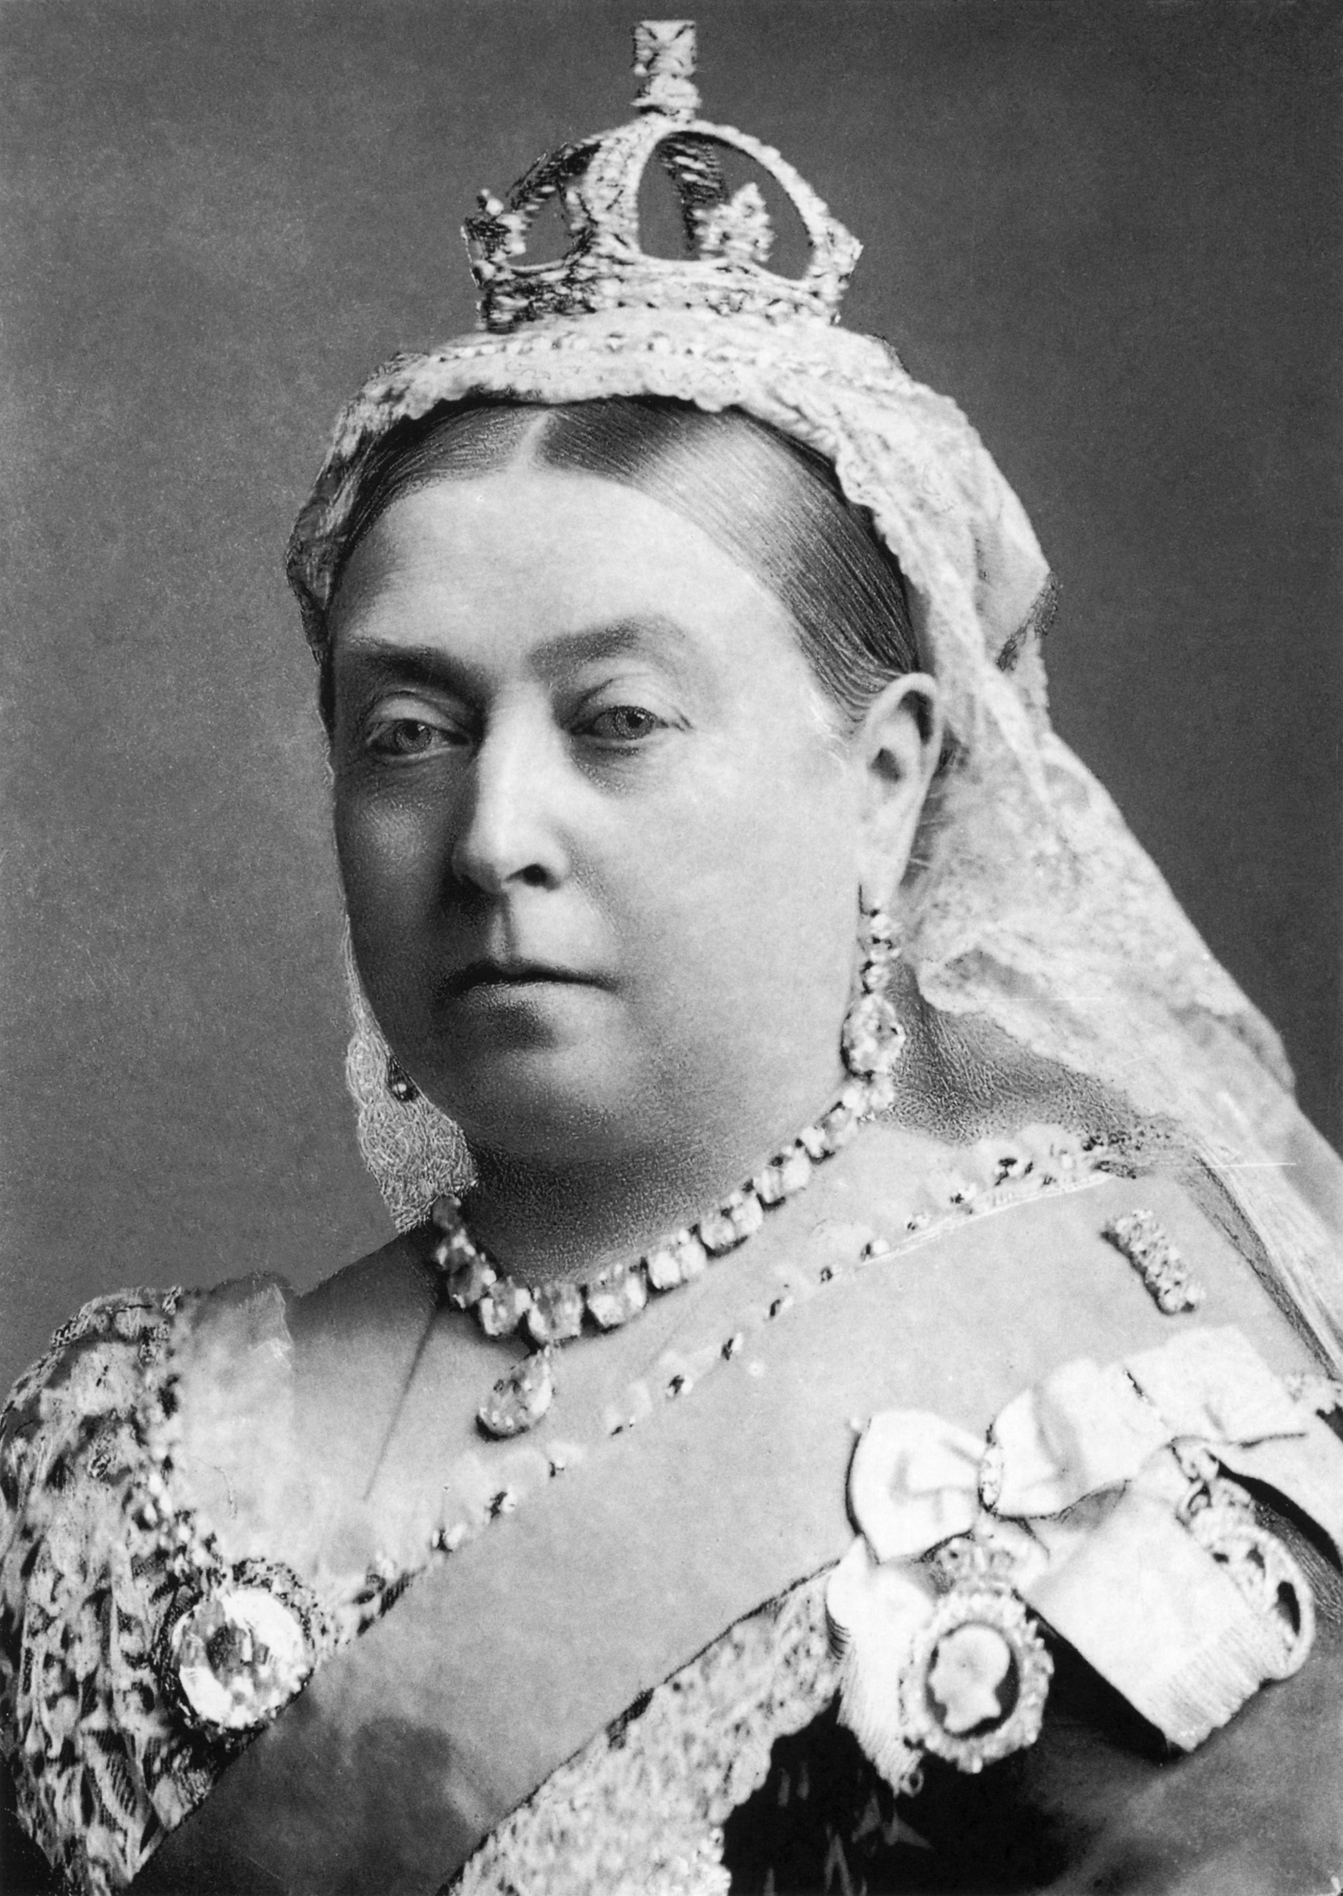
English
Writing
In English lessons, the children will be undertaking three writing journeys linked to our topic. They will be continuing to practise basic spelling, punctuation and grammar skills, as well as developing their knowledge of different writing styles.
They will create nonsense poetry after studying the poem ‘The Owl and the Pussycat’. You may want to learn this at home with your child, especially if you are familiar with it yourself. Another writing task will be writing descriptions and a balanced argument that will discuss the evidence of Victorians being both vile and victorious.

Reading
The children will continue to read a range of high-quality texts in our daily reading lessons, developing fluency, comprehension and discussion skills. We will be reading a range of texts including fiction and non-fiction pieces and identifying key features of each piece, as well as learning to retrieve information from the text to answer comprehension questions.

Please continue to support your child by continuing to read with them on a daily basis, recording this in their reading record. This will ensure they are ‘Year 5’ ready.
Victorians
Year 4
Summer 1
Music

Year 4 will have the wonderful opportunity of taking part in drumming workshops led by West Sussex, these lessons will be every Friday.
Design Technology
Year 4 will be taking inspiration from the vast amount of both silly and world changing inventions that occurred during Victorian times. The children will have fun creating their own inventions that may solve a problem and be relevant to today’s world, particularly their lives.

Maths
As usual, we will start the term with a focus on Place Value – this is vital to the children’s understanding of the number system. We will focus on the areas identified as being still weaker such as rounding numbers. We will also be using decimals.
Maths will move onto the 4 rules of number: addition and subtraction, multiplication and division. We will focus on standard written method for each of these in readiness for Year 5. If you can help by ensuring your child practises these at home that would be great. They should be methods you are familiar with yourself but if not, Khan academy website is excellent at explaining them, with videos.
It is vital that you continue to encourage your child to practise their times tables, especially in the lead up to the Multiplication Tables Check in June. Please see the email sent about this test for more details, following on from the parent presentation that was held on March 3rd.

French

The children will continue to build upon their basic French conversational language. Most lessons are oral with lots of repetition and practise which means it embeds the language better. They will play games and learn songs to also help with this.

