
LYMINSTER PRIMARY SCHOOL
Wick Street, Littlehampton, West Sussex, BN17 7JZ
www.lyminster.w-sussex.sch.uk

Headteacher: Mr. S. McGinley Telephone No. (01903) 713642
Email: office@lyminster.w-sussex.sch.uk Facsimile No. (01903) 732013

February 2026

Dear Parents/Carers,
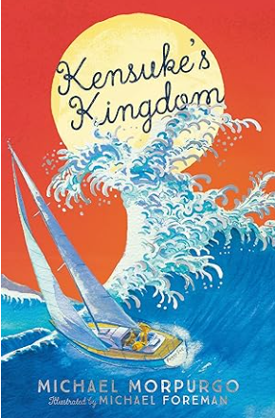
A very warm welcome back for Spring 2, we hope your children managed a restful, enjoyable half term holiday.
And so, on to this new half term- we have another very busy one coming up so read on for all the information and dates.

Topic: Author Study, Michael Morpurgo

During this topic we will focus on two Michael Morpurgo books. Firstly, ‘The Day I met a Whale’ then ‘Kensuke’s Kingdom’. These will provoke lots of discussion. The children will be doing some of their writing work based on these, reading will be mainly focused on these texts. We will also learn a bit more about the author himself and the children will be encouraged to read other books of his. Any support with this would be welcome e.g. reading one at home with your child.

Sub-topic: Living Things- Animals and plants- life cycles and reproduction.

In this Science unit we will be learning all about different life cycles and comparing them. We will also learn about reproduction of plants. We hope the children will really enjoy the practical element planned so lessons are really engaging and fun. Amongst other things, we are hoping to plant some vegetables and do an experiment with spring onions. We are also hoping to watch for real the life cycle of a butterfly in our butterfly home and then be able to release them! Our Art will also be related to this topic. Our trip to Arundel Wetlands will also bring this topic to life and really enhance the learning of this area. We have found the experiences at this centre are high quality and enjoyable where the children not only learn so much but are out in nature and having fun. More details are in a separate email/letter.

Key Dates

- Monday 23rd February – back to school
- Thursday 5th March - World Book Day. The annual event- bring a book to share and dress up as a book character if your child wants to. The whole day’s lessons will be focused on this event. More information to come.
- Wednesday 11th March 2.30-3.30 - Mid-year celebration of learning – parents and carers are invited in to share your child’s work.
- Friday 20th March - Annual pupil reports sent out to parents/carers.
- Friday 27th March - Easter Breakfast
- Friday 27th March - Break up for Easter
- Monday 13th April - Start of Summer term

Key Information and Polite Reminders:

School mornings: Year 5 will still be coming into class from 8.45am- the expectation is that they are in by 8.50 to register. The exception to this will still be Fridays when all staff have a business meeting. Children should then wait by the classroom door and they will be let in at 8.50am.

P.E. KITS
P.E lessons will be on TUESDAYS AND THURSDAYS. Children need to be in school P.E kits please. See the school website for information on what the school P.E kit should be- their Lyminster house colour t-shirt and hoodie, neutral-coloured shorts or tracksuit bottoms and trainers. Earrings should be removed for P.E days or tape provided from home to cover them please. All other jewellery must be removed for safety reasons.

Reading and Homework:
Homework remains the same: Reading at least 5 times per week, ideally every night with an adult, practising spelling rules and words, Dragon Fire Maths, and online MyMaths work to be completed and handed in/done by Monday. If your child doesn’t have their book, they are told to write their name on it and put it in their bag.

Finally, please do come and see us if you have any questions or concerns or email ejohnston28@lyminster.w-sussex.sch.uk or the office and we will respond to you between the working hours of 9am and 5pm.

Kind Regards,

Miss Johnston
Year 5 teacher

