**Maths**

We have 2 main areas of this subject this half term- Place Value and The Four Operations.

Place Value: revising and extending our understanding of the value of digits, rounding, ordering and negative numbers. This will include decimal numbers.

The Four Operations: We will be revising, practising and extending our ability to use standard written and mental methods to add, subtract, divide and multiply amounts. We will be using decimal numbers and amounts within a context eg. Money. This will include problem solving tasks and investigations.

**English**

During this half term we will continue to focus on writing fluently and neatly, according to the school style.

We will be reading Black Powder during the school day and will complete Guided Reading activities linked to this text.

Please support your child with their homework by questioning them about their reading and by asking them the meaning of the spellings they are learning.

In writing sessions, as well as having ‘free writing’ opportunities, our main writing journey will be creating a non-chronological report where the children will create their own creature and describe it in a more formal way. We will look at examples of texts already written, plan our reports before drafting, editing and proofreading them to ensure a final, well finished piece.

**Personal, Social and Health Education (PSHE) and Religious Education (R.E.)**

PSHE – We will be following the Jigsaw scheme of work to explore ‘Being Me in My World.’ We will look at families and how they are made up of a range of people and discussing how it feels to be included in a group.

RE- We will be looking at Christianity. We will focus on the main themes of this religion and try to relate them to our own lives. There will be lots of discussion in these lessons.

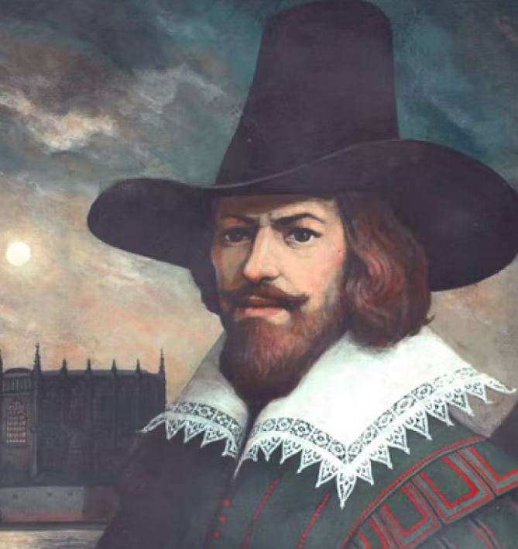

**Computing**

We will be learning about historical figures in computing, the evolution of it and explore codebreaking. We will explore the computers that were created at Bletchley Park and their importance during World War 2. Hacking and the necessity for secure passwords will underpin all of the work that we do with computers this half term.

**Science**

Our first Science topic in Year 6 is Evolution and inheritance where we learn about how traits and features are inherited from parents. We study fossils and why they are important evidence of the past. We also look at how different species have evolved over time including the theories of human evolution.

**Art**

Our art is linked to our Science topic where our theme is ‘fossils’. We will create clay ammonites and then practice our drawing skills by copying a range of fossils. We will look at a range of artwork that has been inspired by fossils which will lead to each child creating their own piece, in their own style, using specifically chosen media.

**History**

In History we will be delving in to the early 17th Century a time of Guy Fawkes and the gunpowder plot. We will be researching the reasons why the conspirators wanted to get rid of King James I. We will be asking ourselves which side would we have been on if we had been there.

We will also be considering the differences between the Parliament of the early 17th Century and that of today.

Autumn 1 2025 –

Gunpowder, Treason and Plot!

Year 6