February 2026
Dear Parents/Carers,

Welcome to Spring 2 in Year 6.
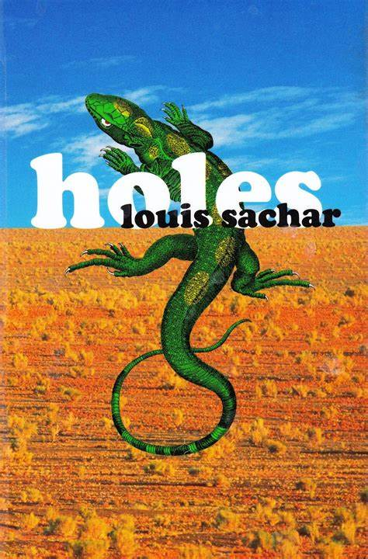
This half term, our topic will be centred on the work of a well-known author: Louis Sachar. The children will be studying his book ‘Holes’, and using this to inspire a range of written work as well as sculptural pieces. The children will research the work of Barbara Hepworth and use these ideas to inspire their own designs. I look forward to inviting you all in to see their previous work at the start of the half term.

Key dates for the half-term:

- Monday 23rd February – back to school
- Thursday 5th March - World Book Day. The annual event- bring a book to share and dress up as a book character if your child wants to. The whole day’s lessons will be focused on this event. More information to come.
- Wednesday 11th March 2.30-3.30 - Mid-year celebration of learning – parents and carers are invited in to share your child’s work.
- Friday 20th March - Annual pupil reports sent out to parents/carers.
- Friday 27th March - Easter Breakfast
- Friday 27th March - Break up for Easter
- Monday 13th April - Start of Summer term
Things to remember:

- Your child will have P.E. on Monday (outdoor) and Wednesday (indoor) therefore they will need to come to school wearing their P.E. kit for both sessions (this includes trainers; school footwear is not suitable). Children are allowed to wear tracksuit bottoms and sweatshirts for outdoor P.E.
- We are still very much in the wetter and colder months (although hopefully warming up soon!) and we do like the children to be outside as much as possible during break and lunchtime even if it is lightly drizzling. Please ensure therefore that your child has a waterproof coat with them every day.
- Your child can bring a healthy snack (fruit or vegetable) to eat at break time. Some children are brining cakes and crisps, which are not allowed as we promote healthy eating, as a school.

Homework reminder:
- Children are asked to read at least 5 times a week. Please encourage your child to read a variety of books both fiction and non-fiction. This will improve their vocabulary and their writing tremendously. This half-term we will focus on an author’s use of language and choice of words, and how we might describe a character or setting based on what we have read. When you read with your child at home, please check their understanding of new or tricky words to help broaden their vocabulary.
- Dragon Fire Maths will be tested every week. Please ensure your child is learning these at home by regularly accessing TT Rockstars.
- Children will be given homework on Thursday, and it will be due in on Thursday. Please ensure that your child has their homework in school every Thursday. This will comprise of reading comprehension/grammar activities, maths questions via MyMaths and spellings. Please support your child with their home learning.
If your child has lost their TTRS username and password, please let us know and I will hand them it again.

Please encourage your child to do the homework as the tasks now set will be supporting and underpinning their learning for the SATs tests. If there are any issues, then please do let me know.

We are continuing to focus on general presentation and handwriting in every lesson. Please be reminded that your child still has free access to our handwriting website: https://www.letterjoin.co.uk. The username is ak3814 and the password is home. This website can be used to practise individual letters or blends of letters that your child may find tricky to join.

Year 6 will continue to come into school from 8:40 am every day except Friday, when they should arrive at 8.50 am. Focused tasks will be set depending on need between 8:40 and 9:00 am. It is therefore important that your child arrives ready for an 8:40 am start.

As always, if there are any worries or concerns, or you just want to check how your child is getting on, please do come and see me.

Kindest regards,

Mrs D Williams
Year 6 Teacher & Key Stage 2 Leader

