Maths
This half-term we will begin by learning about the properties of a circle and how to calculate the circumference, radius and diameter.
Following that we will be looking at ratio and proportion where we will be solving problems involving the relative sizes of 2 quantities; the calculation of percentages; scale factors and how to use the bar method to solve ratio problems.
Finally, just before Easter we will be looking at algebra.
We will be:
-using simple formulae
-expressing missing number problems algebraically
-finding pairs of numbers that satisfy an equation with 2 unknowns.
To support your child, please continue to test them on their times tables and division related facts and encourage them to practise this on TTRS. Please ensure they complete their Maths homework where resources are available to support their learning.

Science
We will be learning about Animal including Humans. The children will explore the circulatory system using diagrams to explain how it works. The children will be comparing how nutrients are transported around human bodies, compared to the bodies of animals.
Linking to PSHCE work, we will also be discussing the impact of diet, exercise, drugs and lifestyle on the way their body’s function.

Personal, Social and Health Education (PSHE) and Religious Education (RE)
PSHE - We will be continuing to follow the JIGSAW scheme of work thinking about being healthy. We will discuss how we keep ourselves emotionally healthy, and learn about substance misuse. We will talk about ways in which people use substances such as alcohol as part of their lifestyle, and evaluate the health risks between responsible use, anti-social use and misuse.
RE - We will continue to follow the Understanding Christianity programme, learning about Salvation and discussing the question: what do Christians believe Jesus did to save Human Beings?

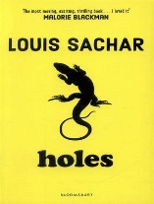
Year 6 Spring 2, 2026
Author Topic: Louis Sachar
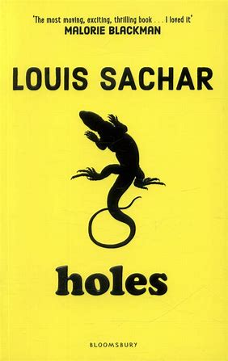
Art
The children will be improving their sculpting skills using a range of materials. They will find out about Barbara Hepworth and the inspiration for her work and discuss their personal response to her sculptures.
The children will then experiment with different materials before designing their own sculpture and creating it from a material of their choice. They will record their learning journey in their sketchbooks and then feed back on each other’s sculptures at the end of the topic before writing an evaluation of their own artwork.
Computing
This term we will continue to learn how search engines work, including how to use them safely and effectively, before researching different creatures and habitats for our non-fiction writing. We will also be developing our understanding of how to keep safe when using the internet.

P.E.
In P.E. we will have two sessions a week: one outdoors, one indoors. The outdoor sessions will focus on football and the children will learn spcific football skills and think about the positions in the game. The indoor sessions will be circuit training with a focus on improving stamina and fitness.
Modern Foreign Languages (MFL)
In French the children will begin to access and understand authentic French listening materials. They will start to understand words, phrases and simple writing. Accurate pronunciation will be a key focus. The children will begin to create their own written work.
Music
This half term, the children will be composing their own piece of music to be played alongside Haikus that they have written. They will explore what composition is and look at a range of famous composers.

English
We will be studying ‘Holes’ by Louis Sachar, which will provide us with lots of exciting writing opportunities. We have been working on cohesion and linking ideas clearly, and after reading reports on yellow-spotted lizards, the children will demonstrate these skills when writing their own fact sheet on a creature of their choice.
They will also write stories linked to escape scenes in the book, and this will be a chance for them to develop their descriptive language. We have also been learning how to use speech to advance the action in stories, so this will also be a focus for their narrative work.
Finally, the children will be working on their formal written language, and will write a letter to the camp’s owner, detailing the children’s experiences there.

