Year 2 Plants –Planning ideas
Real life links;
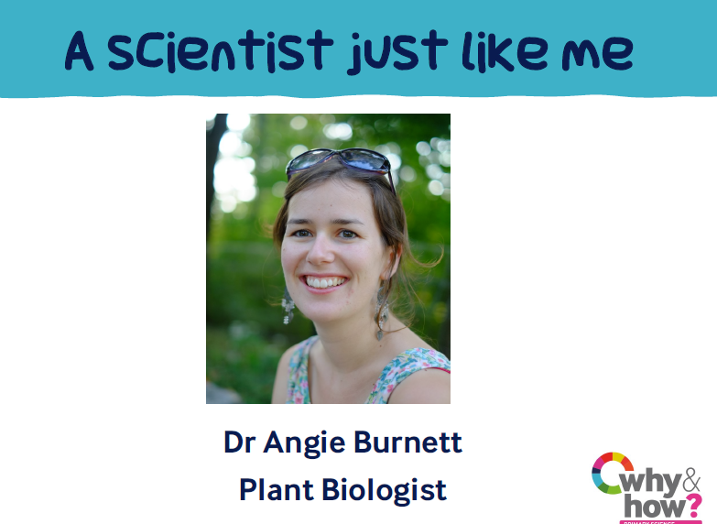
Starter Activity Video: Paper friction – linked to seed dispersal https://www.youtube.com/watch?v=JCM_k3L_LOc&feature=youtu.be
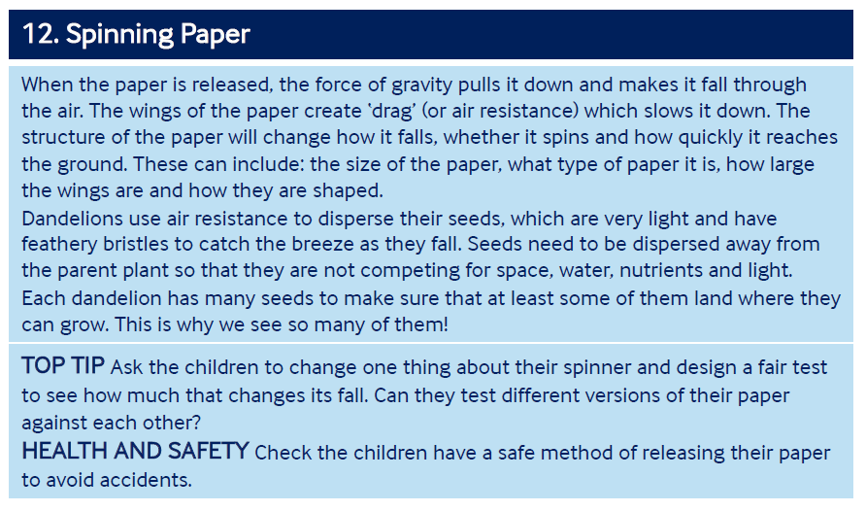

Pictures for talk activity:
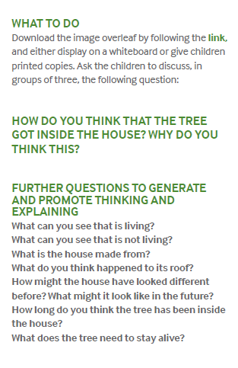
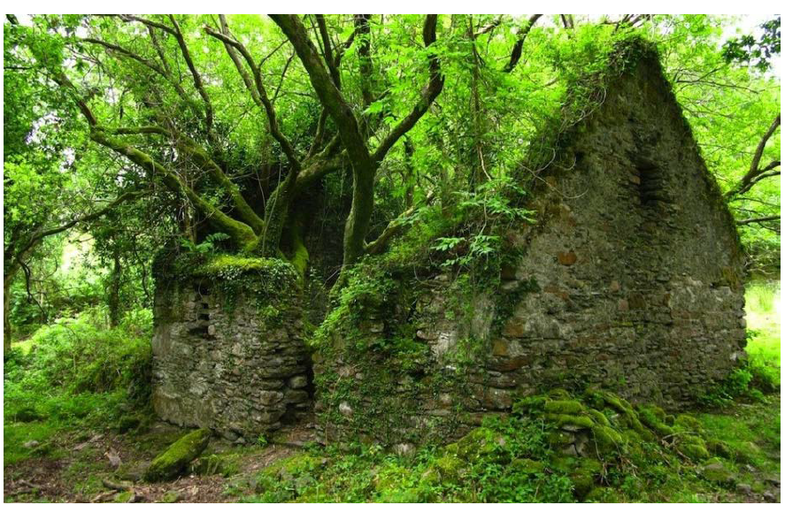

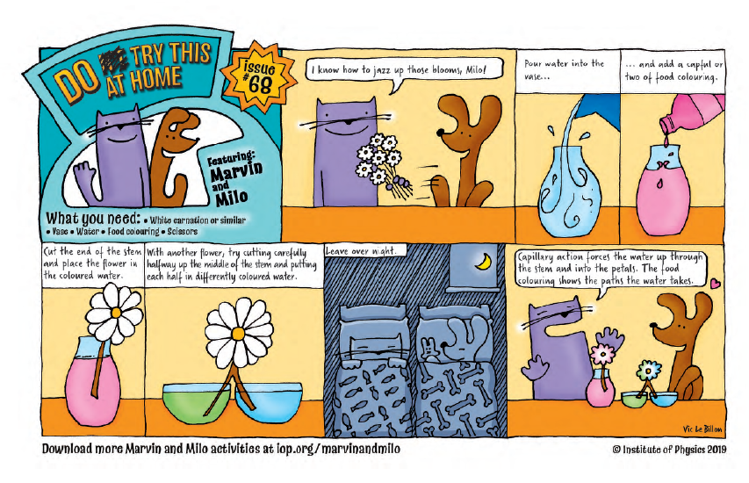
Comparative test enquiries:
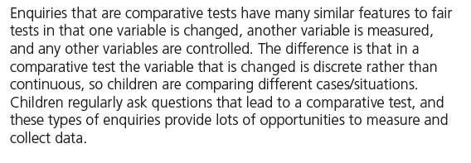
Do cress seeds grow quicker inside or outside?
Which soil absorbs the most water?
Ideas over time enquiries:
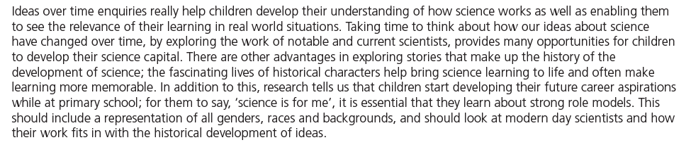
What ideas did the Botanist Arthur Tansley have about habitats in 1935?

Research enquiries:
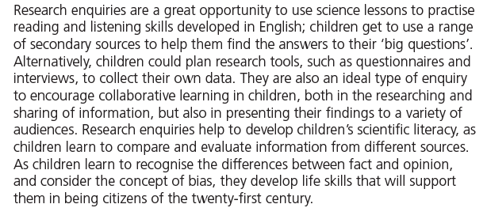
How does a cactus survive in the desert with no water?
Identifying and classifying enquiries:
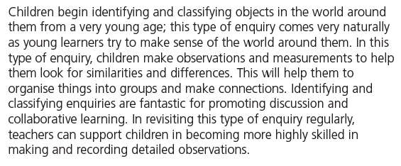
How can we identify the trees in our playground?
How can you group these flowers and animals based on the habitat you would find them in?
Pattern seeking enquiries:
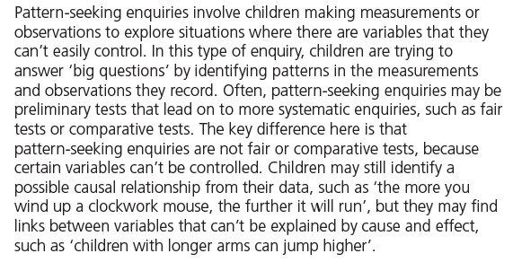
Do bigger seeds grow into bigger plants/flowers?

Observing over time enquiries:
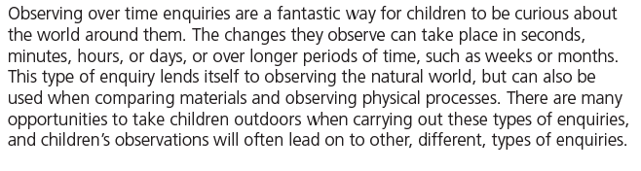
What happens to the seed when I have planted it?

