Year 3 Forces and Magnets –Planning ideas
Real Life links;
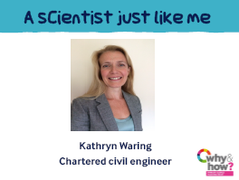
Starter Activity Video: Paper friction
https://www.youtube.com/watch?v=-Pe4qPnesz0&feature=youtu.be
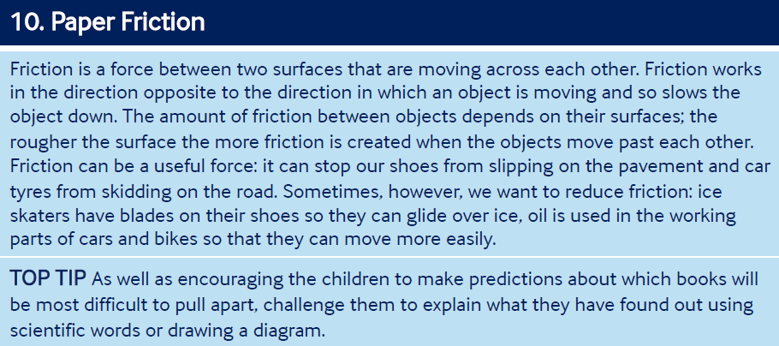

Pictures for talk activity:
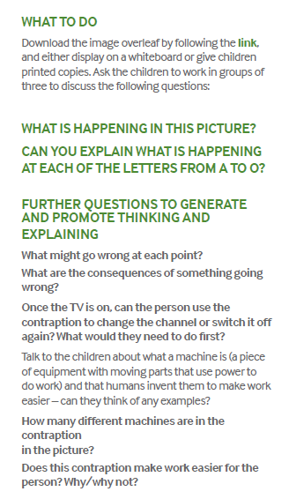
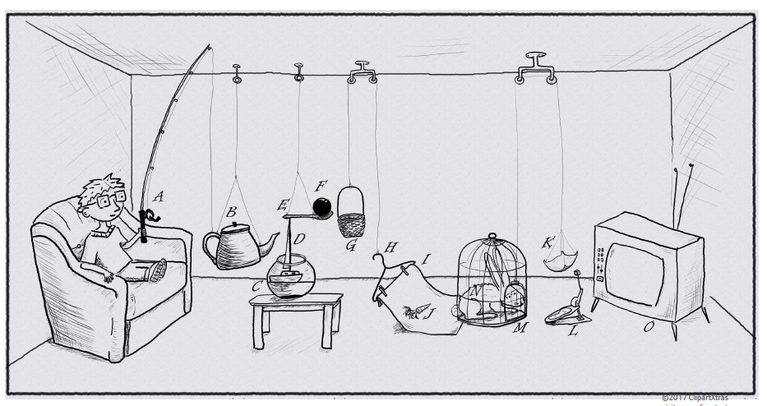

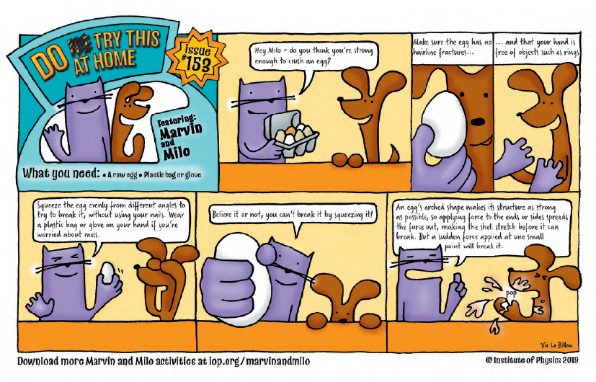
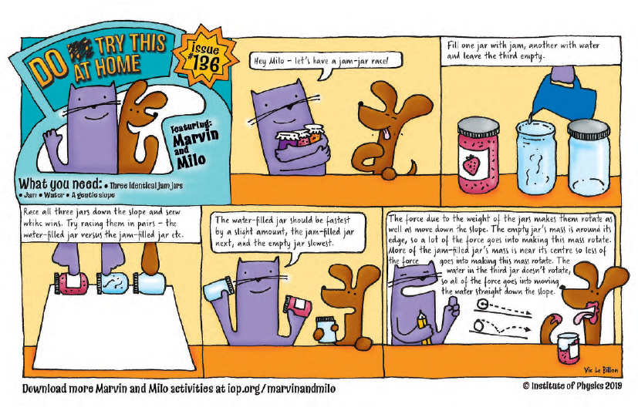
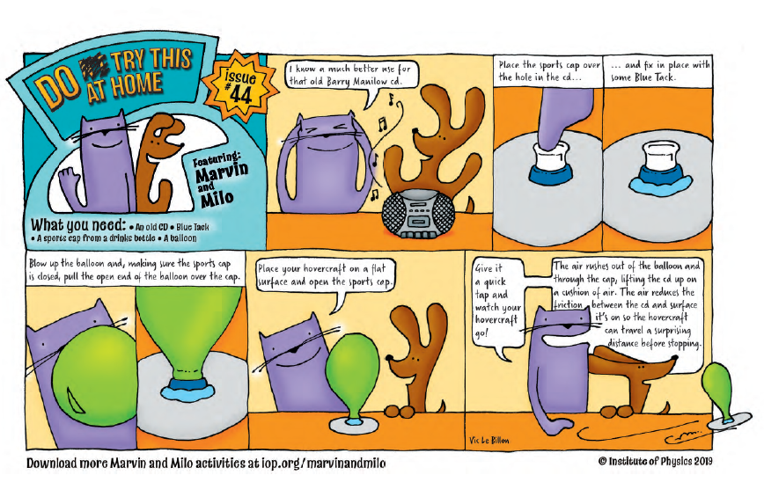
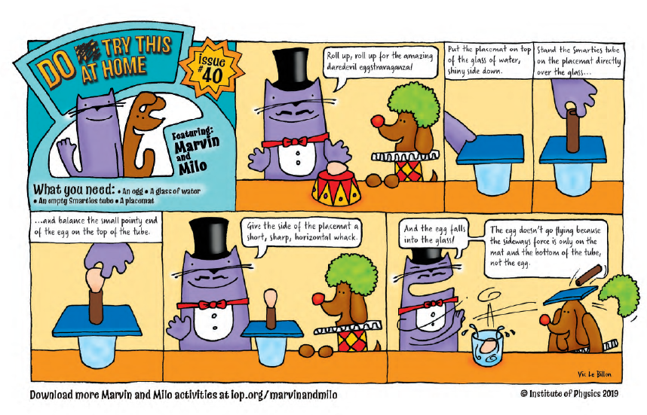
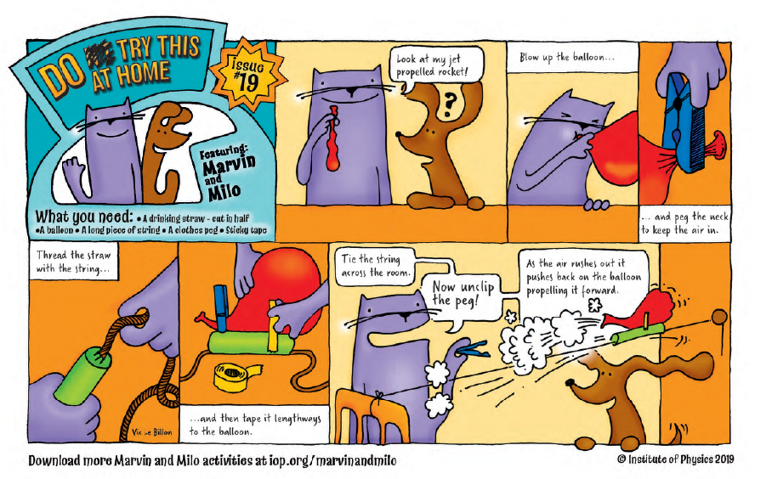
Comparative test enquiries:
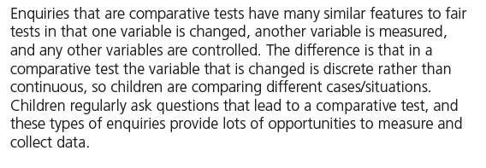
Which magnet is the strongest?
Which surface is the best to stop you slipping?
Ideas over time enquiries:
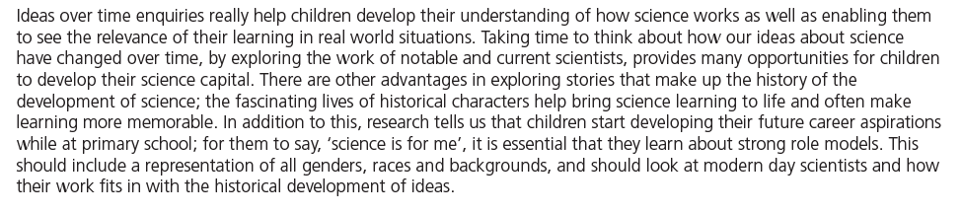
How have ideas about magnets changed over time?

Research enquiries:
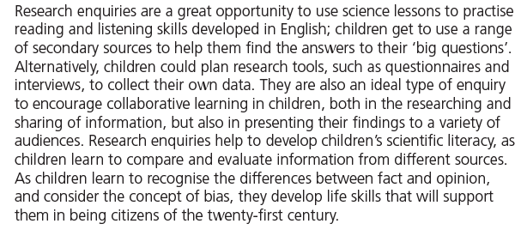
How have our ideas about forces changed over the years?
How does a compass work?
Identifying and classifying enquiries:
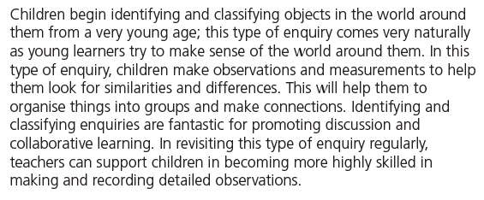
Which materials are magnetic?
Pattern seeking enquiries:
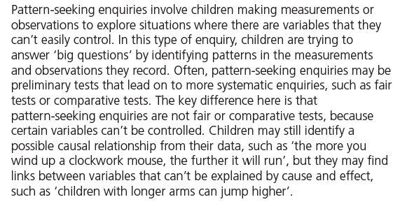
Does the size and shape of a magnet affect how strong it is?
Observing over time enquiries:
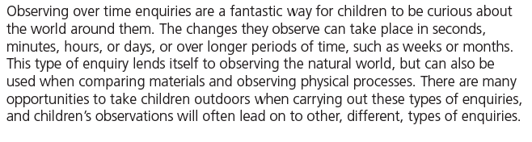
If we magnetise a pin how long will it stay magnetised for?

