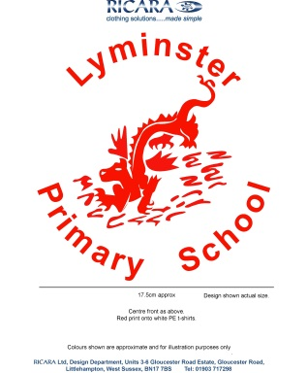 **LYMINSTER PRIMARY SCHOOL**

Wick Street, Littlehampton, West Sussex, BN17 7JZ

www.lyminster.w-sussex.sch.uk

Headteacher: Mr. S. McGinley Telephone No. (01903) 713642

Email: office@lyminster.w-sussex.sch.uk Facsimile No. (01903) 732013

07 October 2025

Dear Parents/Carers,

Welcome back to another exciting half term in Year 3! We have lots of wonderful things planned, as well as a brilliant build up to the Christmas holidays. Below is some information about the coming half term, and a few other important pieces of useful information plus some additional reminders.

**Our Topic: Celebrating Differences**

For our Autumn 2 half term, the children will be looking at self-identity and how we are all different, and yet still part of one world-wide community. The children will be exploring this through our science topic of Animals including humans, as well as our DT and PSHCE topics.

**Dates for your diary**

* **Monday 3rd November –** Autumn 2 begins
* **Monday 3rd November -** Parents Evening bookings open. Book online. Please go into or contact the office if you have any issues
* **Wednesday 12th November –** Parents evening 3:30-6.30pm
* **Thursday 14th November –** Parents evening 3:30-5:00pm
* **Friday 28th November –** INSET DAY – school closed for pupils
* **Wednesday 3rd December –** School Panto
* **Friday 5th December -** KS1 nativity dress rehearsal to KS2
* **Wednesday 10th December –** Christmas Fayre from 3.30pm - more information to come
* **Thursday 11th December –** Christmas Jumper Day, full non-uniform
* **Thursday 18th December –** KS2 Carol Concert 2:30 & 6pm, all children are expected to attend both concerts
* **Friday 19th December –** Last day of term

**Reminders**

* Full P.E. kit needs to be in school every MONDAY and THURSDAY. Please ensure everything is named and that earrings are taken out or that ear tape is in their PE kits to cover them up. If your child wears tights to school please ensure they have a pair of socks in their bag for our lessons.
* As the weather is changing, please ensure your child has a named coat in school. We do try and go outside as much as possible for break and lunch playtimes and it is important to keep dry and warm.
* Homework will continue to be given out every Wednesday and needs to be in school by the following Tuesday. Maths is still being set weekly using MyMaths. If you are having problems logging on or accessing this system please do reach out and speak to one of the Year 3 team.
* Math Magicians will continue to take place in class on a Thursday. The sheets will be sent home in homework books to help children focus on specific times tables areas.

**Reading at Home**

We have been working particularly hard on reading in school and it is great to see this happening at home as well! Reading is a vital part of the children’s education and it is expected that they read ideally every day, whether that is to an adult or by themselves. Reading certificates will be awarded in celebration assemblies for the number of times the children have read and to monitor this the children or adults will need to record this in their reading record, numbering each entry- 1 per day. 50 entries – bronze reading award, 100 entries – silver reading award, 200 entries – gold reading award. Reading records will need to be in the children’s book bags every day for adults in school to record one to one reading.

Our reading comprehension focus this half term is **summarising**. As you read, it is good to pick out key information such as what a character is doing and see if you can explain the book in one sentence.

For children reading chapter books, they may wish to challenge themselves by taking notes about the chapter they have just read to tell you about the ‘key areas’.

And finally, please remember that your role in your child’s education is crucial. If you would like more information, or would like to become more involved in school (e.g. as a reader or as a helper), or if you have any resources such as books you don’t need any more or other resources to offer the school, it is always greatly appreciated.

Thank you for your continued support,

Kind regards,

Mrs Gordon and Mrs Terrill

Year 3 Team