Year 4 Sound –Planning ideas
Real life links;
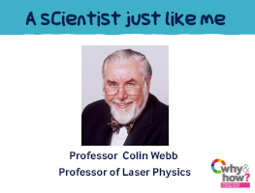
Starter Activity Video: Making Music https://www.youtube.com/watch?v=GmSCzRvyg_0
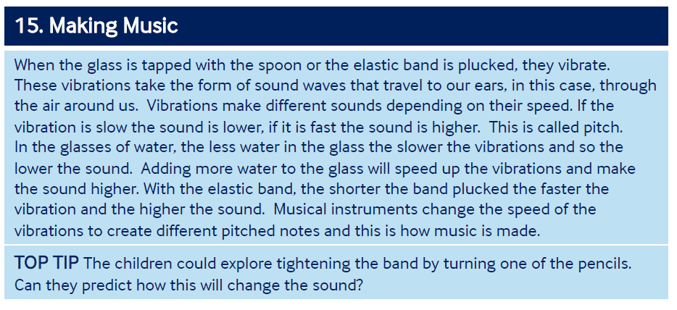

Pictures for talk activity:
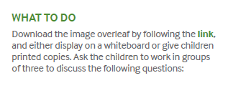
What is going on in this picture? How is the rice moving?
Further questions to generate and promote thinking and explaining.
What will happen when the speaker is turned off? If the volume is turned up will the rice jump higher? What scientific words can you use to describe what is happening? How does sound travel?
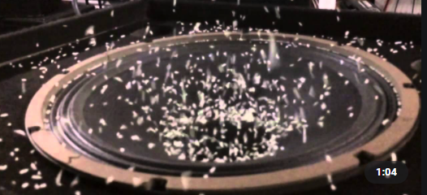
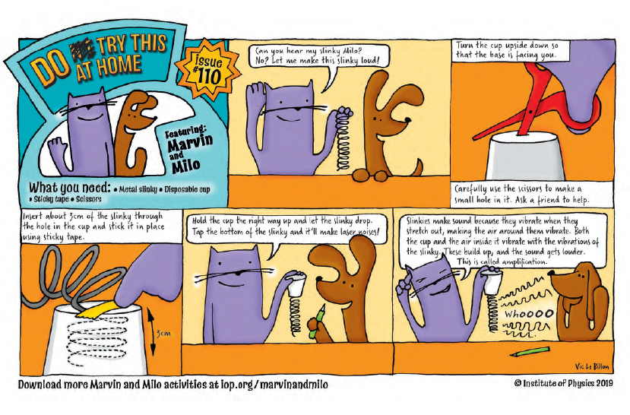
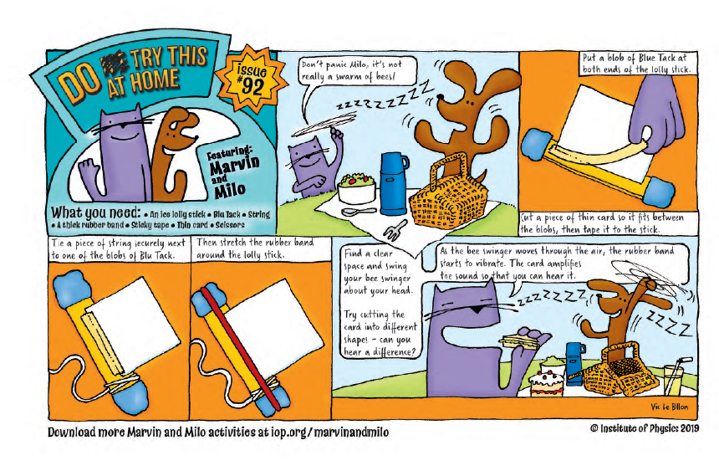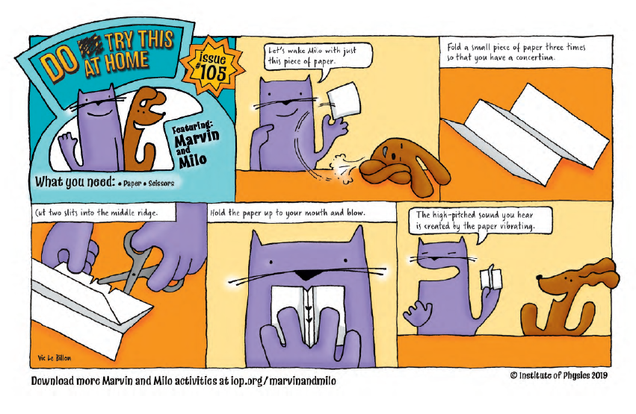
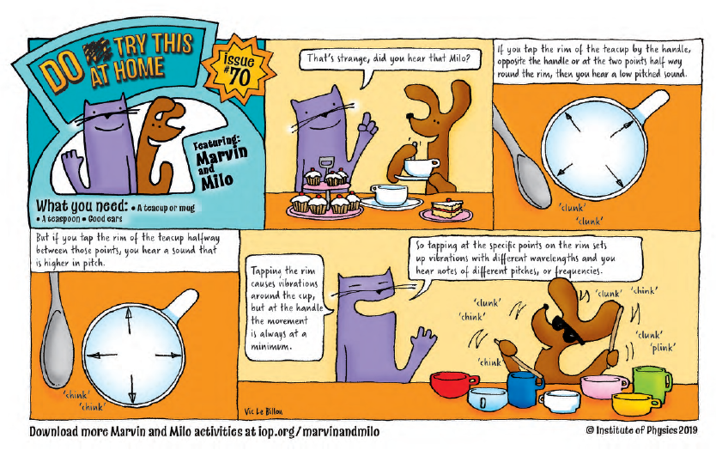
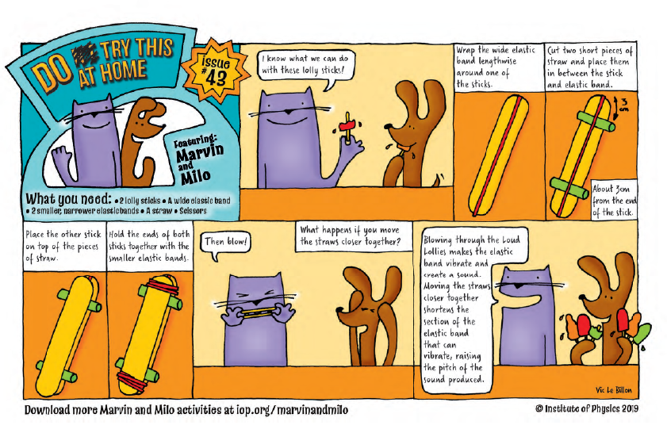
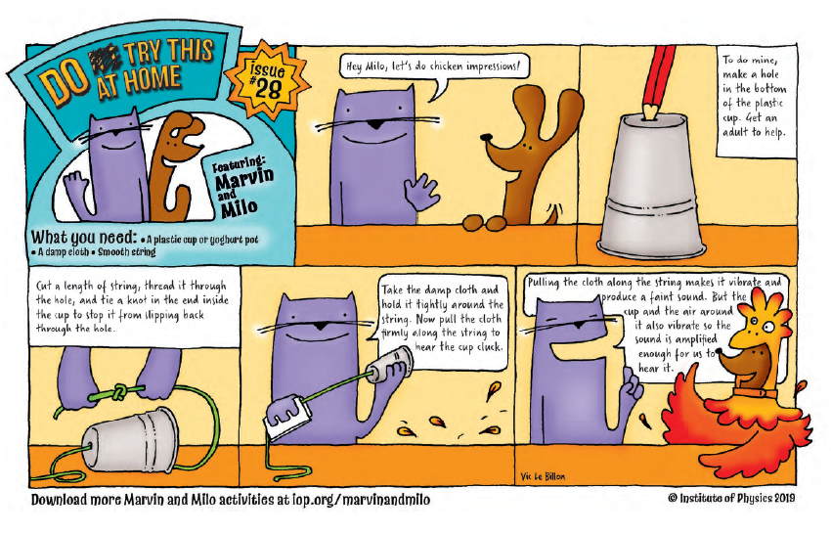
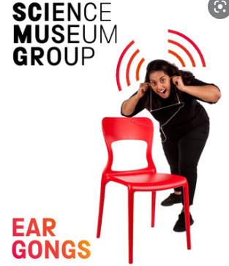

Comparative test enquiries:
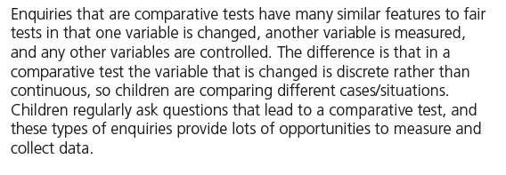
Are two ears better than one?
Which material is the best to use for muffling the sound in ear defenders?
Ideas over time enquiries:
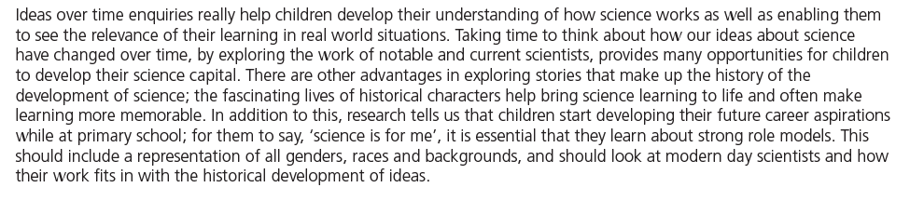
Since the 1800s how has science helped people who are deaf?
Research enquiries:
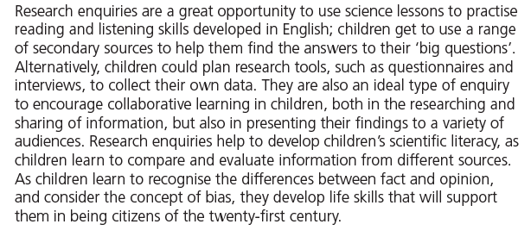
Do all animals have the same hearing range?
Pattern seeking enquiries:
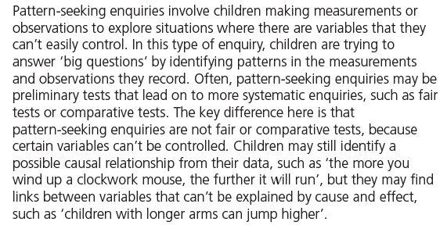
Is there a link between how loud it is in school and the time of the day? If there is a pattern, do you think it will be the same in every school?
Observing over time enquiries:
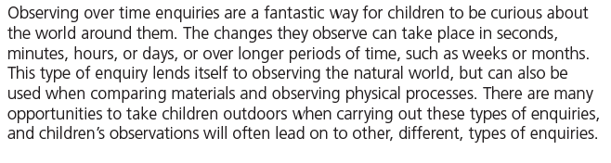
When is our classroom the quietest?

