**Lyminster Primary** **School**

Relationships & Sex Education Policy

Sept 2024 – Sept 2025

|  |  |  |
| --- | --- | --- |
| **Approved by:** | Headteacher |  |
| **Last reviewed on:** | Sept 2024 | |
| **Next review due by:** | Sept 2025 | |

**Contents**

1. Aims 2

2. Statutory requirements 2

3. Policy development 2

4. Definition 3

5. Curriculum 3

6. Delivery of RSE 3

7. Roles and responsibilities 4

8. Parents’ right to withdraw 4

9. Training 4

10. Monitoring arrangements 5

Appendix 1: Curriculum map 6

Appendix 2: Parent form: withdrawal from sex education within RSE 9

**1. Aims**

The aims of relationships and sex education (RSE) at our school are to:

Provide a framework in which sensitive discussions can take place

Prepare pupils for puberty, and give them an understanding of sexual development and the importance of health and hygiene

Help pupils develop feelings of self-respect, confidence and empathy

Create a positive culture around issues of sexuality and relationships

Teach pupils the correct vocabulary to describe themselves and their bodies

Help to safeguard the pupils against abuse

In line with our school values, to give the children confidence in themselves and the changes that will take place, as well as care and kindness towards others as they change

**2. Statutory requirements**

As a maintained primary school we must provide relationships education to all pupils as per section 34 of the [Children and Social work act 2017.](http://www.legislation.gov.uk/ukpga/2017/16/section/34/enacted)

However, we are not required to provide sex education but we do need to teach the elements of sex education contained in the science curriculum.

In teaching RSE, we must have regard to [guidance](https://www.gov.uk/government/consultations/relationships-and-sex-education-and-health-education) issued by the secretary of state as outlined in section 403 of the [Education Act 1996.](http://www.legislation.gov.uk/ukpga/1996/56/contents)

At Lyminster Primary School we teach RSE as set out in this policy.

**3. Policy development**

This policy has been developed in consultation with staff, pupils and parents. The consultation and policy development process involved the following steps:

1. Review – a member of staff or working group pulled together all relevant information including relevant national and local guidance
2. Staff consultation – all school staff were given the opportunity to look at the policy and make recommendations
3. Parent/stakeholder consultation – parents and any interested parties were invited to attend a meeting about the policy
4. Pupil consultation (Years 5 & 6) – we investigated what exactly pupils want from their RSE
5. Ratification – once amendments were made, the policy was shared with governors and ratified

**4. Definition**

RSE is about the emotional, social and cultural development of pupils, and involves learning about relationships, sexual health, sexuality, healthy lifestyles, diversity and personal identity.

RSE involves a combination of sharing information, and exploring issues and values.

RSE is not about the promotion of sexual activity.

**5. Curriculum**

Our curriculum is set out as per Appendix 1 but we may need to adapt it as and when necessary.

We have developed the curriculum in consultation with parents, pupils and staff, taking into account the age, needs and feelings of pupils. If pupils ask questions outside the scope of this policy, teachers will respond in an appropriate manner so they are fully informed and don’t seek answers online.

Primary sex education will focus on:

Preparing boys and girls for the changes that adolescence brings

How a baby is conceived and born

Starting to develop an understanding of rights and responsibilities around sex and sexuality

For more information about our curriculum, see our curriculum map in Appendix 1.

**6. Delivery of RSE**

RSE is taught within the personal, social, health and economic (PSHE) education curriculum. Some biological aspects of RSE are taught within the science curriculum, and other aspects are included in religious education (RE).

Pupils in Years 5 and 6 also receive stand-alone sex education sessions delivered by a senior member of staff.

Relationships education focuses on teaching the fundamental building blocks and characteristics of positive relationships including:

Families and people who care for me

Caring friendships

Respectful relationships

Online relationships

Being safe

We mainly use the Jigsaw Scheme of Work for PSHCE, including RSE, and for more information about our RSE curriculum, see Appendix 1, as well as the relevant section of our school website.

These areas of learning are taught within the context of family life taking care to ensure that there is no stigmatisation of children based on their home circumstances (families can include single parent families, LGBT+ parents, families headed by grandparents, adoptive parents, foster parents/carers amongst other structures) along with reflecting sensitively that some children may have a different structure of support around them (for example: looked after children or young carers).

**7. Roles and responsibilities**

**7.1 The governing board**

The governing board will approve the RSE policy, and hold the headteacher to account for its implementation.

**7.2 The headteacher**

The headteacher is responsible for ensuring that RSE is taught consistently across the school, and for managing requests to withdraw pupils from non-statutory components of RSE (see section 8).

**7.3 Staff**

Staff (class teachers) are responsible for:

Delivering RSE in a sensitive way

Modelling positive attitudes to RSE

Monitoring progress

Responding to the needs of individual pupils

Responding appropriately to pupils whose parents wish them to be withdrawn from the non-statutory components of RSE

Staff do not have the right to opt out of teaching RSE. Staff who have concerns about teaching RSE are encouraged to discuss this with the headteacher.

**7.4 Pupils**

Pupils are expected to engage fully in RSE and, when discussing issues related to RSE, treat others with respect and sensitivity.

**8. Parents’ right to withdraw**

Parents do not have the right to withdraw their children from relationships education.

Parents have the right to withdraw their children from the non-statutory components of sex education within RSE.

Requests for withdrawal should be put in writing using the form found in Appendix 3 of this policy and addressed to the headteacher.

Alternative work will be given to pupils who are withdrawn from sex education.

**9. Training**

The delivery of RSE is included in our teachers’ continuing professional development calendar.

The headteacher will also invite visitors from outside the school, such as school nurses or sexual health professionals, if required/requested to provide support and training to staff teaching RSE.

**10. Monitoring arrangements**

The delivery of RSE is monitored by Steve McGinley, Headteacher through pupil, parent & staff voice/feedback, as well as lesson drop-ins.

Pupils’ development in RSE is monitored by class teachers as part of our internal assessment systems.

This policy will be reviewed by Steve McGinley, Headteacher. At every review, the policy will be approved by the governing body.

**Appendix 1: Curriculum map**

We use the Jigsaw scheme of work for all aspects of PSHCE eductaion, including RSE, and more information about this scheme can be found here: [www.jigsawpshe.com](http://www.jigsawpshe.com)

Additional materials are used in Years 5 and 6 for the enhanced sessions on sexual harassment, violence and exploitation (NSPCC lesson planning and resources). These are shared with parents in advance. Additional materials are also used for the enhanced sessions on puberty, sex and sexuality in the Summer Term. For Year 6 only, this also includes a brief discussion on intercourse with an animated (internal) example, for the purposes of ensuring the children can recognise abuse in this form. These materials are shared with parents in advance of their use.

The Realtionship Education aspect is mainly delivered in Summer 1, and the Sex Education aspect in Summer 2. More information on this, including what is covered in each year group as part of the PSHCE lessons, can be found in the curriculum map below:

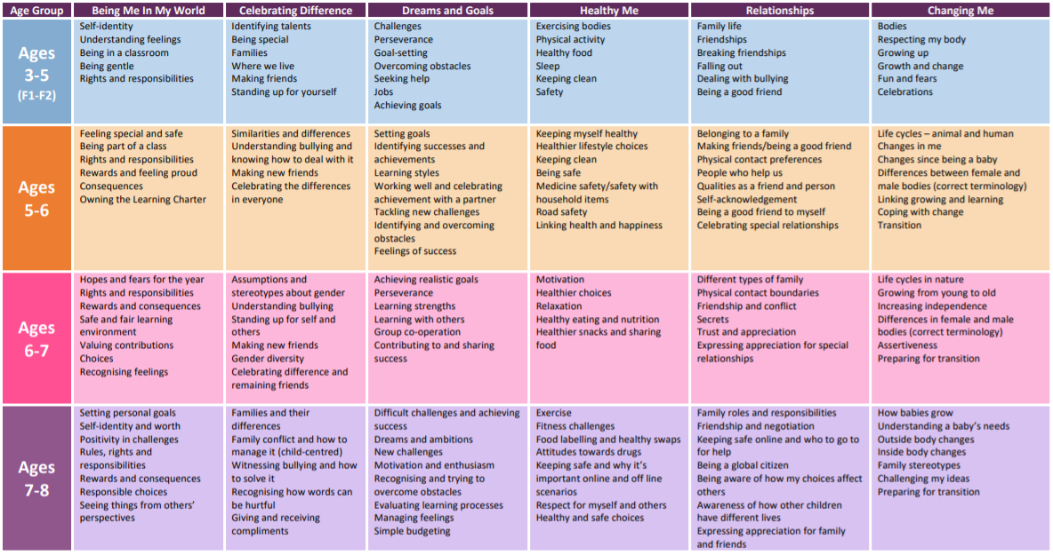

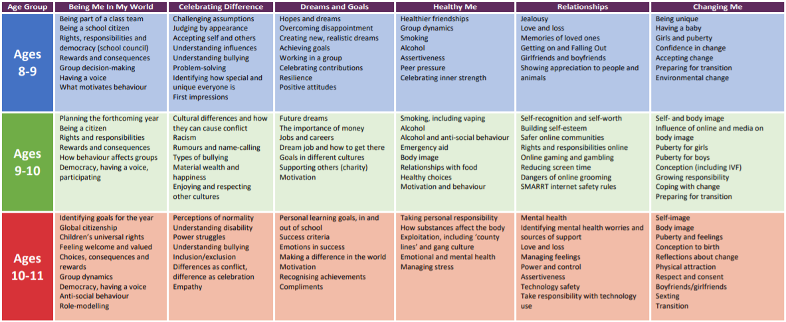

**Appendix 2: Parent form: withdrawal from sex education within RSE**

| To be completed by parents | | | |
| --- | --- | --- | --- |
| Name of child |  | Class |  |
| Name of parent |  | Date |  |
| Reason for withdrawing from sex education within relationships and sex education | | | |
|  | | | |
| Any other information you would like the school to consider | | | |
|  | | | |
| Parent signature |  | | |

| To be completed by the school | |
| --- | --- |
| Agreed actions from discussion with parents | *Include notes from discussions with parents and agreed actions taken.*  *Eg: Joe Bloggs will be taking part in all relationships lessons and during the sex education lessons, he will be working independently on a project in the Year 5 classroom* |
|  |  |