Reading At LMPS – Everyone a Reader!

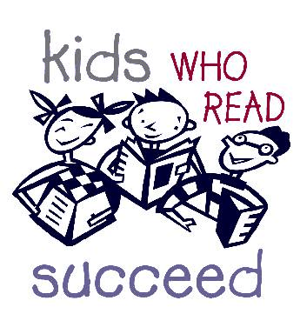Supporting our children to be confident and fluent readers is a vital objective for all children at LMPS. We understand how reading supports our learners in so many ways, including:

* building language skills
* developing vocabulary
* supporting self-expression
* providing direct knowledge
* supporting social learning
* developing attention and focus
* supporting wellbeing
* developing critical thinking
* supporting memory function
* building self-confidence
* supporting emotional literacy and empathy
* fostering creativity
* developing an understanding of different cultures and traditions
* providing an opportunity for parents and children to connect

We support our children to be fluent readers, with the requisite skills to decode the texts that they read. We also understand that children have to be supported in relation to their language comprehension and that it is both of these elements intertwined that make for a successful and confident reader.

Reading is an absolute priority in our curriculum from the Early Years all the way through the school. We also prioritise supporting the children to love to read through activities to promote reading for pleasure as we aspire for all of our pupils to be lifelong readers.

Fluency

We define reading fluency as:

‘reading with accuracy (reading words correctly), automaticity (reading words at an appropriate speed without great effort) and prosody (appropriate stress and intonation).’

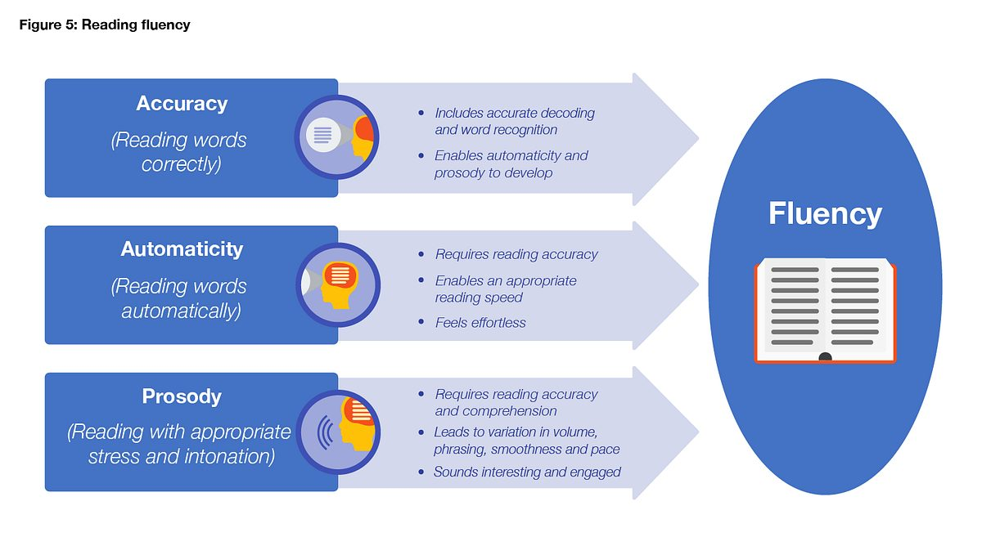

All children begin their reading journey to fluency through exposure to early reading opportunities and engagement in the ‘Read, Write, Inc’ (‘RWI’) phonics programme from the early years. This means that they learn how to ‘read’ the sounds in words and how those sounds can be written down. We teach the children simple ways of remembering these sounds and letters in line with the methodology of the programme.

Children progress through the Set 1, 2 and 3 sounds to develop confidence in decoding these sounds and blending sounds together to read words. The progression of the sounds as they are taught in school as well as how to pronounce these sounds is set out in Appendix 1.

As well as learning to read and blend real words, children will have plenty of opportunities to apply their sound recognition skills on reading ‘Nonsense words’. This helps us to assess how secure the children are using the sounds that they have learned and how effective their blending of these sounds is.

Children will be introduced to ‘Ditty books’ when they successfully begin to read single words. Children use sound-blending (Fred Talk) to read short ditties. They will bring these home once they have read and discussed the book in class. Children will then be challenged to use their developing phonic knowledge to write short sentences.

Within all the RWI books, children will have **red** and **green** words to learn to help them to fluent speedy readers. **Red** words are words that are not easily decodable and challenge words to extend children’s vocabulary. **Green**words are linked to the sounds they have been learning and are easily decodable.

When using RWI to read the children will:

* A collection of colorful children's books

  AI-generated content may be incorrect.learn 44 sounds and the corresponding letter/letter groups using simple picture prompts
* learn to read words using Fred Talk
* read lively stories competently featuring words they have learned to sound out
* show that they comprehend the stories by answering questions.
* learn to write the letters/letter groups which represent 44 sounds, using a helpful handwriting phrase.
* learn to write words by saying the sounds using 'Fred Fingers'

The children practise their reading with books that match the phonics and the ‘tricky words’ they know, both at school and at home. We promote reading confidence by allowing them to success and think that they *can* read through access to appropriate reading materials.

As pupils progress through the school, their independent reading book will change to a ‘book banded’ book using the Collins scheme (see Appendix 2). Again, this is to ensure that the children have access to reading books that they can access and read independently to support their fluency and comprehension. Once they have progressed through this scheme, children move onto non-scheme literature where access is provided to a wide range of books, both fiction and non-fiction, to support both a love of reading and language development.

Fluency continues to be considered as children transition through into Key Stage Two, where pupils are assessed on their reading fluency through 1:1 and group reading as well as through the use of technology. This information is used to channel support to children where required to support them to develop their reading fluency.

LMPS has a language acquisition specialist who runs group intervention and support for any pupil significantly behind in their reading in Key Stage Two, providing intensive catch-up support in addition to that provided by class teachers and teaching assistants. We also utilise an alternative reading scheme for less confident readers in school (see Appendix 2). The aim of this is to support continued positive engagement in reading through the provision of appropriate reading materials to all pupils.

We further promote reading through whole class reading, both with texts matched to the curriculum that are read together and by adults reading a variety of literature, including stories, poems and non-fiction texts, to the children. This exposure allows for different types of language to experienced as well as for children to hear the rhythm and metre of this language, supporting children with reading prosody. These opportunities also further widen children’s vocabulary, as well as their general knowledge.

Comprehension

We define reading comprehension in the context of learning as:

‘Reading comprehension strategies focus on the learners’ understanding of written text. Pupils learn a range of techniques which enable them to comprehend the meaning of what they read. These can include: inferring meaning from context; summarising or identifying key points; using graphic or semantic organisers; developing questioning strategies; and monitoring their own comprehension and then identifying and resolving difficulties for themselves (see also [metacognition and self-regulation](https://educationendowmentfoundation.org.uk/education-evidence/teaching-learning-toolkit/metacognition-and-self-regulation)).’ Education Endowment Foundation

The teaching of comprehension is woven into our reading curriculum and occurs throughout pupils’ reading education, from the Early Years up to when the children leave us in Year 6. We comprehensively cover National Curriculum Objectives across the school through reading lessons, focussing on the key skills and understanding as stated.

This development is supported through the use of the ‘VIPERS’ strategy with children to support their understanding of different reading skills:

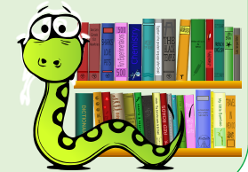V - Vocabulary

I - Infer

P - Predict

E - Explain

R - Retrieve

S – Summarise

We understand the direct link between reading ability and writing ability and utilise a ‘reading into writing’ approach in order to support children’s language development. Part of this approach is the use of class core texts where vocabulary, structure and content is analysed and utilised within the teaching of writing.

The regular use of shared texts within the curriculum also further supports vocabulary development and knowledge acquisition, as well as allowing for links to be actively developed to learning across other subjects.

Love Of Reading

We aim for all children to leave our school as not only capable and confident readers, but also who read for pleasure. We support positive reading habits through a variety of actions, including:

* Carefully designed reading sections in each classroom with engaging texts which are both appealing and accessible for children.
* ‘First Chapter Friday’ reading of texts to raise curiosity and interest in a variety of authors books.
* Sharing of children’s recommendations for what to read.
* Acting on children's requests for literature within the classroom.
* Providing regular access to a well-stocked school library.
* Allowing children time to immerse themselves in reading independently.
* Adults modelling reading to children and sharing what they themselves are reading.

**Appendix 1 – Progression of sounds taught through the Read Write Inc programme**

The children are taught the sounds in 3 sets.

Step 1:

**Set 1 Sounds**are taught in the following order together with rhymes to help children form the letters correctly and instantly recognise sounds ready for blending.

|  |  |
| --- | --- |
| **Set 1** | |
| **Sound** | **Rhyme** |
| **m** | Down Maisie then over the two mountains. Maisie, mountain, mountain. |
| **a** | Round the apple, down the leaf. |
| **s** | Slither down the snake |
| **d** | Round the dinosaur's back, up his neck and down to his feet. |
| **t** | Down the tower, across the tower, |
| **i** | Down the insects body, dot for the head. |
| **n** | Down Nobby and over the net. |
| **p** | Down the plait, up and over the pirates face. |
| **g** | Round the girls face, down her hair and give her a curl |
| **o** | All around the orange |
| **c** | Curl around the caterpillar |
| **k** | Down the kangaroos body, tail and leg |
| **u** | Down and under the umbrella, up to the top and draw a puddle |
| **b** | Down the laces, to hell, round the toe |
| **f** | Down the stem and draw the leaves |
| **e** | Lift off the top and scoop out the egg |
| **l** | Down the long leg |
| **h** | Down the horse's head to the hooves and over his back |
| **sh** | Slither down the snake, then down the horse's head to the hooves and over his back |
| **r** | Down the robot's back, then curl over his arm |
| **j** | Down his body, curl and dot |
| **v** | Down a wing, up a wing |
| **y** | Down a horn, up a horn and under the yak's head. |
| **w** | Down, up, down, up the worm. |
| **th** | Down the tower, across the tower, then down the horse’s head to the hooves and over his back |
| **z** | Zig-zag-zig, down the zip. |
| **ch** | Curl around the caterpillar, , then down the horse's head to the hooves and over his back |
| **qu** | Round the queen’s head, up past her earrings and down her hair |
| **x** | Down the arm and leg, repeat the other side |
| **ng** | A thing on a string |
| **nk** | I think I stink |

Step 2:

The children are then taught **Set 2 Sounds**- the long vowels. When they are very confident with all of set 1 and 2 they are taught **Set 3 Sounds.**

|  |  |  |  |
| --- | --- | --- | --- |
| Long  vowel sound | **Set 2 Speed Sound cards** | **Set 3 Speed Sound cards** | |
| ay | ay: may I play | a-e: make a cake | ai: snail in the rain |
| ee | ee: what can you see | ea: cup of tea | e: he me we she be |
| igh | igh: fly high | i-e: nice smile | |
| ow | ow: blow the snow | o-e: phone home | ao: goat in a boat |
| oo | oo: poo at the zoo | u-e: huge brute | ew: chew the stew |
| oo | oo: look at a book |  |  |
| ar | ar: start the car |  |  |
| or | or: shut the door | aw: yawn at dawn |  |
| air | air: that’s not fair | are: share and care |  |
| ir | ir: whirl and twirl | ur: nurse for a purse | er: a better letter |
| ou | ou: shout it out | ow: brown cow |  |
| oy | oy: toy for a boy | oi: spoil the boy |  |
| ire |  | ire: fire fire! |  |
| ear |  | ear: hear with your ear |  |
| ure |  | ure: sure it’s pure? |  |

**Appendix 2 – progression in Collins Reading Scheme**

|  |  |  |
| --- | --- | --- |
| **Book Colour** | **Scheme** | **Approximate Year group/age** |
| Blending booklets | **RWI** | Reception 4-5 |
| Red- Ditty | **RWI** | Reception 4-5 |
| Green | **RWI** | Reception 4-5 |
| Purple | **RWI** | Reception 4-5 |
| Pink | **RWI** | Reception 4-5 |
| Orange | **RWI** | Year 1- 5-6 |
| Yellow | **RWI** | Year 1- 5-6 |
| Blue | **RWI** | Year 1- 5-6 |
| Grey | **RWI** | Year 1- 5-6 |
| Gold | **Collins Big Cat** | Year 2  6-7   (Move onto Gold when completed RWI scheme) They don’t have to stay long on this colour if fluent and have good comprehension.  Year 2 |
| White | **Collins Big Cat** |
| Lime | **Collins Big Cat** |
| Copper | **Collins Big Cat** | Year 3  7-8    Dandelion Scheme for catch up if needed |
| Topaz | **Collins Big Cat** |
| Ruby | **Collins Big Cat** | Year 4  8-9  Dandelion Scheme for catch up if needed |
| Emerald | **Collins Big Cat** |
| Sapphire | **Collins Big Cat** | Year 5/6  9-11  Fresh Start RWI phonic interventions |
| Diamond | **Collins Big Cat** |
| Pearl | **Collins Big Cat** |
| Non Scheme    ‘free reading’ | **Non Scheme** | Year 5  9-10 10-11 (advanced literature available from library- see LS if needed)  <https://schoolreadinglist.co.uk/reading-lists-for-ks2-school-pupils/suggested-reading-list-for-year-5-pupils-ks2-age-9-10/>    Year 6  10-11 (advanced literature available from library- see LS if needed)    Other texts suggested for year 6  <https://schoolreadinglist.co.uk/reading-lists-for-ks2-school-pupils/suggested-reading-list-for-year-6-pupils-ks2-age-10-11/>    Suggested list for Year 7  <https://schoolreadinglist.co.uk/reading-lists-for-ks3-pupils/suggested-reading-list-for-year-7-pupils-ks2-age-11-12/> |
|  |

|  |  |  |
| --- | --- | --- |
| **Alternative Schemes of Books for Less Confident Readers** | | |
| Catch up readers Years 3/4 | Dandelion Catch Up Readers | Books to support children who have not completed the RWI at the end of KS1.  Some children may benefit from continuing with RWI scheme and some may need to do this scheme. |
| Progress Readers  Text Level/Age Level | Collins Big Cats | Books to support less confident readers with more advanced topics.  Text coloured/ Age level |
| Little Gem Dyslexia friendly texts  (Gold level to Lime) | Little Gems | Books written to support children with Dyslexia |