**Remote Learning Day Two**

**Maths- WALT find square and cube numbers**

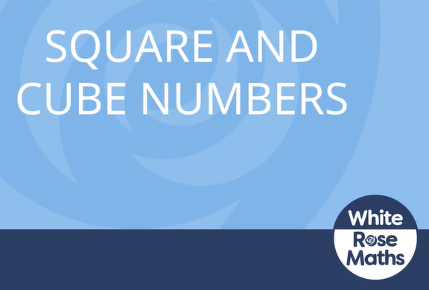

[Y6 Autumn Block 2 TS6 Square and cube numbers on Vimeo](https://vimeo.com/731430626) – video link

Questions and answers below

**English – WALT read and understand Charles Dickens**

Text and questions below

**SPaG – WALT answer question**

Choose a SPAG activity and complete

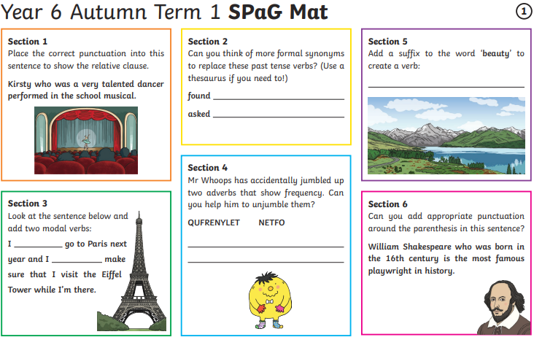

**French – WALT to describe ourselves**

[Lesson: Saying your name, age and birthday and describing yourself | KS2 French | Oak National Academy (thenational.academy)](https://www.thenational.academy/teachers/programmes/french-primary-ks2-l/units/cest-moi-b60c/lessons/saying-your-name-age-and-birthday-and-describing-yourself-74w36d#slide-deck)

**Music – WALT recognise the melody**

[Recognising melody (thenational.academy)](https://classroom.thenational.academy/lessons/recognising-melody-c8v3jd?utm_source=email&utm_medium=email&utm_campaign=sharing-button)