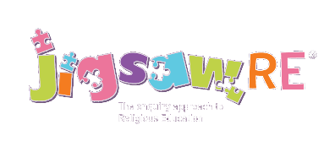
LMPS Skills Ladder

Working At” Expectation  Most children are expected to reach these: | Green Descriptors:  Personal resonance with or reflection on the concept/belief underlying the subject matter of the enquiry.  The child’s own thoughts, opinions, belief, empathy.  (Personal development) | Blue Descriptors:  Knowledge and understanding of the subject matter of that enquiry (substantive/ subject knowledge) | Red Descriptors  Skills of evaluation, research, critical thinking in relation to the enquiry question (disciplinary knowledge)
Age 7 | I can tell you/talk about what concepts like belonging, commitment, kindness, forgiveness, sacrifice, belief mean to me in my world.  I can verbalise and/or express my own thoughts and feelings. | I can recall knowledge about the worldviews I have studied, begin to use the religious vocabulary and start to explain the significance and meaning of the learning, practices etc. | I can start to think through the enquiry question using some knowledge and am beginning to see there could be more than one answer.
Age 9 | I can tell you/talk about the concept/belief e.g. belonging and start to relate this to the worldview I am studying e.g. Jews  I can express my own opinions and start to support them with rationales. | I can recall knowledge about the worldviews I have studied, select the knowledge that is most significant to the enquiry and start to explain its relevance and importance. | I can apply my knowledge to the enquiry question and give an answer supported by my one or more elements of the knowledge gained in the enquiry from appropriate sources.
Age 11 | I can explain how this concept/belief e.g. forgiveness resonates in my own life and can also see this might be different for other people because of their worldview.  I can express my own thoughts and feelings, having reflected on them | I can recall knowledge about worldviews and explain differences in practice and interpretation within and between worldviews. | I can weigh up evidence from different sources and consider different aspects, the diversity of different beliefs and the knowledge learnt in the enquiry and express my answer supported by evidence and/or a rationale.

