OPTIONS CHOICES 2024-2026

PURPLE PATHWAY

PUPIL NAME: FORM:
You MUST choose

GEOGRAPHY
or
HISTORY

Rank order 3 subjects 1-3 with 1 being your favourite, you will be allocated TWO subjects only.

ART & DESIGN
CREATIVE iMEDIA
DRAMA
FOOD PREPARATION & NUTRITION
BTEC HEALTH & SOCIAL CARE
BTEC TECH AWARD LEVEL 1 & 2 ENTERPRISE
MUSIC
PHOTOGRAPHY
PHYSICAL EDUCATION GCSE
RELIGIOUS STUDIES
TECHNOLOGY
SPANISH*
(*must be agreed in advance –
please discuss with your Spanish teacher)

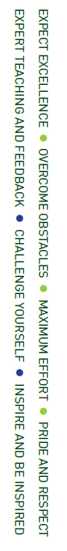

OPTIONS INFORMATION REPLY FORM 2024
Students: Please make sure that you select a range of different subjects, giving you a variety of skills for when you leave Madeley School in 2026.

Name: Form:

Students:
- Do you have any thoughts on a future career? If yes, then briefly describe what it is.

- Briefly explain why you have selected your pathway and subjects.

Signed: (Student)

Parents / Carers

I can confirm that I have discussed the options with my child (name) and agree with their choices.

Signed: (Parent / Carer)

Form Tutor

I can confirm that, having reviewed the teachers’ recommendations and relevant data, and having discussed this with the student, the Option Pathway and subjects selected are suitable / not suitable for
(name) and recommend that no changes / the following changes are made:

Signed: (Form Tutor)

SENCo referral (if applicable) – please tick

Senior Member of Staff Consultation

I can confirm that I have discussed the Option Pathway and subject with and confirm that no changes / the following changes are to be made:

Signed: (SLT Member)

