

6th September 2024
Dear Parents and Teachers
I Would like to say a warm welcome back to a new school year, I hope you all had a great Summer. I would like to remind you of my fellow PTFA members who carry out specific jobs within the PTFA.
Chair Lisa Smith lisasmithptfa@gmail.com
Vice Chair Rachel Hobson rachelhobsonptfa@gmail.com
Treasurer Keith Garrity keithgarrityptfa@gmail.com
Secretary Jenny Garrity-Searle jennygsptfa@gmail.com
The PTFA looks forward to all the exciting new projects that this year brings and hopes to have your continued support in the run up to these events. Throughout the school year the PTFA have many events planned including, Children’s Fun Days, Autumn, Christmas and Summer Fayres, Bingo Nights, Quiz Nights and Discos.
The PTFA is a non-profit all volunteer association which is run by parents and teachers just like you to benefit all the Children here at Maharishi Primary and Secondary School. Our Role in partnership with the school and parents is to enhance the educational experience and wellbeing of the children. The PTFA does this by providing resources and activities for the children as well as augmenting the facilities for the children’s use.
We hope you get involved with the PTFA as much as you are able and help support all the things we do to raise much needed funds for our school.
We would like to introduce a communication group which will help with organised events, PTFA communication and newsletters to keep you up to date. Classlist is GDPR compliant, there is no need to share your personal details to access this communication group called Classlists, many of the parents and carers have already signed up and we greatly appreciate that, if you have still yet to sign up please scan the QR code at the bottom of this letter.
We have a new easy fundraising page that you can help raise funds by simply shopping as you would normally online and every purchase you make gives a donation to our school PTFA. Please scan the QR code at the bottom of this letter to sign up and start raising free much needed funds.
We Also have a new School Lottery which we hope many of our friends and family will sign up to with the chance to win cash prizes every week. Sign up details will be posted on Classlist.
We hold regular PTFA meetings throughout the year, our next meeting is Thursday 19th September 2024 at 4.15PM in the High school, Woodley Park Road, please come along and join us. (children welcome)
We understand there is a lot of information in this letter and would like to thank you for your continued support.
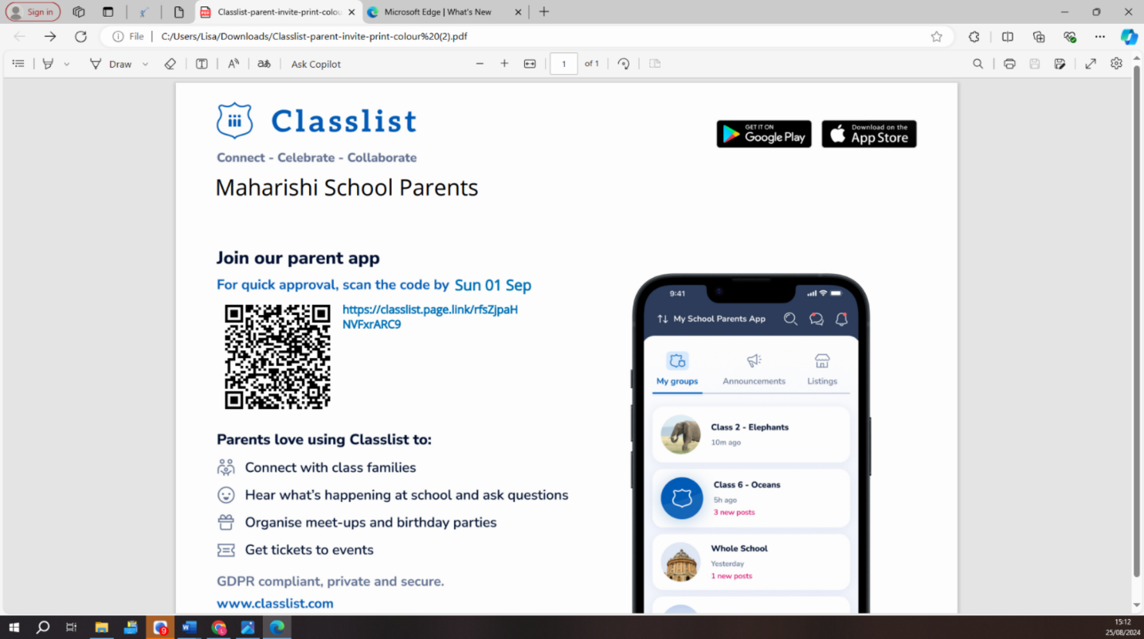

Please do not hesitate to get in touch, by emailing me or the PTFA school email maharishischoolptfa@gmail.com, if you have any queries or ideas.
Thank you for your support!
Lisa Smith PTFA Chair
Classlist
Easyfundraising
lisasmithptfa@gmail.com

Maharishi School Parent  Teacher and Friends Association | Cobbs Brow Lane, Lathom, Ormskirk  L40 6JJ | T: 01695 729912  E: maharishischoolptfa@gmail.com

