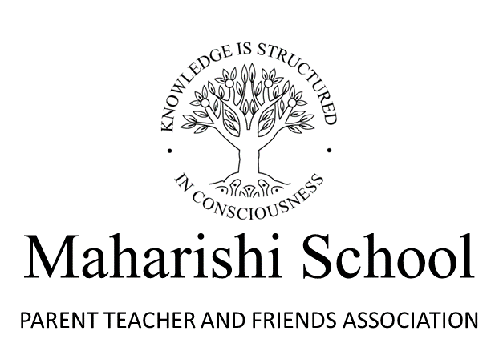

Social Media Policy

This policy explains how our association uses social media. It is available and applies to all members of our association.
Details of the social media used by our association
Maharishi PTFA uses Facebook. You can see this group here:
Maharishi School PTFA

Access to the social media used by our association
Maharishi PTFA uses Facebook. This is a closed group meaning that you can apply to join but this will need to be approved by the PTFA through our Facebook group administrator. Only approved members can see posts made to the group. However, once you are a member of the group, you can also post and these will be seen by all other members of the group who have been similarly approved.

Permitted members
The Facebook group of Maharishi PTFA is only intended for members of the association, in this case the parents and teachers of Maharishi school. This is regulated through this being a closed group and members needing to gain permission to join from the PTFA’s Facebook group administrator.

Maharishi PTFA does not want to encourage inappropriate use of social media by children. No application to join our Facebook group will be accepted by anyone aged less than 13 years.
Pupils at the school are not usually regarded as PTFA members. However, especially at secondary level, it could be advantageous to allow those appropriately aged to access the social media.

How this is used by our association
Maharishi PTFA uses its Facebook group exclusively for the running of the association. It is used to communicate with members, promote events or elements of events, to recruit volunteers to support the PTFA’s activities, thank local supporters and canvass members’ views.

Usage that is not permitted
The Facebook group of Maharishi PTFA does not allow any personal correspondence between members, is not intended for discussing any aspect of the school other than the PTFA and its activities and should not be used to promote any business other than where this is done for the benefit of the PTFA and with its permission. Inappropriate posts, including any derogatory comment, can and will be removed by the administrator and the PTFA retains the right to ban any user who continues to make inappropriate use of the group.

Photographs
The Facebook group of Maharishi PTFA allows members to post photographs. However, it is explicitly assumed that anyone posting a photograph will own the rights to the image and will have the permission of anyone featured to do so. Maharishi PTFA accepts no responsibility regarding ownership or permissions for any photographs posted by members of the group.

Application of this policy
By using the Facebook group of Maharishi PTFA you are accepting the terms of this policy. If you do not agree with any of the terms, please remove yourself as a member of the group.

Availability of this policy
This policy is annually reviewed and updated to all members of the PTFA.

.

