-------------------------------------------------------------------------------------------------------------------------------
The Inspirer
-------------------------------------------------------------------------------------------------------------------------------
12/01/2022 | Issue 1
-------------------------------------------------------------------------------------------------------------------------------

Welcome to our magazine!

This is the first issue of our school magazine - The Inspirer! Written and edited by pupils from our school it is full of interviews, reviews, recurring sections and much more. Throughout the last half term we have worked very hard to bring you this celebration of the talent that we have from interviewers to illustrators!

But we would love to hear from you: what kinds of articles do you want to read, what topics do you want to hear about and how do you think we can make The Inspirer a big success? It is a magazine for you after all.

So read on and we hope you enjoy this issue…

In this issue:

- Interviews with our head pupils
- Read the winning short stories from last terms competition and meet the authors
- Wellbeing and LGBTQ pages
- Book and anime reviews
- Feature: Halo Infinite review
- Crossword, sudoku and other puzzles
- And more
Meet our new Head Pupils
---------------------------------------------------------------------------------------------------------
This term staff and pupils listened to our year 11 candidates stand up and deliver their speeches. After the vote it was decided that Maiya Critchley and Jamie Graff are going to be our new head pupils. We met with our new Head Pupils to find out a bit about them and what they are doing for our school.
---------------------------------------------------------------------------------------------------------
Maiya:
Tell us a bit about yourself:  Hi, I’m Maiya, I have been in the school since year two and I have a lot of passion for the school. I understand that people may find it difficult to come into school  sometimes and that they may need a safer and nicer environment to come into. I am interested in performing arts, fashion and focusing on mental health.  What are your achievements so far?  I have introduced charity fundraising which gives people an opportunity to support different charities. I have been put in charge of the year 11 prom and leavers hoodies and I have started to discuss setting up a mental health club. | “I want to make school a comfortable environment for everyone”
What are your goals?
To be a good listener as I have a lot of experiences and I really see myself as someone who wants to help people that struggle. I want to make school a comfortable environment for everyone. Every month there will be a new charity jar outside the office.

If anyone has an idea you are welcome to share it.
------------------
Jamie:
Tell us a bit about yourself:  I like to go on walks with my dog on the beach. My influences are my family. I play Rugby for Ormskirk. When I won I felt happy and that I had gained the power to improve the school.  What are your achievements so far?  I have talked to Ms Edwards about setting up a committee. We would get together at lunch time. I would always attend, and Maiya could if she wishes.  ------------------ | “I want students to have an influence on every decision”
What are your goals?
I want to negotiate going out for lunch. I would like to reopen clubs e.g. chess club, and start the committee. People should be able to talk about anything to the Head Pupils.

I want students to have an influence on every decision.
Wellbeing
---------------------------------------------------------------------------------------------------------
Wellbeing is the state of both your mental and physical health. We believe that wellbeing is very important and needs to have a greater awareness. Our wellbeing quote of the issue is “nothing is impossible, the word itself says “I’m possible””.
---------------------------------------------------------------------------------------------------------

Why is Wellbeing important? Our Wellbeing Champions:
Wellbeing is important because it can seriously affect someone's life.  In the last decade researchers have discovered that people with a higher level of wellbeing are more sociable, energetic, more creative and do better at work. | This term, thanks to Ms Ingram and Jackie Robinson, pupils from each class were trained as Wellbeing Champions. They stayed after school for six sessions where they covered topics such as resilience, health and nutrition, anxiety and mindfulness.  There are now over twenty Wellbeing Champions in the school who will be there to promote wellbeing, help fellow pupils and spread awareness and love as well as lots of other aims.  Congratulations to all the pupils who took part in this program and to all the guests who came in to speak to them.
Who can I speak to if I am worried?

If you need to talk to someone you can talk to any of the Wellbeing Champions, Jayne, Ms Ingram or Ms Webster. There is a “Support my Wellbeing” box at the bottom of the stairs and there will soon be a notice board to let you know which Wellbeing Champions are happy to talk.

------------------

What is depression?  Depression is a mood disorder that makes you feel constant sadness or lack of interest in life. Most people feel sad or depressed at times. It's a normal reaction to loss or life's challenges. | What are the signs of depression?  Symptoms occur most of the day, nearly every day and may include: feelings of sadness, tearfulness, emptiness or hopelessness, angry outbursts, irritability or frustration  If you have these symptoms it’s best not to diagnose yourself, but go to a professional.
Our aspiring young authors with their amazing stories
---------------------------------------------------------------------------------------------------------
The talent in this school really showed this term when the school ran a short story competition with pupils able to submit a short story in the categories of Spooky, Tragedy or Comedy. The winner of the competition was Emily Parkin with her fantastic story “Mental health in a world of green”. The runners up were Hermione Tapia-Bowes and Lucy Reynolds with their stories “Almost” and “Last Words”. We interviewed them to see what they had to say.
---------------------------------------------------------------------------------------------------------

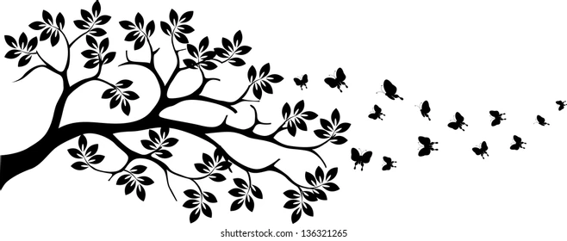

Emily Parkin:

Tell us a short summary of story:  “It's about this girl who is struggling a lot  with her mental health, then her parents  die and there is a trans cat”.  What was your reaction when you won:  “I clapped for myself”. | What was your inspiration?  “It was based on an anonymous person  who does not want to be named”  How did you spend the voucher you won?  “A Santa Claus outfit”.
------------------

Hermione Tapia-Bowes:

Tell us a short summary of story:  “It starts off with a triplet. It’s about someone’s birthday going to the train to London, they get mugged, he says ‘I will kill you and mug her or the other way round’, they look into each other's eyes and he says ‘her’”.  What was your reaction when you won:  “I was genuinely surprised”. | What was your inspiration?  I generally like to read a lot of books, in particularly mystery and murder. I wanted it to be very short with a lot of points. I pick up a lot of words and lines from books I have read.  How did you spend the voucher you won?  “A new school bag”.
------------------
Lucy Reynolds:

Tell us a short summary of story:  “A boy whose grandad dies because of a stroke”.  What was your reaction when you won:  “Surprised”. | What was your inspiration?  “It came into my head”.  How did you spend the voucher you won?  “New pencils”.
------------------

Thank you to Emily, Hermione and Lucy for their interviews and for letting us put their stories in this issue of the Inspirer. Well done to everyone who sent in a story to the competition. Also a big thank you to Ms Webster for running the competition and we hope there are more to come.
---------------------------------------------------------------------------------------------------------
---------------------------------------------------------------------------------------------------------

Poem of the issue: Flint by Christina Rossetti

An emerald is as green as grass,  A ruby red as blood;  A sapphire shines as blue as heaven;  A flint lies in the mud. | A diamond is a brilliant stone,  To catch the world’s desire;  An opal holds a fiery spark;  But a flint holds fire.
Mental health in a world of green
By Emily Parkin
Illustration by Verity Cooke
---------------------------------------------------------------------------------------------------------
The bell rang from one end of the school to another, dismissing all of the students that now swarmed into the hallway. Although it was crowded she still felt isolated, all alone, nobody to catch her if she fell. The journey was over, she had made it into the outside world. Which now felt like another dimension. After being cramped in a cell all day and glued to a chair which curved your back as if you had no other choice but to rest it there. She felt the cold fresh air enter her airway. The wind blew her hair as if it was her moment to shine. Birds were singing, people were chatting, parents were screaming, cars were beeping and then... darkness, full on darkness. As if someone had spread ink around her. The feeling came back, the feeling of having nobody. No safety net. Not a single heartbeat could be heard by this teenage girl. She twirled her tatty greasy hair around her fingers as if she wanted it to go purple and fall off! She ran home trying not to be seen by a soul. She was good at this now as she has had years of practice.

Her mum was not there to greet her nor was her dad, only her cat who was used to greeting her despite not being able to hear him. Her cat was called Mittens. He was an old guy, 10 to be exact they were nose blind because they have been living with it for months now. She plumped onto the bed, the only thing she was certain she could rely on. She changed out of her school uniform and put on some joggers and a jumper. Slipped into her converse and ran into the forest behind her house.

She left her shoes at the stop sign, which she had always done. It was her way of keeping a routine when she needed some alone time. Her foot sunk into the grass,this was a feeling she loved! As she ran through the forest she left a trail of her emotions behind her. She would pick them back running back to her house. She continued to run through the green nails stabbing into her foot yet leaving no marks. She was here...her favourite place on earth. She stopped and took a deep breath in.The cold air hit her lungs. She looked up at the trees suffocating her in the forest. A small fragile bunny leaped past her and over her foot that was placed on the grass in a patch of daisies. It took the bunny a split second to acknowledge the teenage girl. It looked back at her and blinked before vanishing into another dimension by disappearing back into the world of freedom. A small fur ball brushes against her arm.

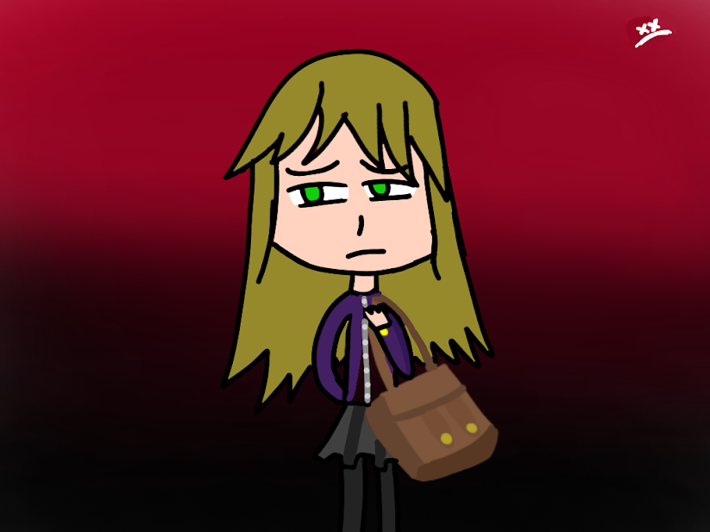
She let out a gasp as she jumped a little, turns out it was Mittens. He had never come this far into the woods but everytime her mental health got worse he followed her further and further into the forest. As if he could sense it. She dragged herself up off the grass that seemed to grow everyday. It was time to collect her crumbs of emotions as she dragged her feet one in front of the other. She walked past the trees feeling every bit of emptiness she felt before. Mittens could only take so much of that sadness away. She collected her shoes and once again she felt her shoulder tense, her brain not able to focus, her feet feeling numb and her heartbeat constantly changing. she had come upon her least favourite place to rest everyday. She stood at the door to her house. She pondered whether to enter her house. She stepped into her house with Mittens at her side. she expected her parents to be there as they always were at this time. Today, they were not. Something was off. She peered into the kitchen to see a river of blood at her feet. Her parents were not with her anymore. They may have been dead but now at least she was free. Just like the rabbit.

Almost
By Hermione Tapia-Bowes
Illustration by Maisie Godfrey
---------------------------------------------------------------------------------------------------------
I almost made it in time to save her. I almost didn't save her at all. She almost made it…
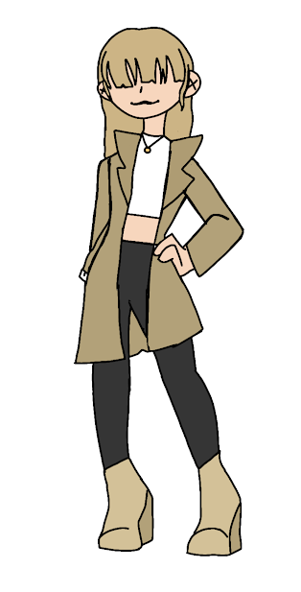
‘Are you nearly ready?’
‘Coming my love!’
Her voice, soft and pure. I'll always remember the sweet tone of her voice, her smile, a smile that made the whole world stop and stare, a smile that lit up the room, a smile that made everything ok. I remember the smooth feel of her hair. The smell of her fruity perfume. I'm remembering all of this whilst wearing her jacket. How she loved this jacket. It's a detective coat. She would wear it with the collar up, jacket open, and belt hanging, she thought she looked cool. Never a care in the world.
‘I can't wait to go! What a wonderful surprise!’
I surprised her for her birthday. It was a train ticket to london. We were going sightseeing.

That was the day it happened. Her birthday. Oh how I loved her. However, when it came to the choice I spoke too soon…When you're held at gunpoint, what would you do?

A man stopped us on our way to the station. We were on a bridge, the water gushing below us. The smell of salt filling my nostrils.
‘Follow me.’ he grumbled
‘Why?’
He pulled out a gun. We followed.
‘I'll give you a choice,’ he pointed at us. The sickly feeling of death sitting at the back of my throat. ‘Her or you?’
‘What?’
‘Her or you?’
‘I don’t understand.’
‘I kill her and loot you, or I kill you and loot her.’
I looked at her. Tears formed in her eyes. Telling me no, telling me to stop, telling me she loved me. But I didn't. Why...
‘Her’ My voice trembling
‘BANG’
She screamed. She clutched my chest as she fell.
‘Kate…’
He grabbed her bag and ran. I called the police. Called an ambulance. I could hear the sirens in the distance. I thought about running. I did this to her. But it was too late. This memory will always be scarred into my memory.

I almost made it in time to save her. I almost didn't save her at all. She almost made it…
---------------------------------------------------------------------------------------------------------
---------------------------------------------------------------------------------------------------------
Last words
By Lucy Reynolds
Illustration by Verity Cooke
---------------------------------------------------------------------------------------------------------
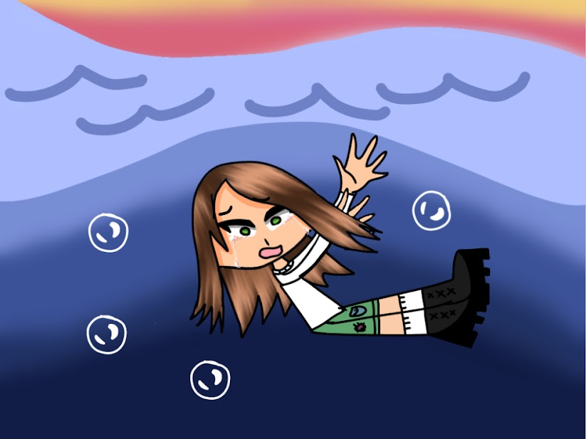
When the person you love most dies, it’s like being dunked into a tank of ice cold water. It feels like a thousand daggers are penetrating your skin but it’s nothing but a numb pain. You have the feeling that you cannot breathe under the water and must do everything possible to get out, but you can do nothing. You are useless against nature, and you feel that your life source has died too. You can hear nothing but a faint buzzing in your ear and anything else you hear is just a muffled sound. You feel trapped and alone. You get the feeling that everything is different, nothing will ever be the same again. When they die, you feel a part of you has died too. All the happiness has been sucked out from you, you feel drained and sick to the stomach. You want to do so much, but all you can do is cry. Sit and cry as though you will never stop. All the colour is gone from the world, your eyes see only black and white.

This is an extract from the story Last Words
LGBTQ+
---------------------------------------------------------------------------------------------------------
Equality is important. One sector in the fight for equality is LGBTQ+ and here at the magazine we are going to bring you a greater understanding by answering questions and making sure everyone knows what different terms and flags mean. Education and understanding is the first step to a fairer world.
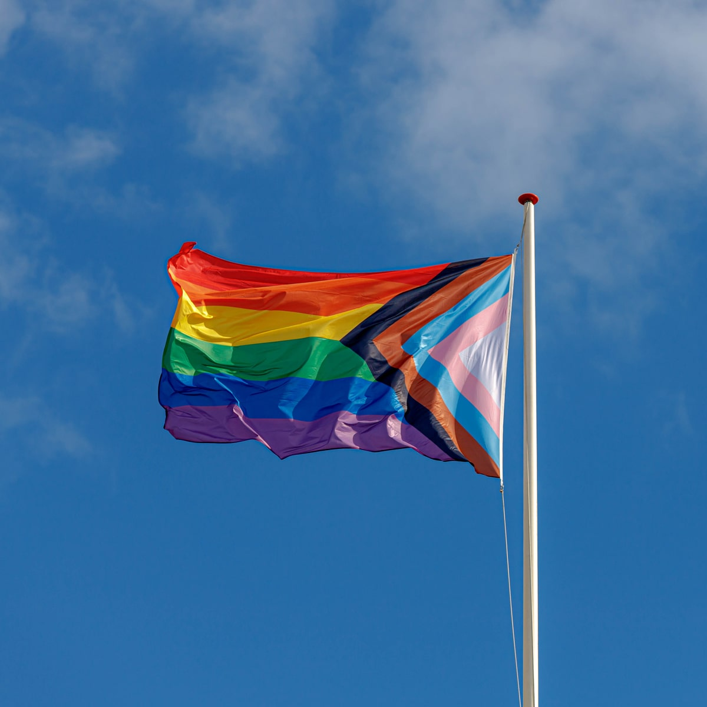
---------------------------------------------------------------------------------------------------------
Understanding LGBTQ+

Lgbtq+ stands for lesbian, gay, bi, trans, queer etc.
Here is a frequently asked question about LGBTQ+:
What if I make a mistake?

It’s ok! Everyone makes mistakes sometimes! The best thing to do if you use the wrong pronoun for someone - for example - is to say something right away, like “Sorry I meant (insert pronoun)”.

You shouldn’t make a big deal out of it as it can make the person feel uncomfortable.

------------------

Here are some of the LGBTQ+ flags and what they mean:

This is the Lesbian flag, it means that a female likes anyone other than male | This is the Gay flag, it means that a male likes anyone other than female. | This is the Bi flag, it means that anyone can like a male or a female. | This is the Transgender flag, it means that a boy chooses to identify as a girl and vice versa. | Nonbinary is where someone doesn't feel like a boy or a girl and chooses to have they/them pronouns

------------------
See next issue for even more questions and flags. Got a question you want to ask? Contact the magazine.
Recipe
---------------------------------------------------------------------------------------------------------
Here is a recipe for some lovely pancakes. They are vegan but why not see them as a recipe that just so happens to be vegan rather than “an alternative”.
---------------------------------------------------------------------------------------------------------

Pancakes:

Ingredients:
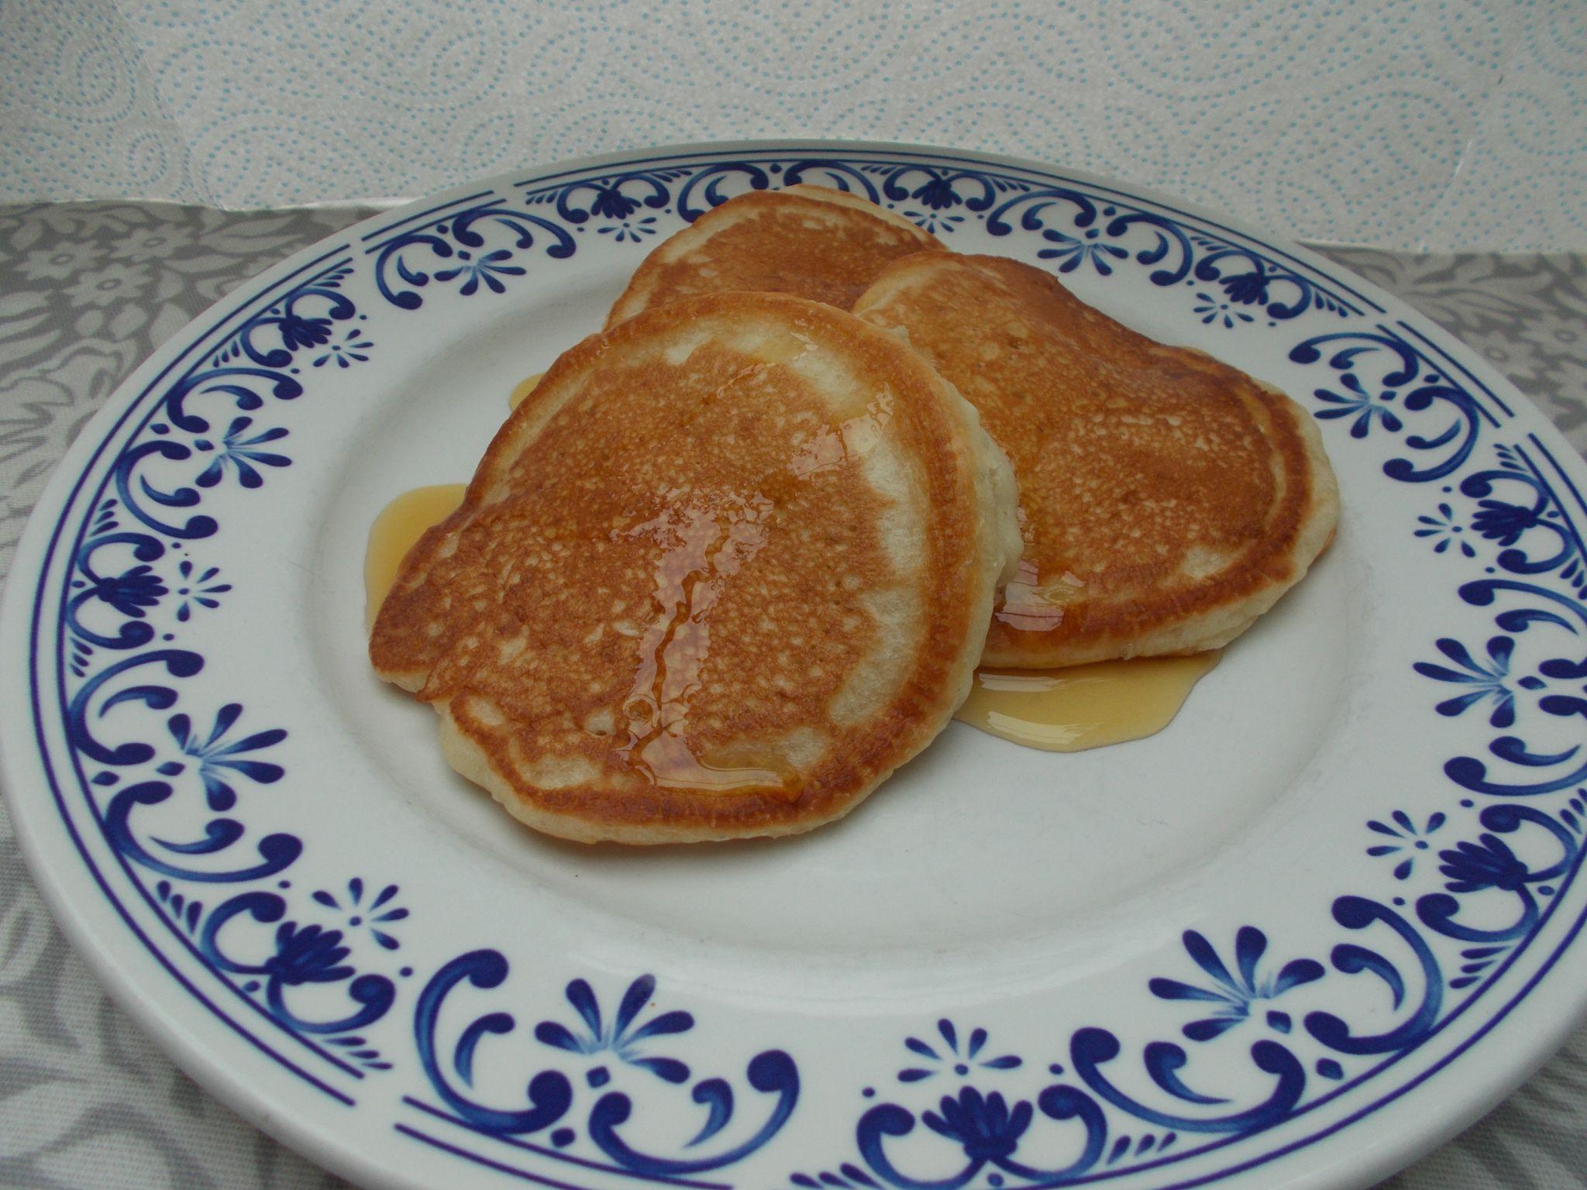
- 360g self raising flour
- 40g cornflour
- 1.5 tsp baking powder
- Pinch of salt
- 8 tbsp agave syrup
- 6.6 tbsp sunflower oil
- 3 tsps cider vinegar
- 400 ml soya milk

Method:

- Mix all the dry ingredients together in a mixing bowl (flour, cornflour, baking powder and salt)
- Mix the wet ingredients in a separate jug and mix (syrup, oil, extract, vinegar and milk)
- Gradually whisk in the wet ingredients into the bowl of dry ingredient
- Fry until cooked in small batches in hot sunflower oil in a frying pan
- Top with a topping of your choice
(Due to the vinegar, do not make the mixture in advance, make it when you are going to cook and eat it).
Puzzles
By Verity McNamara
---------------------------------------------------------------------------------------------------------

Crossword:
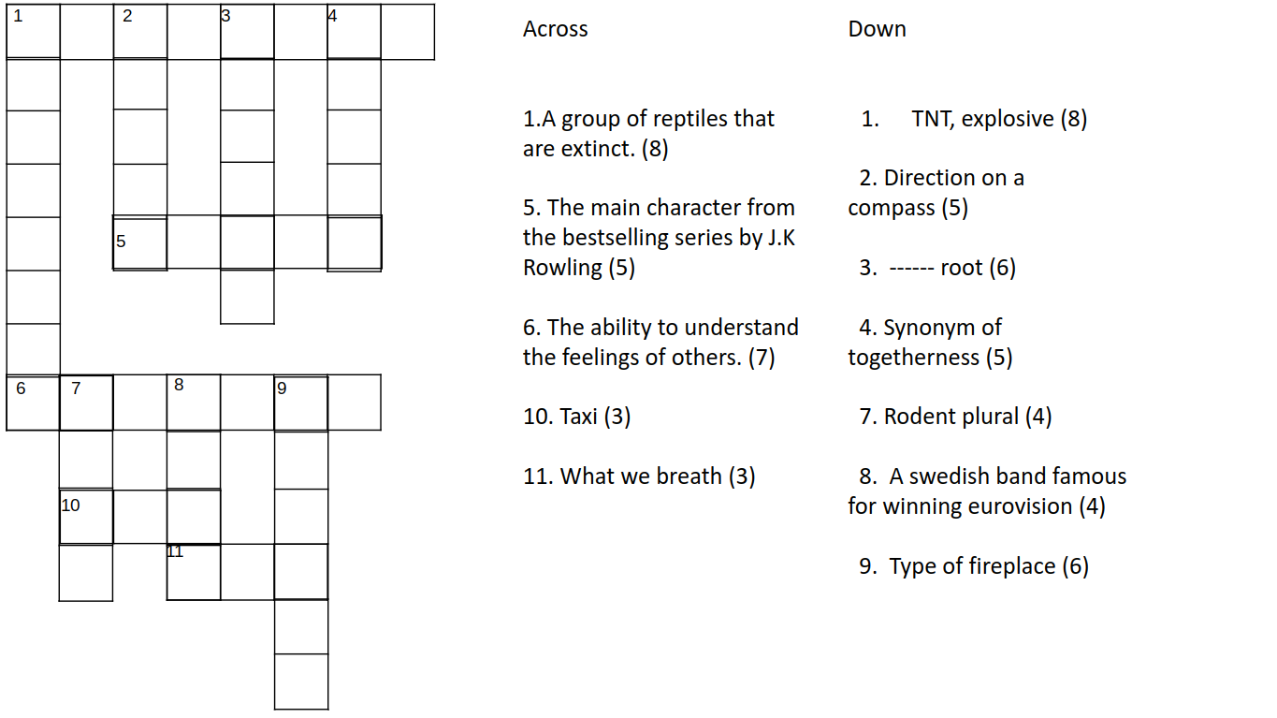

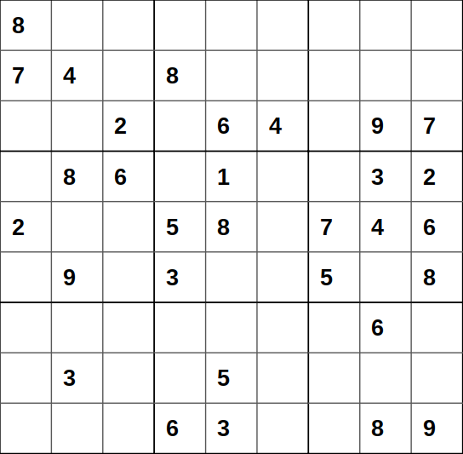
Sudoku:

Every square has to contain a single number.
Only the numbers from 1 through to 9 can be used.
Each 3×3 box can only contain each number from 1 to 9 once.
Each vertical column can only contain each number from 1 to 9 once.

Futoshiki:

The aim is to place numbers 1 to 5 into each row and column so that not number is repeated twice in each row or column

All of the inequalities must be right
(< - is smaller than, > - is greater than)

Wordsearch:

Find the following nature related words:

- Flower
- Root
- Branch
- Tree
- Bark
- Leaf
- Sap
- Crow

Answers for the puzzles will be published in the next issue.
Reviews
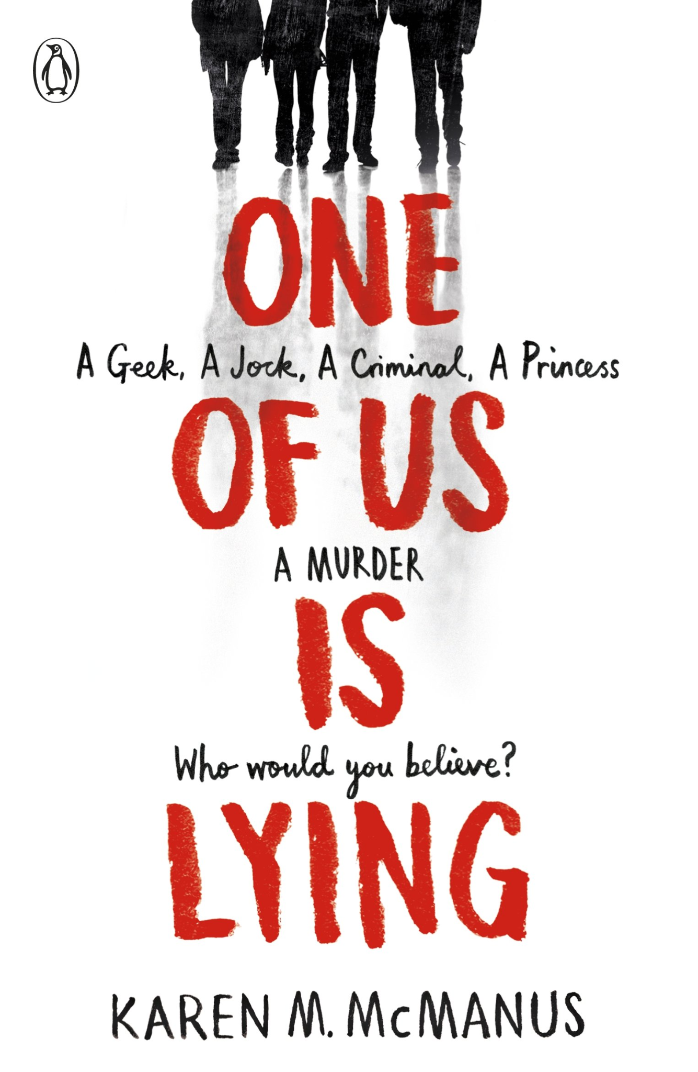
---------------------------------------------------------------------------------------------------------

Book Review by Niamh Hanlon

Book title: One of us is lying
Author: Karen McManus
My rating: 8.5/10

One of us is lying follows four characters, Bronwyn Rojas, Nate Macauley, Addy Prentiss and Cooper Clay, after one of their classmate’s dies in detention. But, they are the main suspects. All four of them know that they aren’t responsible for their classmate's death, but do they believe that the other three are innocent too?

One of us is lying follows how their relationships grow with each other and how they work together to find out who was actually responsible for their classmate’s death. I would highly recommend this book because it is great. One of us is lying is part of a series, it’s sequel ‘One of us is next’ which follows Bronwyn’s younger sister, Maeve Rojas, a year after her sister’s murder investigation.
---------------------------------------------------------------------------------------------------------

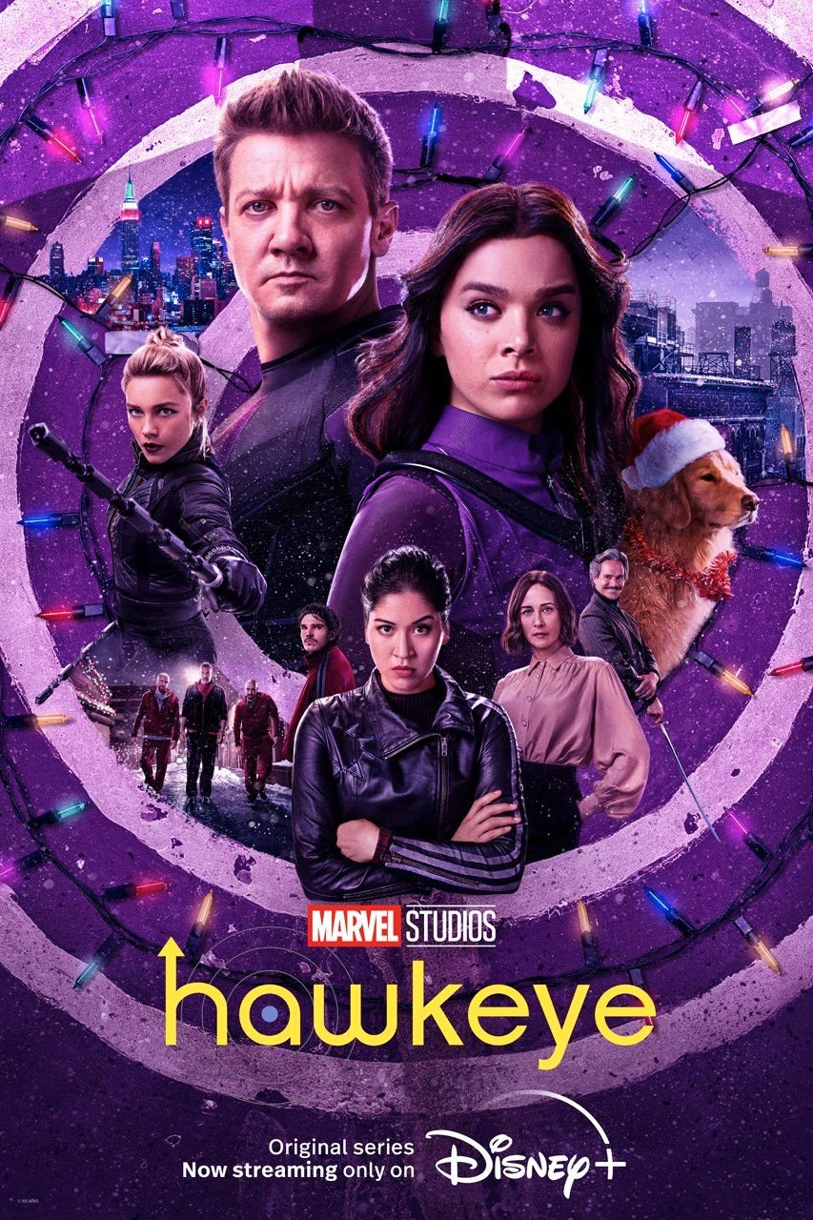
TV review by Seren Sackville-Jones

Series title: Hawkeye
Where to watch: Disney+
My rating: 8/10

Hawkeye is the newest Marvel series on Disney+ and came out in the weeks leading up to christmas. It has a fun, light-hearted tone while still delivering some brilliant fight scenes and insight to the realities of being an avenger. Kate Bishop - an avenger wannabe - finds herself in the middle of a conflict between a gang and Ronin, a part of Hawkeye’s past he wanted to leave behind. Hawkeye and Bishop must work together to get Hawkeye back home in time for Christmas while coming up against both new and returning characters.

This is an easy-to-watch series and the diverse cast and comedy in it makes it a refreshing Marvel series which seems heart felt and I hope that this is a taster of what is to come from Marvel. I would highly recommend this as a fun, action-packed watch.
Anime Review by Eva Welsby
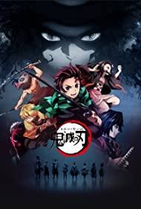
Anime title: Demon slayer: Kimetsu no yaiba
Where to watch: Demon slayer is a UFO table anime that you can watch on netflix, funimation and crunchyroll.

Demon Slayer is a manga and series written by Koyoharu Gotouge, it's one of the most popular anime/manga. It is an ongoing series(one full season)and there is currently one movie: Mugen train.

Tanjiro Kamado, a young boy, arrives at his home to find his entire family had been murdered and his sister, Nezuko had been turned into a demon. When Nezuko starts attacking Tanjiro, a slayer named Giyu comes to their rescue and forges a deal with Tanjiro - let Nezuko live if Tanjiro becomes a slayer and defeats the head demon, Muzan. Tanjiro begins his mission on helping Nezuko, he trains for over 2 years and becomes a slayer. Join Tanjiro, Nezuko, Inosuke and Zenitsu on a journey to defeat demons.

Storyline:
Demon slayer has an interesting storyline, it’s quite sad in a way but also very thrilling. (storyline explained in the description).

Art style:
The demon slayer has quite a unique art style compared to other anime. The art is good quality, creative and really beautiful.

Characters:
There are lots of characters in demon slayer, all with full, all with their own individual personality. They all have good backstories and have things that everyone loves about them.
---------------------------------------------------------------------------------------------------------

Look out for more reviews in the next issue.

Feature: Halo Infinite Review
By Ethan McGarrigle
---------------------------------------------------------------------------------------------------------
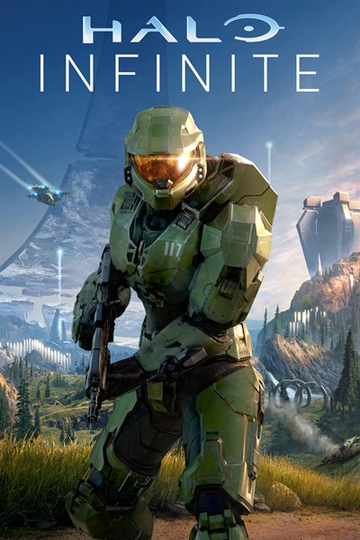
Multiplayer:

Halo Infinite’s multiplayer is truly a return to form. From its return to the classic artstyle and it’s excellent gameplay loop, Infinite is easily one of the best multiplayer shooters debuting this year.

Gameplay:
One of the best parts of Infinite’s gameplay are the engagements. They are either intense 1v1’s or full teams duelling off over an object. Even better is the fact that every engagement lost feels as though it should have been lost. Either losing to either being ouskilled, outnumbered or the enemy simply having better weapons.

Speaking of weapons, players start with an MA40 Assault Rifle and an MK50 Sidekick, fulfilling the roles of a solid automatic weapon and a backup pistol respectively. Both weapons are formidable in their own right but are able to be replaced with power weapons. These are weapons that provide specialist roles (such as precision weapons like the S7 Sniper Rifle and melee weapons like the Energy Sword) and require more skill to use. I enjoyed using all of these weapons, though three of them (VK78 Commando, Ravager and the Plasma Carbine) felt less than stellar, suffering from low fire rate, low damage or just not fitting on role. Unfortunately several of the old weapons from previous games aren’t in Infinite. Some of these weapons are the M6G Magnum, M90 shotgun, M392 DMR and many more.

One thing that really stuck out to me was the sound effects. All of the weapons sound excellent with the sound of hitting someone in the head sounding especially nice. Despite all of this, there is one thing that Infinite does that doesn’t stick well. The melee just feels off. This may be due to the lack of player collision, but there is a chance that this might be a desync issue and may be fixed or added back in by the time this review is published. Overall, Infinite’s core gameplay loop is one of the best I've seen in a while, and I highly recommend it to anyone who enjoys arena shooters.

Map Design:
All of the maps in Infinite are fun to play, with only one that I dislike. Despite them all being 3 lane maps (meaning that you can only go one of 3 ways), they all play excellently and especially on the Quick Play maps feel as though there is always a new way to begin an engagement.

Spread throughout the maps are special abilities that your spartan can use to get an edge on your opponents. These are things like the grapple hook and the overshield which allow you to quickly move about and defend yourself respectively.
Infinite’s are definitely the type where you can look at them and say ‘Yep, that's a classic’, especially for maps such as Streets and Aquarius. I can definitely see myself coming up with new interesting routes to flank my opponents and take them by surprise.

Progression:
The best way to describe Infinite’s progression is that there is so much it could have. Because Halo has now gone free to play, it has adopted the Battle Pass system of progression from games like Fortnite and Apex Legends. Despite the pass never expiring, its rewards are pieces of armour ported over and remastered from Halo: Reach at best and duplicate charms and challenge swaps at worst.

Speaking of challenges, these are how you’ll level up the Battle Pass. These renew every week and can be swapped using Challenge Swaps. These range from acceptable (Get 15 kills with the Assault Rifle) to nearly impossible (Kill 3 enemy Wasps). While you are able to get a level in under an hour, this is only once per day and you’ll mainly be completing challenges for experience. I am personally not a fan of this system due to locking progression behind weekly challenges and halting players' experience all because they’ve completed all their challenges.

In addition to the paid battle pass, Halo Infinite includes a free battle pass that disappears and reappears several times throughout the season. The current fracture event, Tenrai, is not the best and the battle pass is mostly challenge swaps and experience grants. It also locks certain game modes behind a limited time system which is annoying for people who only play these now limited time game modes.

Halo Infinites progression is probably one of the worst I've seen in a while, however the developers have addressed the community’s concerns and are working to fix it. Hopefully by next season the battle pass will be significantly better.

Update: As of time of writing (January 1st, 2022), the progression system has been changed to allow for easier experience gains and the Tenrai event has had the vast majority of its xp grants and challenge swaps removed and replaced with cosmetics.

Other:
The armour coating system Infinite uses to customise its players characters is definitely good on paper, bad in practice. Locking certain colours behind a paywall is even worse. This system could have been a lot better if they had allowed players to have the basic colours for free and made interesting colour combinations and textures available in the in-game store as armour coatings.

Due to becoming free to play, Halo Infinite has added an in-game for players to purchase cosmetics and other things such as armour. These are mixed for me. Some of these are absolutely the things that belong in the store. Things like armour coatings, charms and weapon skins. Amour being in the store is a mixed bag for me. On one hand, the game is free to play and needs to make money and on the other hand selling items that very clearly should have been in the battle pass or where in the marketing for the battle pass is not the best. Overall, I’m willing to give Infinite’s store a shot, but I would like the ability to earn currency through either the battle pass or by playing the game.
Campaign:

Halo Infinite’s campaign is easily becoming one of the in the genre, with great character, a beautiful soundtrack and incredible open world, Infinite truly is proof that Halo is still as great as it was 20 years ago.

Graphics And Artstyle:
Standing up high and looking down on the map is easily one of my favourite pastimes in Halo Infinite. Although Zeta Halo’s sprawling landscapes can get a bit repetitive, I still found myself enjoying them every time I saw them.

Even better is looking at the ring itself. It’s looming presence makes the Master Chief feel so small and lost in such an open world. The ring is not whole however, as months of battles between Banished and UNSC forces have left the ring heavily scarred. Designed beautifully by 343 Industries designers, Zeta Halo is truly a work of art.

That’s not all though, as Halo Infinite returns to the series’s classic artstyle. For those that don’t know, when current developer 343 Industries took over from previous developers and series creators Bungie, one of the largest changes was a new artstyle. The large majority of the community disliked this change and as such after nearly a decade Halo has returned to its original artstyle. The incredible graphics alongside the return of the old artstyle has made chief look better than ever before.

Story:
Set 6 months after the destruction of the UNSC Infinity, a surviving pilot by the name of Echo 216 finds the Master Chief floating in space. Going from a tale of a hopeless last stand to a story of triumph, Infinite’s story is very easily my favourite in the series. Between some incredible reveals and excellent characters, Infinite definitely has the capacity to be enjoyed by anyone.

Before I go any further with this section, there is one thing that needs to be mentioned. Infinite’s primary antagonist Escharum, Brute warlord of the banished. In the roughly one hour of screen time he gets, Escharum has quickly become my favourite antagonist in the franchise and quite possibly my favourite antagonist in gaming. The idea of an old and dying warlord looking for one last glorious fight against you, the Master Chief, is one of the best ideas for an antagonist I’ve seen in a long time.

The reason why Infinite's story stands out to me is because it combines the greatest story-telling aspects from both 343 and Bungie. Takings Bungie’s emphasis on the one man army and the idea of stopping a greater threat and 343’s more human Master Chief with a deep connection with his A.I and those around him.

Speaking of A.I, Chief now has a new A.I companion, The Weapon. I love The Weapon. Without going into spoilers, she’s like an imitation of Cortana from someone who only knows the basics but can’t help but add their own charm to it. Add in some excellent voice acting by Jen Taylor and you’ve made a new fan favourite.

Open World:
Although not as large as other open worlds, Halo Infinite’s is easily one of the best. The player is required to F.O.Bs, also known as Forward Operating Bases, to unlock objectives and rewards on the map. These range from rescuing marine squads to assaulting banished bases and assassinating key targets. The player can also find armour lockers spread out through the map. Interacting with these unlock customization options in the game’s multiplayer.

Completing tasks in the game rewards the player with Valour, which (once enough has been gained) unlocks things such as vehicles, weapons that can be spawned at F.O.Bs and UNSC marines to fight alongside you. I love this system as it rewards players who take their time and complete side tasks while at the same time not punishing those players who don’t as all the rewards aside from the marines can be found on Zeta Halo.

Overall Halo Infinite’s open world does one key thing that other games often times fail to do, making the side quests fun and not essential to the players power level

Soundtrack:

Before I give my verdict on the game, there is one last thing I would like to talk about, Infinite’s soundtrack. It is easily one of the best soundtracks ever made. Composed by a trio of Gareth Coker, Joel Corelitz and Curtis Schweitzer, it combines the original Bungie era music made by Martin O’Donnell and Michael Salvatori with the theme of the Banished. Some tracks such as Escharum, The Weapon, Know My Legend and Reverie have quickly risen to become some of my favourite songs of all time. Bravo 343, bravo.

Verdict:

9.9
/10

Between one of the best multiplayer I’ve seen in years and the single greatest campaign I’ve played in my entire life, Halo Infinite is truly a new age for the franchise. Although it has a few issues with useless weapons and progression and customization, I am confident they will be non-existent by the end of the year.

---------------------------------------------------------------------------------------------------------

Watch out for another exciting feature in our next issue.

Credits:
---------------------------------------------------------------------------------------------------------

- Template of magazine: Seren Sackville-Jones
- Intros: Seren Sackville-Jones
- Interviewers for the head pupils: Ethan McGarrigle, Verity McNamara, Seren Sackville-Jones and Alice Taylor
- Wellbeing: Verity Cooke, Seren Sackville-Jones and Isla Deakin
- Interviewers for stories: Verity McNamara and Ethan McGarrigle
- Illustration for Mental health in a world of green: Verity Cooke
- Illustration for Almost: Maisie Godfrey
- Illustration for Last Words: Verity Cooke
- LGBTQ+: Alice Taylor and Verity Cooke
- Recipe and photo: Seren Sackville-Jones
- Puzzles: Verity McNamara
- Reviews: Niamh Hanlon, Seren Sackville-Jones and Eva Welsby
- Feature: Ethan McGarrigle

Pictures from the internet: amazon uk, IMDb, Xbox Wire Halo Infinite Available Now with Xbox Game Pass - Xbox Wire, Adioma, Shutterstock, Game rant, National today
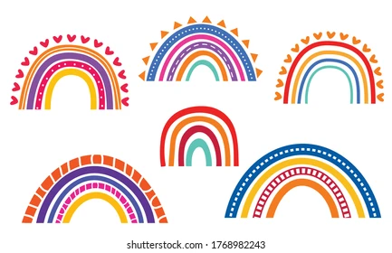

A big thank you to Ms Webster for setting up the magazine and organising it all!

